Template
End of Life Policy

July 2018

Introduction

Our End of Life Vision
We will ensure that every patient registered at ORGANISATION NAME who is at the end of their life has a dignified and comfortable death.

Practice Promise
We will
- Ensure patients who are at the end of their life are recorded on the practice palliative care register. This should be 1% of your registered population

- Ensure patients on the palliative care register are reviewed by a multidisciplinary team at least every 3 months.

- If deemed to be in the later stages of palliative care endeavour to see face to face on a 2 weekly basis.

- Involve patients and their nominated representatives in the planning of end of life care.

- Instigate DNAR discussions with the patient where this has not been done.

- Instigate place of care and death preference discussions with the patient where this has not been done

- and READ code this in the electronic record

Consider pre-emptive prescribing in a timely manner.

- Ensure instruction to administer forms are completed in a timely manner.

- Ensure Out of Hours providers are notified of a patients’ end of life status.

- Ensure Community Nursing services are notified of a patients’ end of life status.

- Ensure effective communications with other Partner Organisations.

Scope
This policy applies to all administrative and clinical staff involved in end of life care for registered patients of ORGANISATION NAME. This includes permanent and temporary employees of ORGANISATION NAME including contractors, apprentices, volunteers and Partner Organisations.

Enforcement
Any ORGANISATION NAME employees, contractors, apprentices or volunteers found in violation of this policy may be subject to disciplinary action, up to and including termination of employment or Partnership Contracts.

Definitions

End of Life
A person in the final hours, days or months of their lives, but more broadly, to those with a terminal condition that has become advanced, progressive and incurable. For the purpose of this policy end of life is defined as death expected within 12 months.

DNAR
The clinical decision to allow natural death to occur and not to attempt to mechanically restart the heart and lungs.

Pre-emptive Prescribing
The prescribing of medicines to ease symptoms of a disease state before that are required by the patient.

Instruction to administer
The proforma used to authorise and detail the administration of medicines by the district nurse to the patient.

Out of Hours
The clinical service deputised to provide care for patients between the hours of 6pm to 8am on a Monday to Friday, and 6pm on Friday to 8am on Monday and during Bank Holidays.

Policy

- Palliative care register.

ORGANSATION NAME will have an electronic palliative care register.
Patients who are given an end of life diagnosis will be added to the palliative care register by adding the code “Palliative Care” to their electronic medical record. This ensures that the information is shared to others via the eSCR.

- Palliative care multidisciplinary team review.

  - The care of patients on the palliative care register will be discussed by a multidisciplinary team at least every 3 months, consisting of
GP
Practice Nurse
District Nurse
Palliative Care or other specialist community Nurse as appropriate (eg. Heart Failure Nurse)
Administration Lead

  - As a minimum, the discussion will consist of
RAG(RED/AMBER/GREEN) status
Current care needs
Place of care/death preference
DNAR status
Pre-emptive prescribing needs
Last face to face review date
Next face to face review date (if indicated)
Review of partner organisations involved
Review of partner organisation communications
Advanced Care Plan update

  - The documentation of the discussion will be recorded in the patient electronic record under the problem “Palliative Care Review”.

- Face to face assessments.
3.1 All patients who are near the end of their life will receive face to face assessments at intervals determined by the palliative care MDT or when triggered by the patient, a clinical colleague providing end of life care to the patient, the patient’s carer or a nominated deputy of the patient.

3.2 All patients must have a face to face assessment by a General Practitioner who is capable of providing a death certificate for that patient within 2 weeks prior to the death of the patient.

- Involve patients and their nominated representatives.

All patients and their nominated representatives will be afforded the opportunity to be involved in the planning of their end of life care unless they expressly dissent to this.

- DNAR.

  - All patients nearing the end of their life will be asked whether they wish to be resuscitated or not in the instance of cardiorespiratory arrest.

  - The discussion will involve
5.2.2 exploration of what it means to undergo resuscitation for

                - the patient,
                - the patient’s relatives
                - carers

5.2.3 exploration of surviving resuscitation
5.3 If the patient wishes to avoid resuscitation, the clinician will complete a DNAR form.
5.4 One copy of the DNAR form will be given to the patient to keep.
5.5 A second copy of the DNAR form will be uploaded to the electronic patient record.
5.6 A code of “Do Not Attempt Resuscitation” will be added to the electronic patient record.

6 Place of death planning.
6.1 All patients will be asked where their preferred place of death is.
6.2 The response will be recorded in the electronic patient record.

7 Pre-emptive prescribing.
7.1 All patients will be prescribed medications to pre-empt the need for relief of symptoms in the end of life period,
7.2 For pre-emptive prescribing guidance please refer to appendix 1
7.3 Medicines unlikely to contribute to the quality or longevity of a patient’s life will be stopped.

8 Instruction to administer forms.
8.1 All patients requiring as required medicines for relief of symptoms in the end of life period will have a “non-syringe driver instruction to administer form” completed.
8.2 The “non-syringe driver instruction to administer form” will be FAXED to the District Nurse Single Point of Contact on 01302 566789
8.3 All patients requiring a syringe driver for relief of symptoms in the end of life period will have a “syringe driver instruction to administer form” completed.
8.4 The “syringe driver instruction to administer form” will be FAXED to the District Nurse Single Point of Contact on 01302 566789

9 Notifications
  - Communications will be sent to notify of the end of life status of the patient to

- Out of Hours.
- District Nurses.

9.2 Communications will be sent when the patient is added to the palliative care register.

Appendix 1

Doncaster LMC Organisational Standards Monitoring Tool – End of Life Care
 | Metric
Goal | Statement of organisional goal.
Measurement of Success | How is the goal going to be measured?
Type of Measurement | Delete as appropriate  Implementation / Effectiveness / Impact
Formula | How is the measurement of success calculated?
Target | What is your threshold for defining success (e.g. 90%)
Evidence | What evidence needs to be collected to prove success?
Source | Where is the evidence above located?
Frequency | How often does this monitoring need to take place?  Yearly – Every August.
Accountability | Who is responsible for the success?
Stakeholders | Who are the key stakeholders?
Reporting | How is the output of this tool going to be fed back to key stakeholders?

Appendix 2

End of Life Checklist

- Add patient name to Practice Palliative Care Register

- Discuss the care of the patient at the Practice Palliative Care MDT

- Organise a face to face review within 2 weeks prior to death

- Discuss place of death preference with patient

- Discuss and document DNAR with patient

- Arrange palliative pre-emptive medicines

- Complete pre-emptive Instruction to administer letters

- Notify the local OOH provider of end of life status

- Notify the DN’s of end of life status

- Notify the Palliative Care Team of end of life status

Appendix 3
Syringe driver Instruction to administer form
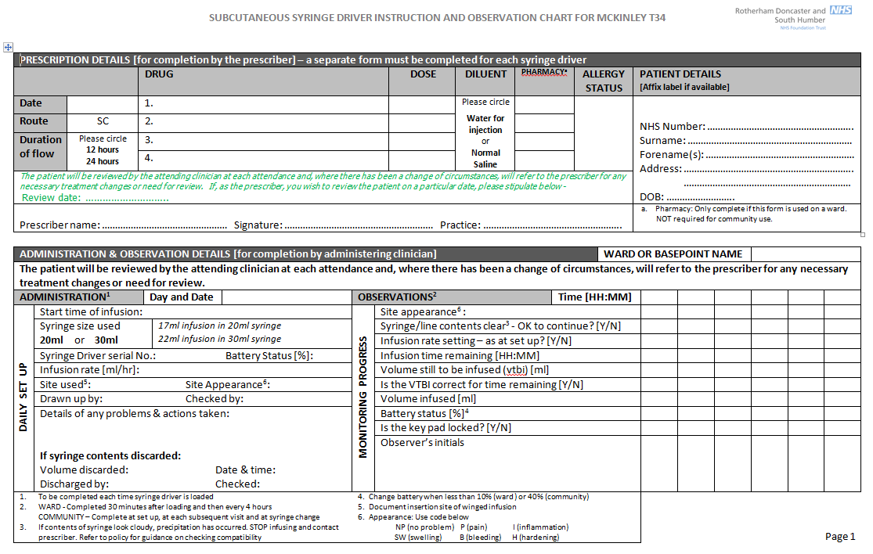

Appendix 4
Non syringe driver instruction to administer form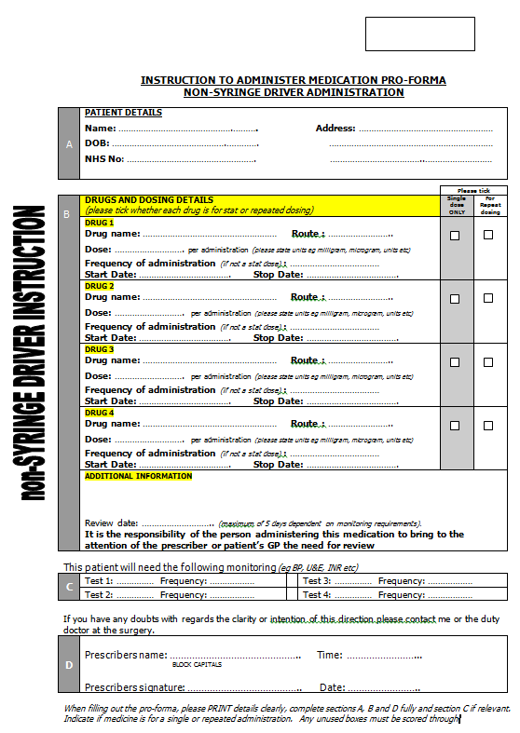

Appendix 5
OOH Notificaton
