INFANT FEEDING GUIDELINES:

A guide to good practice

(Preconception, pregnancy
and 0 – 5 years)

2018 Edition

This is guide is intended for professional use only, and is not to be shared with the general public.

Contents Page

Section | Topic | Page number
1. | Introduction, Rationale & Aims | 3-5
2. | Preconception Nutrition & Nutrition during pregnancy | 6-38
3. | Breastfeeding | 39-93
4. | Bottle feeding | 94-112
5. | Fluids and drinks | 113-121
6 | Weaning and infant feeding | 122-141
7. | Vegetarian and vegan weaning | 142-152
8. | Special dietary consideration for infants | 153-158
9. | Dietary guidelines for the under 5’s and Eating for Future Health | 159-178
10. | Oral Health | 179-191
11. | Other information | 192-197
12. | Resources | 198-205

SECTION 1

Introduction, Rationale

& Aims

1.1 Introduction

The Infant Feeding Good Practice Guide was originally developed by the Doncaster and Bassetlaw Infant Feeding Steering Group, in consultation with health professionals in Doncaster and Bassetlaw involved with infant feeding. This group has now disbanded, and the guides’ content is now reviewed by the Public Health Improvement Co-ordinator, with support from the Health visitor lead for infant feeding and Midwife lead for infant feeding.

1.2 Rationale

Nutrition before and during pregnancy, and in the early years of life, is a major determinant of physical growth and development and may also significantly influence adult health.

Professionals working with expectant mothers, infants and young children, and those working in child care and early years settings (including local authority or private nurseries and child minders), can assist parents in adopting and developing appropriate feeding habits and practices. This can help to prevent some of the following problems:

- Low birth weight
- Allergy
- Dental caries
- Constipation
- Being overweight and obesity
- Faltering growth
- Fussy eating and food refusal
- Nutritional deficiencies (such as iron deficiency anaemia)
- Gastroenteritis
- Speech problems
- Diabetes, coronary heart disease (CHD) and strokes in later life

1.3 Aims of the Good Practice Guide

- To provide evidence-based information and practical guidance on feeding practices for infants and young children, as well as diet during pregnancy and breastfeeding, in order to optimise health and safety.
- To enable health professionals and others working with parents-to-be, parents, carers, infants and/or young children to give consistent advice and information.
- To provide a baseline of advice to professionals working in the Doncaster and Bassetlaw area. It is acknowledged that individual adaptations may be necessary. However, if advice is given that deviates from the guide, this must be clearly documented along with a rationale so that other health professionals know what has been advised and why.

This is a multi-professional document and it is expected that all staff work within their own professional guidelines.

1.4 Important notes for infants and children with special clinical issues

Infants and children requiring specialised nutritional advice or a therapeutic diet arising from disease states, e.g. malabsorption or metabolic abnormalities, should be referred to a Paediatric Dietitian for assessment and treatment.

SECTION 2

Preconception Nutrition & Nutrition during Pregnancy

2.1 Introduction

Evidence continues to demonstrate the importance of good nutrition for satisfactory birth outcomes. In particular, poor nutrition during pregnancy has been linked to an increased risk of a low birth weight (LBW) baby (defined as a birth weight less than 2.5Kg (Scientific Advisory Committee on Nutrition (SACN), 2011)) and nutritional deficiencies present in the new-born. The full extent to which foetal development and growth is influenced by the nutritional intake and status of the mother continues to be debated.

Poor rates of foetal and infant growth have also been linked to higher rates of premature death in adults and an increased incidence of cardiovascular and other diseases, such as diabetes, hypercholesterolemia, high blood pressure and obesity (SACN, 2011).

Evidence suggests that the foetus is particularly sensitive to both nutrient availability and toxins during the early stages of development and it is therefore important for a mother to eat a healthy balanced diet in the months prior to conception as well as during pregnancy. Once pregnant, the mother also needs to reduce the risk of foetal exposure to toxins (e.g. alcohol) and bacteria (e.g. listeria) and these pregnancy recommendations should be followed as soon as the woman stops using contraception, as she may be pregnant for some time before finding out.

Being overweight or obese can also affect birth outcomes and put the mother at greater risk during pregnancy. Women should not try to lose weight during pregnancy, but instead aim to achieve a healthy weight prior to conception.

2.2 Preconception nutrition

There is growing evidence that maternal nutrition during the preconception period (defined as 12 weeks prior to conception) and the first few weeks of pregnancy, can strongly influence whether a healthy foetus develops. It can influence both fertility and birth outcomes.

Importance of preconception and early pregnancy nutrition for early foetal development

The growing foetus receives nutrition from the maternal dietary intake and from existing body stores. If there is a history of poor maternal nutrition, nutrient stores in the body will be low, preventing the foetus from obtaining adequate nutrients. This should also be considered for women who have a history of following restrictive weight reducing diets. If maternal diet during pregnancy is nutrient-deficient, this will further increase the risk of inadequate nutrition for the growing foetus.

The embryo forms and develops in the first trimester starting with fertilisation of the egg. A phase of rapid cell division then begins until all major organs of the body are formed. This takes about 8 weeks and during this time the foetus is particularly sensitive to environmental factors and nutritional imbalance. A mother’s weight at her first antenatal clinic, smoking status and alcohol intake have all been shown to influence the size of the baby at birth (SACN, 2011).

It is thought that the time of greatest nutritional vulnerability is before a woman even suspects she is pregnant and it is therefore important to ensure a good quality diet before conception and it is advised that the dietary advice for pregnancy (see section 2.3), is followed as soon as contraception is stopped due to the possibility of conception.

Maternal weight, lifestyle choices and fertility

Women who are a healthy weight (Body Mass Index (BMI) 20-25Kg/m²) have higher rates of conception than those who are underweight, overweight or obese. A healthy weight is also recommended to maximise effects of fertility treatment (National Institute for Health and Clinical Excellence (NICE), 2013).

Women who are underweight may suffer with amenorrhoea and therefore have a lower chance of conception. This is especially common in women with anorexia nervosa and this subgroup needs to be recognised and managed by appropriate healthcare professionals. Women with a BMI less than 19Kg/m² and with irregular/ no menstruation should be advised that increasing body weight is likely to help resume ovulation, restore fertility and improve their chances of conception (NICE, 2013).

Excess weight and obesity can also affect ovulation and response to fertility treatments. Studies show that women with a BMI over 30 kg/m² take longer to conceive compared with women of a healthy BMI. If a woman has a BMI over 29kg/m² and is anovulatory, there is evidence that a supervised weight loss programme including exercise and dietary advice can help reduce weight, resume ovulation and improve pregnancy rates and success (NICE, 2013). Men also have reduced fertility if their BMI is over 29 kg/m².

It is recommended that women with a BMI >29 kg/m² be informed that it may take longer for her to conceive and that losing weight can improve her chance of ovulation. If there is a short time frame between ceasing contraception and conceiving, it may be unrealistic for a woman to achieve a BMI within the healthy range. Women should therefore be advised to manage their weight by following a healthy balanced diet (See section 2.3) and that a target weight loss of 5-10% could increase their chances of becoming pregnant (NICE, 2010).

Other factors that can influence fertility include alcohol, caffeine and smoking. There is a significant association between smoking and reduced fertility in general. Smoking also decreases maternal and paternal success during assisted fertility treatment (NICE, 2013).

There is inconsistent evidence about the impact of alcohol on fertility in women although there is strong evidence that excess alcohol is harmful to the foetus itself (see section 2.4.1). In men it is unlikely that a moderate alcohol consumption will affect semen quality (NICE, 2013). However, alcohol intake of more than 1 unit a day up to one year prior to assisted fertilisation has been associated with decreased rates of conception success for women (NICE, 2013).

Maternal caffeine has adverse effects on assisted fertility including IVF treatments (NICE, 2013).

Maternal weight and birth outcomes

Being underweight is associated with women having a higher incidence of LBW babies, premature delivery (NICE, 2013), pre-term births, a birth weight < 5th centile and the woman having anaemia (Gandy, 2014). During the preconception period, women who are underweight should have a dietary assessment by a qualified health professional to ensure appropriate weight gain following a nutritionally balanced diet (Gandy, 2014).

Women who are overweight or obese have a higher risk of complications during both pregnancy and labour and present with higher risks of gestational diabetes, pre-eclampsia and thrombosis. Pelvic joint pain and urinary tract infections are also more likely. In addition, excess body fat may make it more difficult for midwives and medical staff to check the size and position of the baby and may affect the clarity of ultrasound scans. A high BMI may lead to a longer labour, a higher risk of Caesarean section, LBW or larger babies and problems with bleeding after birth. These risks are modest if a woman is overweight (BMI 25-30kg/m²), but significant if she is obese (BMI ≥30kg/m²), particularly if her BMI is over 40kg/m². In addition, the risk of congenital malformations, including neural tube defects (NTD) is higher and obese women should take larger doses of folic acid during the preconception period and pregnancy (see section 2.3.13) (NICE, 2010 and SACN, 2011).

2.3 Nutrition during the preconception period and pregnancy

If a healthy foetus is to grow and develop, it needs an adequate nutrient supply from the mother during pregnancy. Although nutrient requirements increase during pregnancy, these are mostly met by an increased absorption and reduced excretion in the body, increased mobilisation of maternal stores and reduced physical activity. With regards to calorie requirements, these stay the same until the last trimester, at which time women need only an extra 200Kcal/ day. Together these all help meet the maternal and foetal requirements during pregnancy (SACN, 2011).

A healthy balanced diet based on the Eatwell guide (figure 2.1) will provide a pregnant woman with most of the nutrients she needs (see section 2.2.4). However, certain nutrients such as iron and calcium are particularly important during pregnancy.

Healthy eating during preconception and pregnancy

The Eatwell guide (see figure 1) shows the types and proportions of foods needed to achieve a well-balanced and healthy diet. Including a range of foods from each of the five food groups will ensure a varied intake of nutrients, maximise fertility, ensure adequate maternal stores and an intake of essential nutrients needed for healthy foetal development. Women should be advised to use the Eatwell guide alongside recommendations for specific nutrients and foods safety as set out in these guidelines.

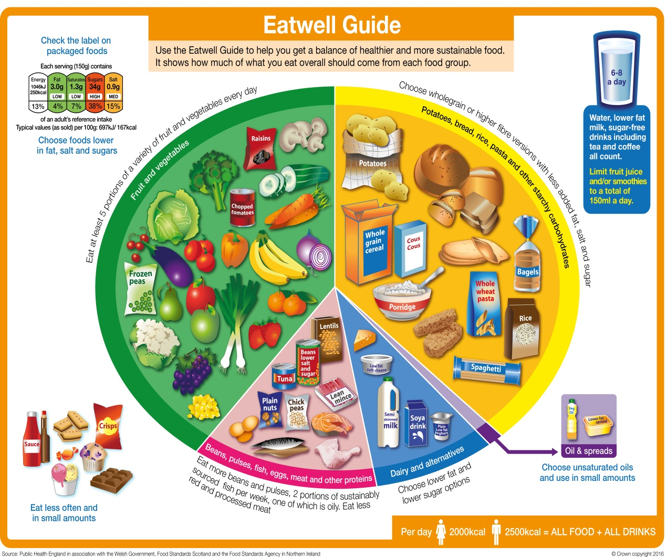

Figure 1 The Eatwell Guide (NHS Choices, 2017)

Bread, rice, potatoes, pasta and other starchy carbohydrates

This food group is displayed as yellow on the Eatwell Guide. The yellow section of the guide suggests basing meals on potatoes, bread, chapattis, rice, pasta or other starchy carbohydrates. Choose wholegrain versions where possible such as wholemeal rice and pasta; wholegrain choices contain more fibre, promoting a feeling of being fuller for longer and can help with regular bowel movements.
Starchy food should make up just over a third of the food we eat. There are also higher-fibre versions of white bread and pasta.
Starchy foods are a good source of energy and the main source of a range of nutrients in our diet.
(Eat well guide, 2017)
Fruit and vegetables

Most of us still aren't eating enough fruit and vegetables. They should make up over a third of the food we eat each day. Aim to eat at least five portions of a variety of fruit and veg each day. Choose from fresh, frozen, tinned, dried or juiced.
(Remember that fruit juice and/or smoothies should be limited to no more than a combined total of 150ml per day.)
Fruit and vegetables are a good source of vitamins, minerals and fibre

A portion is 80g (2 ½ oz.):
One handful of fresh fruit
2 tbsp. vegetables
1 small bowl of salad
1 tbsp. dried fruit (only counts once towards your five a day)
150 ml glass of fruit juice (only counts once towards your five a day)
(Eat well guide, 2017)

Milk and dairy products

Try to have some milk and dairy food (or dairy alternatives) - such as cheese, yoghurt and fromage frais. These are good sources of protein and vitamins, and they’re also an important source of calcium, which helps to keep our bones strong. Some dairy food can be high in fat and saturated fat, but there are plenty of lower-fat options to choose from. Go for lower fat and lower sugar products where possible. For example, why not try 1% fat milk which contains about half the fat of semi-skimmed milk without a noticeable change in taste or texture. Reduced fat cheese is also widely available. You could have just a smaller amount of the full-fat varieties less often. When buying dairy alternatives, go for unsweetened, calcium-fortified versions.

(Eat well guide, 2017)

Meat, fish, eggs, beans and other non-dairy sources of protein

This group includes meats, fish and alternative protein sources such as eggs, beans, lentils, nuts, tofu and other meat substitutes. Many of these foods are also good sources of iron which is important for healthy blood (see section 2.3.8). It is recommended that 2-3 portions from this food group are eaten daily.

A portion is:
2-3oz (60-90g) meat
4-5oz fish (120-150g) fish or tofu/ meat substitute
2 eggs
1½oz (40g) unsalted nuts
4 tbsp. cooked beans/ pulses

These foods are sources of protein, vitamins and minerals, so it is important to eat some foods from this group. Beans, peas and lentils (which are all types of pulses) are good alternatives to meat because they’re naturally very low in fat, and they’re high in fibre, protein, and vitamins and minerals. Pulses, or legumes as they are sometimes called, are edible seeds that grow in pods and include foods like lentils, chickpeas, beans and peas. Other vegetable-based sources of protein include tofu, bean curd and mycoprotein; all of which are widely available in most supermarkets.
Aim for at least two portions (2 x 140g) of fish a week, including a portion of oily fish. Most people should be eating more fish, but there are recommended limits for oily fish, crab and some types of white fish. Examples of oily fish are mackerel, salmon, sardines, pilchards and fresh tuna (not tinned). However, oily fish contain low levels of pollutants that can build up in the body if eaten in excess. Women of childbearing age should therefore consume no more than two portions of oily fish per week and should avoid shark, swordfish and marlin altogether.
Some types of meat are high in fat, particularly saturated fat. When you’re buying meat, remember that the type of cut or meat product you choose, and how you cook it, can make a big difference. To cut down on fat: choose lean cuts of meat and go for leaner mince, cut the fat off of meat and the skin off of chicken, try to grill meat and fish instead of frying and have a boiled or poached egg instead of fried. If you eat more than 90g of red or processed meat per day, try to cut down to no more than 70g per day. The term processed meat includes sausages, bacon, cured meats and reformed meat products.
(Eat well guide, 2017)

Foods and drinks high in fat and/or sugar

Foods and drinks which are high in fat and sugar, no longer feature as part of the eat well guide, this is because these foods are not required in the diet, and therefore should be eaten less often and in smaller amounts.
This includes products such as chocolate, cakes, biscuits, full-sugar soft drinks, butter and ice-cream. If you consume these foods and drinks often, try to limit their consumption so you have them less often and in smaller amounts. Food and drinks high in fat and sugar contain lots of energy, particularly when you have large servings. Check the label and avoid foods which are high in fat, salt and sugar.
The following tips should be used to reduce the amount of fat and sugar in the diet:
- Avoid eating fried foods
- Avoid adding fat/ oil to cooking methods such as roasting and frying
- Choose skimmed or semi skimmed milk and low fat dairy products
- Choose lower fat spreads instead of full fat spreads/ butter
- Use no added sugar/ sugar free alternatives of foods and drinks
- Use sweeteners instead of sugar for example in hot drinks
- Choose healthier alternatives to sweets, biscuits and cakes such as fruit or low fat yoghurt
(Eatwell Guide, 2017)

Salt

Everyone should limit salt intake to less than 6 g/ day (approximately 1 teaspoon) to reduce the risk of high blood pressure, stroke and heart disease. 60-90% of salt intake in the UK is from processed foods e.g. processed meats, ready-made sauces, gravies, tomato sauce, salad dressing and pre-packaged meals.

Iron

Iron is needed to manufacture haemoglobin in both maternal and foetal red blood cells. It is therefore important to oxygenate the blood and prevent anaemia which may lead to tiredness and a feeling of lethargy. There is a proven link between maternal iron intake and birth weight of the baby (Alwan et al, 2011). The current Dietary Reference Value (DRV) for iron in adult women is 14.8µg per day (Committee on the Medical Aspects of food (COMA), 1991) and there is no recommended increase during pregnancy (Royal College of Obstetricians and Gynaecologists (RCOG), 2010). The foetus accumulates most of its iron from the mother so it is especially important that this requirement is met during pregnancy. The level of iron absorption increases progressively as pregnancy advances to meet the rising demands for the foetus and mostly occurs in the last trimester. At this time iron requirements do slightly increase however needs are met by adaptation of the digestive system to increase absorption and reduce losses.

The Reference Nutrient Intake (RNI) for pregnancy is based on the assumption that all women of childbearing age have sufficient stores to cope with the metabolic demands of pregnancy. However, if a woman starts pregnancy with low iron stores, perhaps due to large menstrual losses and/ or low dietary intake she is at risk of developing iron deficiency during pregnancy. It is therefore especially important for women to ensure they eat iron rich food daily prior to conception to build up adequate iron stores.

It is important to encourage women to consume a variety of iron rich foods which include:
- Meat, especially red meat, such as beef or lamb
- Pilchards and sardines (maximum 2 portions a week)
- Pulses (peas, beans and lentils)
- Fortified breakfast cereals
- Green, leafy vegetables
- Dried fruit e.g. apricots, prunes, raisins

The iron in red meat (haem iron) is absorbed better than iron from other foods (non haem). The following can enhance iron absorption, especially from vegetarian sources:

- Having food or drink containing vitamin C with a meal e.g. orange juice, fresh tomatoes.
- Avoiding drinking tea during, and 30 minutes either side of, mealtimes as the tannins in tea bind with iron in food and reduce absorption.

Iron supplementation may be recommended for women with a history of anaemia, those likely to have low iron stores or for women who develop clinical signs of anaemia during pregnancy. Iron supplementation is not necessary for all women and may result in side effects such as constipation or nausea. If it is considered, it should be discussed with a GP.

NOTE: Although liver is high in iron it is recommended that liver and liver products are avoided during pregnancy due to the high levels of vitamin A (retinol) it contains (see section 2.3.12).

Calcium

Adequate calcium intake is required for healthy bones in both the mother and the foetus. The current RNI in adult women is 700µg calcium per day, with no increase recommended during the preconception period or pregnancy (RCOG, 2010). This is because calcium absorption increases during pregnancy and this usually allows any additional needs to be met. However, pregnant adolescents (under 19 years old) have higher calcium requirements, as they have not yet achieved their own peak bone mass and they have an RNI of 800µg calcium per day (COMA, 1991).

Women should be advised that three portions of dairy a day is the easiest way to achieve an intake of 700μg calcium and 3-4 portions to achieve 800μg. For women who do not eat dairy products it is important that they obtain adequate calcium from other sources.

Special attention may be needed for Asian mothers as they often have high fibre intakes, which can impair calcium absorption. They may also have a low vitamin D status which will impair the absorption of calcium. It is important to encourage these women to eat plenty of calcium rich foods.

For women who do not eat dairy products it is important that they obtain adequate calcium from other sources, including:
- Fish eaten with bones (½ tin sardines with bones contains the same calcium as one portion of dairy)
- White flour products (these are fortified with calcium) e.g. white bread
- Tofu
- Spinach and other dark green vegetables
- Beans and sesame seeds
- Dried figs and oranges
- Alternatives to dairy such as soya milk must have added calcium

Vitamin D

Vitamin D is a fat soluble vitamin which regulates the absorption of dietary calcium and phosphorous. It is needed for the growth and development of an infant’s bones and to keep the mothers bones healthy. A developing infant will rely on the mother’s stores of vitamin D during pregnancy (and breastfeeding) and if these are poor it may adversely affect foetal bone mineralisation.

A deficiency of vitamin D can result in rickets and osteomalacia. Although these are rare amongst the white UK population, there is a significant incidence in UK South Asian and Afro-Caribbean subpopulations (SACN, 2007).

Several factors affect maternal vitamin D status including genetics, skin pigmentation, age, season, latitude, clothing and the use of sunscreens (SACN, 2007). A low vitamin D status is where levels of the active form of vitamin D (D3) are less than 25nmol/l in the blood.

The UKs Chief Medical Officers (CMO) wrote to healthcare professionals to raise awareness of the importance of adequate vitamin D in 2012 and recommended that all pregnant and breastfeeding women should take a daily supplement containing 10μg vitamin D to ensure adequate foetal stores for early infancy (CMO, 2012). Infant vitamin D status appears to be more affected by supply during pregnancy than during breastfeeding.

The best source of vitamin D is sunlight, as the skin synthesises vitamin D after exposure to ultraviolet rays. Vitamin D can be obtained from sunlight in the UK from 5-15 minutes skin exposure (20% of body) between April and September and between 11am to 3pm. Care must be taken to avoid burning and more time may be needed for darker skinned women. In the UK, the sun is not strong enough between September and April for vitamin D production (SACN, 2007) and people need to rely on their body stores (from summer exposure) and dietary intake. However, it should be born in mind that vitamin D from dietary sources is not utilised as efficiently as that from sunlight. The current reference nutrient intake (RNI) for vitamin D for pregnant women is 10μg (400IU) vitamin D per day (SACN, 2007) and supplements are recommended to guarantee this, as in many cases this isn’t met through sunlight/diet (SACN, 2007).

Dietary sources of vitamin D include:
- oily fish (at a level of 5-10μg per 100 g of fish)
- fortified spreads (approximately 7μg per 100 g)
- some fortified breakfast cereals (3-8μg per 100 g)
- egg yolks (~5μg per100 g)
- red meat (but only in small amounts, approximately 1μg per 100 g)
(Quantities from SACN, 2007).

All pregnant women should be advised about the benefits of vitamin D supplements and encouraged to take these during pregnancy. Healthcare professionals should ensure that women at greatest risk are following advice to take a vitamin D supplement during pregnancy and breastfeeding, especially those who have limited skin exposure to sunlight, for example those who cover their skin for cultural reasons and women with darker skin such as South Asian and African women (NICE, 2014). However, women should be advised not to take more vitamin D than recommended as excess intake could be toxic. There is no risk of excess vitamin D from sunlight as the body regulates production.

Omega 3 (long chain polyunsaturated fatty acids n-3) fatty acids

There is some evidence that low omega 3 fatty acid intake and high omega 6 fatty acid intake during early pregnancy may be associated with reduced foetal growth but further evidence is needed (SACN, 2011). To ensure adequate omega 3 intake, 1-2 portions of oily fish are recommended per week. Food sources include mackerel, kippers, pilchards, tuna (fresh or frozen), trout, sprats, salmon, herring, crab (fresh), whitebait, swordfish and sardines. People who do not eat fish can get omega-3 from the following foods: nuts and seeds e.g. walnuts and pumpkin seeds; vegetable oils e.g. rapeseed and linseed; soya and soya products e.g. beans, milk and tofu; and green leafy vegetables.

Vitamin B12

It is important to consume adequate vitamin B12 in the diet during the preconception period and pregnancy to prevent anaemia and neural tube defects. Good sources include fortified yeast extracts, fortified soya milk, fortified textured soya protein and fortified cereals. If these are not included in the diet, then a vitamin B12 supplement which is safe for pregnancy may be needed.

Vitamin A

Vitamin A can be obtained in two forms, vitamin A (retinol) and pre-vitamin A (beta carotene). The RNI for vitamin A for women aged over 15 years is 600µg/ day and for pregnant women this value is increased to 700µg per day. Very high intakes of retinol (animal form of vitamin A) of more than 3300µg per day during pregnancy have been associated with birth deformities. The plant form of vitamin A, beta-carotene, found in many vegetables and fruit is only converted in the body to vitamin A as needed and is therefore safe.

An average portion of liver can contain four to twelve times the maximum RNI for pregnancy in the form of retinol. Liver and liver products such as liver pâté should therefore be avoided by women who are or who might become pregnant (RCOG, 2010).

Cod liver oil supplements should be avoided for the same reason and any supplements containing vitamin A in the form of retinol should be avoided. While many manufacturers of vitamin supplements for pregnancy have switched the source of vitamin A to beta-carotene, supplements should be checked.

Folic acid to prevent neural tube defects

There is a proven link between folate intake and neural tube defects (NTD) (RCOG, 2003). Folate is a B vitamin found in green leafy veg such as kale and broccoli, potatoes, pulses, oranges and cereal products. As a vitamin (B₆), it is vulnerable to heat and dissolves in water, therefore cooking for long periods and boiling can considerably reduce the folate content of foods.
It is difficult to obtain optimal folate from diet alone and so a supplement is recommended in the form of folic acid in addition to eating foods rich in folate. NICE (2008) recommend that all pregnant women take a 400µg folic acid supplement 3 months prior to conception and during the first 3 months of pregnancy to reduce the risk of first time NTD’s.
Supplements containing the recommended 400µg folic acid are available on prescription in certain cases.

Some women are at increased risk of NTD’s and so those who meet certain criteria will require a supplementation of 5mg (5000ug) each day (only available on prescription). These include women who:
- Have Diabetes (type 1 and 2)
- Have Coeliac disease
- Have a family history of NTD’s (e.g. pregnant woman, partner or previous pregnancy)
- Are obese (BMI >30Kg/m²)
- Are taking anti-epileptic medication
- Women who have thalassemia

If choosing an ‘over-the-counter’ vitamin supplement, women should ensure it contains adequate levels of folic acid without giving excessive amounts of other vitamins such as vitamin A. A multivitamin sold specifically for pregnancy is usually appropriate although these should still be checked.

2.4 Other dietary considerations during pregnancy

Alcohol during preconception and pregnancy

Experts are still unsure exactly how much – if any – alcohol is completely safe for you to have while you're pregnant, so the safest approach is not to drink at all while you're expecting.
Is it safe to drink alcohol when pregnant?
The Chief Medical Officers for the UK recommend that if you're pregnant or planning to become pregnant, the safest approach is not to drink alcohol at all to keep risks to your baby to a minimum.
Drinking in pregnancy can lead to long-term harm to the baby, with the more you drink, the greater the risk. (NHS Choices, 2017)

Caffeine

It is important to limit the amount of caffeine consumed to no more than 200mg of caffeine a day. This is because high levels of caffeine can lead to low birth weight, increase the risk of health problems in later life, or even lead to miscarriage.

New European Union food regulations in 2011 require that all high caffeine drinks be labelled and the amount of caffeine per 100ml stated.

The amount of caffeine in food and drink will vary, but as a guide each of these contains roughly 200mg or less of caffeine (NHS Choices, 2013):
- one mug of instant coffee: 100mg
- one mug of filter coffee: 140mg
- one mug of tea: 75mg
- one can of cola: 40mg
- one can of energy drink: up to 80mg
- one 50g bar of plain chocolate: most products on the UK market contain less than 25mg
- one 50g bar of milk chocolate: most products on the UK market contain less than 10mg

Caffeine is also found in certain cold and flu remedies. Always check with a pharmacist, GP or other health professional before taking any medication or over the counter remedies.

Peanuts

In August 2009, the Government revised its advice to consumers about eating peanuts during pregnancy following a major review of the scientific evidence showing no clear evidence that eating or not eating peanuts (or foods containing peanuts) during pregnancy, has any effect on the chances of a child developing a peanut allergy. It is therefore no longer recommended to avoid eating peanuts or products containing them during pregnancy unless the pregnant woman herself has a peanut allergy (NHS Choices, 2013). Women can therefore continue to enjoy peanuts as part of a healthy diet throughout their pregnancy.

Energy intake and weight gain during pregnancy

The body uses more energy during pregnancy to support the growth of the foetus and to enable fat deposition in the mother’s body for later use during lactation. However, this additional energy need is mostly met by a reduction in physical activity and metabolic rate. As a result, the Dietary Reference Values for Food, Energy and Nutrients in the UK Report (COMA, 1991) conclude no need for increased energy intake during the first two trimesters of pregnancy and only a modest increase (additional 200kcal) during the last trimester. This has later been confirmed in a scientific report by RCOG, 2010. A woman’s appetite is the best indication of how much food is needed during pregnancy which is likely to fluctuate over time.

Recorded antenatal weight changes, range from weight loss to weight gains of 25 kg (55 lb) or more. However, a higher incidence of clinical complications occurs at the extreme ends of this range. Putting on too much weight during pregnancy can increase the woman’s risk of gestational diabetes and high blood pressure/ pre-eclampsia and can increase difficulties during delivery. A 3 year report by the Centre for Maternal and Child Enquiries (CMACE) (2010) found that 4.99% of women had a BMI >35Kg/m² at any point throughout their pregnancy and the rate of stillbirths for women giving birth with a BMI >35Kg/m² is double that for the general population. Equally, losing weight or not gaining enough may increase the risk of a premature birth and a LBW baby and may lead to inadequate fat stores for breastfeeding. Although it is recommended for women to have a healthy weight during pregnancy, NICE (2010) suggest that concerns regarding weight should be dealt with prior to pregnancy as ‘dieting’ is not recommended during pregnancy due to the risk of under nutrition for the foetus.

In a study of more than 3800 subjects, Hytten (1991) found a weight gain of 12.5 kg (27.5 lb) associated with the best outcomes, in terms of infant birth weight, survival and incidence of pre-eclampsia. A guide of 12.5 kg weight gain has traditionally been used in the UK. There are still no UK based guidelines on appropriate weight gain in pregnancy. However the American Institute of Medicine (IoM) guidelines (IoM, 2009) are now widely used in literature and by the British Dietetic Association to measure appropriate weight gain. They recommend the following weight gains based on the woman’s pre-pregnancy BMI:

Pre pregnancy Weight Category | Body Mass Index* | Recommended  Range of  Total Weight (lb) | Recommended Rates of Weight Gain† in the Second and Third  Trimesters (lb) (Mean Range [lb/wk])
Underweight | Less than 18.5 | 28–40 | 1 (1–1.3)
Normal Weight | 18.5–24.9 | 25–35 | 1 (0.8–1)
Overweight | 25–29.9 | 15–25 | 0.6 (0.5–0.7)
Obese (includes all classes) | 30 and greater | 11–20 | 0.5 (0.4–0.6)

Most women gain between 10 kg and 12.5 kg (22 to 26 lb) (NHS choices, 2015), but this varies according to the woman’s weight prior to pregnancy.

Women should be advised that if they do fall pregnant there is no need to ‘eat for two’ (NICE, 2010) and also that dieting during pregnancy is not recommended.

Recommended vitamin supplements during pregnancy (including Healthy Start)

All Women in Doncaster who are at least 10 weeks pregnant are entitled to the Department of Health (DoH) vitamin drops, which are part of the Healthy Start scheme. Pregnant women requiring supplements should consult their GP or midwife for advice on where to obtain these locally.

The Healthy Start scheme launched in November 2006 and has vitamins available for pregnant women and for young children.

The pregnancy Healthy Start vitamins contain the following:
- 70mg of vitamin C
- 10μg vitamin D
- 400μg folic acid

They are suitable for vegetarians and are milk, egg, gluten, soya and peanut residue free. Women who are eligible are entitled to one bottle of 56 tablets every eight weeks. The following link shows where women can obtain healthy start vitamins http://www.nhs.uk/Service-Search/Healthy-start-vitamins/Doncaster/Results/108/-1.128/53.523/348/6237?distance=25 .

It is important for healthcare professionals to discuss the importance of these vitamins with women.

Note: Most commercial multivitamins contain vitamin D and folic acid, but are not suitable in pregnancy as they will provide too much vitamin A which can be toxic (see section 2.3.12).

Medicines, herbal remedies, vitamin/mineral supplements

Women are advised not to take any over the counter medications when trying for a baby or during pregnancy without first consulting a pharmacist or GP. This is because some over the counter medicines could harm the foetus e.g. ibuprofen. Women are also advised to consult a pharmacist or GP before taking any vitamin/mineral supplements during preconception and during pregnancy.

Women are advised not to take any herbal remedies when planning a pregnancy as these are not licenced products and there is little/limited information about their safety for the foetus if taken prior to conception/during pregnancy (NICE, 2012).

Multiple pregnancies

Women who are pregnant with twins or triplets should be given the same advice as women who are having a singleton pregnancy with regards to diet, lifestyle and nutritional supplements. It should be considered that women of multiple pregnancies are at higher risk of anaemia and this will therefore need to be more closely monitored.

2.5 Food safety during pregnancy

General food handling guidelines

The following general food handling guidelines should be followed:

- Keep kitchen clean, particularly work surfaces
- Wash hands before preparing food
- Wash fruit, vegetables and salad before use
- Keep fridge temperature below 5°C, freezer below –18°C
- Store raw meat covered at the bottom of the fridge, separate from cooked foods
- Defrost frozen meat thoroughly before cooking
- Cook foods thoroughly and according to manufacturer’s instructions
- Cool leftover food quickly and use within 24 hours. Do not reheat more than once
- Never eat foods after the “use-by” dates on the packaging
- Keep pets out of the kitchen and away from work surfaces
(British Nutrition Foundation (2015)

Listeria

Listeriosis is a disease caused by the bacterium listeria monocytogenes which is a mild flu-like illness. This infection can pass from the mother to the foetus and may lead to miscarriage, stillbirth or delivery of an acutely ill infant. Listeria infection is very rare, affecting approximately 1 in 20,000 pregnancies however women are advised to avoid foods associated with the illness. These include:
- Uncooked mould ripened, soft cheeses with a white rind such as Brie, Camembert and Chèvre (a type of goats’ cheese)
- Uncooked blue veined cheeses such as Danish Blue, Gorgonzola and Roquefort
- Unpasteurised milk (cows, sheep or goat) and all products made from it
- Pâté (liver, meat, fish or vegetable)
- Pre-prepared salads and salad vegetables

All cook-chill foods, ready prepared meals and ready cooked foods (e.g. cooked poultry) should be heated until piping hot and the leftovers discarded. These should not be eaten cold.

Hard cheeses, cream cheeses, cottage cheese, cheese spread, fromage frais and yoghurts are safe to eat
(NHS Choices, 2015)

Toxoplasmosis

This is an infection caused by a parasite, found in raw meat, cat faeces and soil. If a pregnant woman becomes infected, it can seriously harm the unborn baby. Although it is again, very rare and reported to affect approximately 1 in 50,000 pregnancies, it is recommended pregnant women adhere to the following advice to reduce the risk:
- wearing gloves while gardening, particularly when handling soil
- washing your hands before handling food
- not eating raw or undercooked meat
- washing utensils and other kitchenware thoroughly after preparing raw meat
- washing fruit and vegetables thoroughly before eating them
- emptying cat litter trays every day
- avoiding direct contact with cat poo in cat litter or soil
(NHS Choices, 2015)

Salmonella

This is a common cause of food poisoning and is particularly associated with chicken and raw eggs. Although salmonellosis cannot pass directly from mother to baby, high temperatures and other effects of the infection may be harmful to the baby, causing miscarriage or premature labour. To reduce the risk of infection pregnant women should:
- Always thoroughly defrost and cook poultry
- Avoid raw eggs and foods containing raw eggs such as mayonnaise, mousse etc.
- Avoid unpasteurised milk and products containing this such as homemade yoghurt and ice cream
- Pregnant women can eat runny yolks as long as the eggs are lion stamped.

All shop bought mayonnaise and salad creams contain pasteurised egg and are therefore safe to eat.
(NHS Choices, 2015)

Other food-borne infections

To minimise the chance of becoming infected with other food-borne organisms, the following guidelines should be followed:
- Avoid unpasteurised milk, including goat’s and sheep’s milk, and cheese made from unpasteurised milk
- Use caution when buying unwrapped foods, e.g. cooked meats and prepared salads. If scrupulous food handling guidelines have not been followed, these foods can easily become contaminated.
- Avoid raw shellfish, e.g. prawns, cockles and mussels unless they are bought packaged and stamped with a use by date
- Shellfish should only be eaten if part of a hot meal and cooked thoroughly

Methylmercury in fish

You can eat most types of fish when you're pregnant. Eating fish is good for your health and the development of your baby, but you should avoid some types of fish and limit the amount you eat of some others.

Fish to avoid:
When you're pregnant or planning to get pregnant, you shouldn't eat shark, swordfish or marlin.

Fish to restrict:
You should also limit the amount of tuna you eat to:
- no more than two tuna steaks a week (about 140g cooked or 170g raw each), or
- four medium-sized cans of tuna a week (about 140g when drained)
This is because tuna contains more mercury than other types of fish. The amount of mercury we get from food isn't harmful for most people, but could affect your baby's developing nervous system if you take in high levels of mercury when you're pregnant.
When you're pregnant, you should also avoid having more than two portions of oily fish a week, such as salmon, trout, mackerel and herring, as it can contain pollutants like dioxins and polychlorinated biphenyls (PCBs).
Fresh tuna is an oily fish, so if you eat two fresh tuna steaks in one week, you shouldn't eat any other oily fish that week.
Tinned tuna doesn't count as oily fish, so you can eat this on top of the maximum amount of two portions of oily fish (as long as it's not fresh tuna).
But remember not to eat more than four medium-sized cans of tinned tuna a week when you're pregnant or trying to get pregnant
(NHS Choices, 2017)

Foods safe to eat during pregnancy

Included as part of a healthy diet, the following foods are safe to eat during pregnancy.
- Cooked shellfish, including prawns that are part of a hot meal and have been cooked thoroughly
- Live or bio yoghurt
- Probiotic drinks
- Fromage Frais
- Crème Fraîche
- Soured cream
- Spicy food
- Mayonnaise, ice cream and salad dressing made with pasteurised egg are safe. Home-made versions may contain raw eggs and should be avoided. If you are not sure when eating out, ask staff for more information or avoid.
- Honey, although it is not suitable for babies under one year
- Many cheeses including:
- Hard cheese, such as cheddar, parmesan and edam
- Feta, Halloumi, Ricotta, Mascarpone and Mozzarella cheese
- Cream cheese
- Cottage cheese
- Processed cheese, such as cheese spreads
- Paneer
(NHS Choices, 2013)

2.6 Women at increased nutritional risk during pregnancy

Some women will require more targeted advice in order to counter individual nutritional problems or inadequacies. The following groups are considered to be potentially at nutritional risk:

Vegetarian and vegan women

Particular attention should be paid to achieving adequate dietary sources of protein, iron, calcium and, for vegans only, vitamin B12. There is less concern for protein, calcium and B12 for vegetarians who consume dairy foods on a daily basis, but there may still be a risk of iron deficiency. Pregnant women who follow a vegan diet should take care to ensure that their diet contains sufficient vitamin B12 from reliable sources.

Women who are homeless or living in bed and breakfast accommodation

These women may have the combined difficulty of living on state benefits and living with limited cooking facilities.

Women on low incomes

A large proportion of women from low income groups are concerned that they are not able to have enough food and feel unable to afford a balanced meal (NICE, 2008). The National Diet and Nutrition Survey showed low-income populations consume fewer fruits and vegetables, having implications for their vitamin C intake. Alwan et al (2011) found a positive relationship between iron intake and socioeconomic profile of pregnant women specifically. Women from this group also do not always understand NTD’s, how serious they can be and the important role of folic acid (NICE, 2008).
The specific circumstances of this group of women should therefore be considered when planning dietary interventions in order for them to be effective (NICE, 2008).

Women with pre-existing medical conditions

This includes diabetes mellitus, food allergies and malabsorption syndromes. These women should be referred to a dietitian prior to pregnancy and have their nutritional status monitored closely throughout.

Other women at risk

- Women who are more than 20% overweight or 10% underweight
- Women with substance misuse or who drink alcohol
- Women who smoke
- Women who are on restrictive diets such as weight reducing or food allergies
- Women who currently have, or have a recent history of, an eating disorder such as anorexia nervosa or bulimia nervosa

2.7 Nutrition related problems in pregnancy

Nausea and vomiting

This is generally accepted as a common occurrence in the first trimester of pregnancy, and usually clears up by weeks 16-20. Nausea is thought to be caused by the changing pregnancy hormones and can be triggered by certain foods, smells and occasionally, hunger.

Small, frequent meals approximately every 2 hours throughout the day based on starchy carbohydrate, e.g. bread, toast, plain biscuits, cereals, and fruit may help in addition to keeping hydrated, drinking fluids little and often throughout the days.

Cold, non-greasy meals and snacks which involve little preparation and/or cooking may be preferable in addition to avoiding strong flavours and smells. Ginger may also help to alleviate the feeling.
(NHS Choices, 2017)

Cravings and taste changes

Cravings and aversions are usually harmless unless they prevent a woman from eating a varied and nutritious diet.

Heartburn

This is generally more common during the last three months (12 weeks) of pregnancy when pressure from the baby in the uterus can cause acid to be pushed back up from the stomach. It is also more common in multiple pregnancies. Women should be advised to avoid foods that are causing symptoms which tend to be spicy and fatty foods, fizzy drinks, citrus fruits and tomatoes. Having a little and often style of eating rather than consuming large portions at once may also help. Sitting up straight when eating to relieve the pressure, avoidance of lying down flat afterwards and if heartburn occurs at night, sleeping propped up by extra pillows may also help.
(NHS Choices, 2017)

Constipation

This is common at all stages of pregnancy and can be relieved by increasing the fibre and fluid content of the diet. Good sources of fibre include wholegrain breads and cereals, rice, pasta, pulses and fruit and vegetables. Aim for at least five portions of a variety of fruit and vegetables each day. Aim to drink eight to ten cups of fluid per day. Iron supplements may also cause constipation, if you are taking these and suffering constipation, discuss with your GP who may be able to prescribe and alternative.

2.8 References

Alwan et al (2011) Dietary iron intake during early pregnancy and birth outcomes in a cohort of British Women, Human Reproduction. Vol 26 (4) pp.911-919.

British Nutrition Foundation, (2015) Food Safety in Pregnancy, https://www.nutrition.org.uk/healthyliving/nutritionforpregnancy/food-safety.html

CMO (2012) Vitamin D – advice on supplements for at risk groups – letter from UK Chief Medical Officers. DoH. London

COMA (1991) Dietary Reference Values for Food Energy and Nutrients for the United Kingdom. Report of the Panel on Dietary Reference Values of the Committee on Medical Aspects of Food Policy. London: HMSO; 1991.

CMACE (2010) Maternal obesity in the UK: Findings from a national project. London: CMACE, London.

Gandy (2014) Manual of Dietetic Practice. 5th edition. Wiley-Blackwell, Oxford.
Hytten (1991). Weight gain in pregnancy. In:Clinical Physiology in Obstetrics, ed. FE Heytten & G Chamberlain, 2nd edn, pp173–203, Oxford: Blackwell Scientific

Institute of medicine and national research council (2009) Weight gain during pregnancy: re-examining the guidelines. Washington DC, The National Academies Press.

NHS Choices (2014) Should I limit caffeine during pregnancy?, http://www.nhs.uk/chq/pages/limit-caffeine-during-pregnancy.aspx?categoryid=54&subcategoryid=130

NHS Choices (2015) How much weight will I put on during my pregnancy? http://www.nhs.uk/chq/Pages/2311.aspx?CategoryID=54#

NHS Choices (2017) Foods to avoid in Pregnancy, http://www.nhs.uk/conditions/pregnancy-and-baby/pages/foods-to-avoid-pregnant.aspx

NHS Choices (2017) Nausea and morning sickness, http://www.nhs.uk/conditions/pregnancy-and-baby/pages/morning-sickness-nausea.aspx

NHS Choices (2017) Indigestion and heartburn in pregnancy, http://www.nhs.uk/conditions/pregnancy-and-baby/pages/indigestion-heartburn-pregnant.aspx

NHS Choices (2015), Listeriosis,
http://www.nhs.uk/Conditions/Listeriosis/Pages/Introduction.aspx

NHS Choices (2015) Toxoplasmosis,
http://www.nhs.uk/conditions/Toxoplasmosis/Pages/Introduction.aspx

NHS Choices (2014) Salmonella
http://www.nhs.uk/Conditions/salmonella-infection/Pages/Introduction.aspx

NICE (2008) Maternal and child nutrition. (Reviewed, 2014)
NICE (2010) Weight management before, during and after pregnancy: quick reference guide. NICE. (Reviewed, 2017)

NICE (2012) Pre-conception, advice and management. http://cks.nice.org.uk/pre-conception-advice-and-management#!scenario:1

NICE (2013) Fertility: Assessment and treatment for people with fertility problems. February. (Reviewed, 2016)

NICE (2008) Antenatal care for uncomplicated pregnancies, https://www.nice.org.uk/guidance/cg62/chapter/1-guidance (Reviewed 2017)

NICE (2014) Vitmain D: Increasing supplement use among at-risk groups. Public health guidance 56. November.

SACN (2007) Update on vitamin D. Position statement by SACN.

SACN (2011) The influence of maternal, fetal and child nutrition on the development of chronic disease in later life. London: TSO.

SACN (2016) Vitamin D and Health.

Royal college of obstetricians and gynaecologists (2003) Periconceptional folic acid and food fortification in the prevention of neural tube defects. Scientific impact paper no.4. April.

Royal College of Obstetricians and Gynaecologists (2010) Nutrition in pregnancy: scientific impact paper No.18, September, RCOG. (paper archived)

SECTION 3

Breastfeeding

3.1 Introduction

This section is intended for use by health workers as a practical guide to breastfeeding for mothers, babies and their families.

It is vital that health workers provide consistent and accurate support and information for mothers who choose to breastfeed so that they can begin and continue to breastfeed successfully.

Breastfeeding is the normal method for women to feed their infants and the Department of Health (DOH) and the World Health Organisation (WHO) recommend ‘Exclusive breastfeeding for the first six months (26 weeks) of an infant’s life, as it provides all the nutrients a baby needs’ (DOH 2003).

In England, the annual rate of breastfeeding initiation for 2016/17 was 74.6%. This was the highest figure recorded in over a decade surpassing the previous high of 74.3% recorded in 2014/15.

The National Institute for Health and Clinical Excellence (NICE) recommends that maternity and children’s services should “Implement a structured programme that encourages breastfeeding, using BFI [Baby Friendly Initiative] as a minimum standard. The programme should be subject to external evaluation” (NICE, 2008).

The UNICEF UK BFI provides a framework (represented by the Ten Steps to Successful Breastfeeding and the Seven Point Plan to support NHS Trusts and other public services to implement best practice. The aim is to help all parents make informed decisions about feeding their babies and support them with their chosen method. Facilities meeting the required standards can be assessed and accredited as Baby Friendly. (UNICEF UK, 2012).

Link to the Baby friendly Standards.

https://www.unicef.org.uk/babyfriendly/baby-friendly-resources/guidance-for-health-professionals/implementing-the-baby-friendly-standards/guide-to-the-baby-friendly-initiative-standards/

Doncaster Metropolitan Borough Council (DMBC), Rotherham Doncaster and South Humber NHS Foundation Trust and Doncaster & Bassetlaw Teaching Hospitals NHS Foundation Trust recognises the important health benefits of breastfeeding and are committed to adopting BFI practices to help promote, protect and support breastfeeding as outlined in Doncaster’s Breastfeeding Strategy.

Rotherham Doncaster and South Humber NHS Foundation Trust and Doncaster & Bassetlaw Teaching Hospitals NHS Foundation Trust have both been reaccredited at stage 3.
3.2 The health benefits of breastfeeding

UNICEF have reviewed the growing evidence looking at the differences in health outcomes of artificially fed and breastfed babies to mother and baby. Below is a summary of the results (UNICEF, 2010).
Artificially-fed babies have a greater risk of:
- Gastro-intestinal infection
- Respiratory infections
- Necrotising enterocolitis and late onset sepsis in preterm babies
- Urinary tract infections
- Ear infections
- Allergic disease (eczema, asthma and wheezing)
- Cardiovascular disease in adulthood
- Type 1 and type 2 diabetes
- Obesity
- Childhood leukaemia
- SIDS
Breastfed babies may have improved
- Neurological development
- Cholesterol levels
- Blood pressure
More research is needed to confirm other potential protective effects of breastfeeding for the infant including a lower risk of:
- Multiple sclerosis
- Acute appendicitis
- Tonsillectomy
UNICEF has also identified studies which link breastfeeding to better cardiovascular health later in life, reduced risks of some childhood cancers and a positive influence on dental health.
Breastfeeding women have been found to have a lower risk of;
- Breast and ovarian cancer
- Osteoporosis (weak bones)
- Cardiovascular disease
- Obesity
Some studies also show a positive impact for rheumatoid arthritis postnatal depression and maternal type 2 diabetes for the mother although more research is needed to confirm this.
Breast milk is not just a food; it has many other properties which help babies develop. It is important to acknowledge that breastfeeding itself is not just the action of giving babies nutrition and beneficial ingredients. Breastfeeding can involve comforting babies and expressing love. Also, breastfeeding is not just a one-way delivery to the baby but is an interaction between mother and baby that is both physical and emotional.

Hormonal control

Higher oestrogen levels in pregnancy which fall after birth are responsible for stimulating the growth of the breasts ductal system.

Higher progesterone levels in pregnancy which fall after birth are responsible for the growth in size of the alveoli and lobes.

Human Placental Lactogen is responsible for breast, nipple and areola growth during pregnancy.

Prolactin also helps to increase alveoli growth during pregnancy.

Prolactin is stimulated by sucking during breastfeeding and peaks at about 90 minutes after feeding, returning to normal after about 3 hours. Milk is produced in the alveoli in response to the release of prolactin. Research shows that the level of prolactin is higher at the times of greater milk production. The highest prolactin levels occur between 2am and 6am after frequent evening feeds when the breast is least full of milk (Cregan, 2002) and lowest when the breast is full.

Oxytocin is released into the mothers’ bloodstream in response to a baby suckling, contracting the myoepithelial cells surrounding the alveoli forcing milk into the duct system down to the nipple openings. This is known as the milk ejection or let-down reflex and has been shown to occur on average 3-4 times during each breastfeed (Ramsay and Mitoulas et al, 2005).

Feedback Inhibitor of Lactation (FIL) is a naturally occurring substance that reduces milk production when the breast is full.

3.3 Breast milk composition

Colostrum

- Colostrum is a concentrated form of breast milk and is high in density and low in volume as a new-born’s immature kidneys cannot cope with large volumes of fluid.
- It contains concentrated levels of protein, fat-soluble vitamins A, E and K and lactoferrin and less lactose, fat and water soluble vitamins than mature milk
- It is rich in antibodies offering protection against infection. The major immunoglobulin is secretory IgA which protects the baby’s bowel against pathogens such as entero viruses, herpes, rubella and rotavirus.
- Colostrum also acts as a natural laxative helping the passage of meconium
Over the course of the first few days the colostrum is diluted and becomes higher-volume milk which happens in response to the stimulation of the baby feeding

Transitional milk
- It is the transition from colostrum to mature milk, where lactation is established and production of milk begins in the breast tissue. Transitional milk is produced from approximately day 8 – 20.
Mature milk
- Mature milk is produced from 20 days after birth, onwards. It can vary in and between individuals and the energy can vary between 270 and 315 kJ per 100mL. This is largely due to the variation in the fat content, as the fat of the milk received by the infant increases as the feed progresses. Mature milk continues to provide immune factors and other important non-nutritional components to the infant.
3.4 What are the nutrients in breastmilk?
Breastmilk contains all the nutrients the infant needs for proper growth and development.
These nutrients include:
- Free water
- Proteins – Protein accounts for 75% of the nitrogen-containing compounds and the non-protein nitrogen substances include urea, nucleotides, peptides, free amino acids and DNA.
- Fats – Essential fatty acids and long-chain polyunsaturated fatty acids
- Carbohydrates – The principal carbohydrate of human milk is lactose.
- Minerals, vitamins, and trace elements.

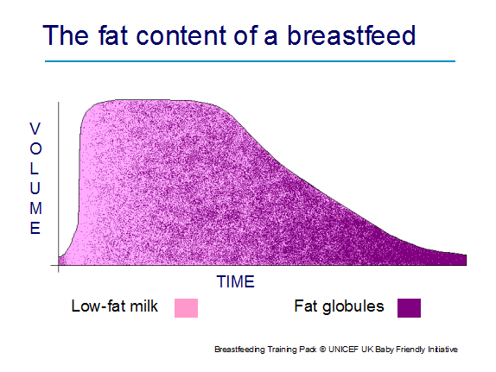

Mature milk is not uniform and varies during a single feed. When a baby begins a breastfeed the milk is high in volume and low in fat, but as the feed progresses, the composition changes as the fluid volume steadily decreases and the fat content increases. The milk near the end of a feed is thus low in volume and high in fat. During a feed the baby determines when he/ she has received the right amount of calories and fluid needed.

3.5 How to help a breastfeeding mother

New parents need time to adjust to their new role. As A practitioner you should:

Assess

When a mother comes to you it is important to assess the whole situation and learn more of a mother’s breastfeeding experience, looking at the whole picture. This would include:

- Taking a breastfeeding history (Links below are assessment tool that are currently used by Midwifery and the health visiting team.)
- Assessing positioning
- Assessing attachment
- Continuing to observe the breastfeed through to the end of the feed
- Note any health concerns with the mother and baby
- Complete a breastfeeding assessment. A breastfeeding assessment form is included in the Personal Child Health Record (‘Red Book’) for completion by health professionals whilst providing mothers with a mechanism to assess breastfeeding for themselves. Refer to www.unicef.org.uk/Documents/Baby_Friendly/Guidance/4/bf_assessment_tool.pdf?epslanguage=en

Midwifery assessment tool.
https://www.unicef.org.uk/babyfriendly/wp-content/uploads/sites/2/2016/10/breastfeeding_assessment_tool_mat.pdf

Health visiting assessment tool.
https://www.unicef.org.uk/babyfriendly/wp-content/uploads/sites/2/2016/10/breastfeeding_assessment_tool_hv.pdf

Mothers own assessment tool.
https://www.unicef.org.uk/babyfriendly/wp-content/uploads/sites/2/2016/10/mothers_breastfeeding_checklist.pdf

Neonatal assessment tool.
https://www.unicef.org.uk/babyfriendly/wp-content/uploads/sites/2/2018/03/breastfeeding_assessment_tool_neonatal.pdf

Positioning

Positioning is about how a mother holds her baby to enable them to attach to the breast effectively. There are lots of different positions but the key principles remain the same whatever position is used, these include:
- Mother sitting comfortably with her back well supported.
- Keep the baby’s body in a straight line with whole body facing the food (nipple and breast)
- Support the neck, shoulders and back so that the baby can tilt his/her head back easily.
- Move the baby towards the nipple.
- Make sure the baby’s lower lip and chin is in contact with the breast first.

BFI video showing effective positioning and attachment.

https://www.unicef.org.uk/babyfriendly/baby-friendly-resources/video/positioning-and-attachment/

https://www.nhs.uk/start4life/baby/breastfeeding/breastfeeding-positions/

Recognising good attachment
Ensuring baby is correctly attached is most important for successful breastfeeding.

Good breastfeeding attachment
What you should see:
- baby tucked in as close to you as possible
- chin against your breast, rather than tucked down, so head slightly tipped back
- wide open mouth
- nose not pressed into your breast
- deep jaw movements
- if some of the areola (the coloured part around your nipple) is showing, there will be more above the top lip than below the bottom lip.
What you shouldn’t see:
- cheeks sucked in
- lips looking like sucking on a straw
- squashed nipple at the end of the feed when your baby comes off.
What you should hear:
- soft sounds of milk being swallowed.
What you shouldn’t hear:
- clicking noises
- lip smacking.
What you may feel:
- a feeling of being ‘firmly gripped’
- the let-down reflex – a tingling, ‘drawing’ feeling in your breasts
- a fleeting pain at the start of the feed in the first few days or weeks. (Imagining a relaxing scene, or getting someone to massage your shoulders, may help in these situations.)
What you shouldn’t feel:
- pain while your baby is actually feeding, or persisting after the feed
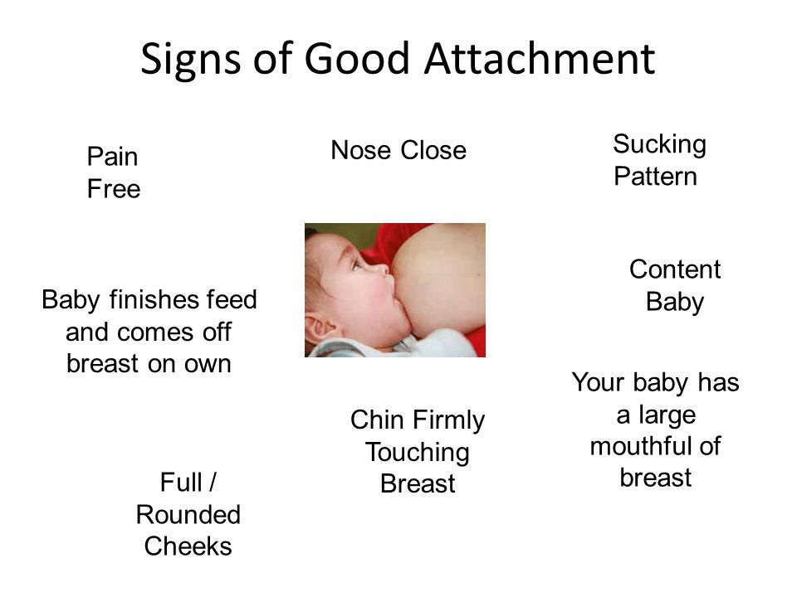

Links below show effective attachment.
https://www.breastfeedingnetwork.org.uk/positioning-attachment/

https://www.breastfeedingnetwork.org.uk/sign-of-effective-attachment/

https://www.unicef.org.uk/babyfriendly/wp-content/uploads/sites/2/2010/11/otbs_leaflet.pdf

other factors and may lead to stopping breastfeeding

The progression of a feed

This section explains how nutritive feeding happens when baby is correctly attached to the breast and feeding effectively.

The following suck-swallow diagram illustrates the pattern of a feed and is divided into 3 phases:
.
- At the beginning of a feed the baby sucks rapidly to stimulate the let-down reflex.
- The baby will then actively suck and swallow. One to two sucks per swallow with regular pauses indicates that the baby is well attached.
More than two sucks per swallow may mean that that the baby is not well attached.
- At the end of the feed the breast milk is low volume and high in fat which is delivered in globules. The baby ‘flutter’ sucks with an occasional swallow. Occasionally this will stimulate a further let down.

The baby should come off the breast spontaneously The second breast should always be offered.

Figure 3.5.The suck swallow pattern of a feed

The next diagram merges the suck swallow pattern of a feed with the fat content of a feed, illustrating what the baby is getting through the progression of a feed.
Fat Volume Increases
Low fat milk
Fat Globules
Time
Volume

3.6

Breastfeeding support – where to find help

Doncaster Support Contacts

Doncaster Single Point of Contact 9-5pm 01302 566776

DRI Infant Feeding Specialist Midwife 01302 366666
DRI Pharmacy re: drugs in breast milk 01302 366666

National Support Contacts

National Breastfeeding Helpline 0300 100 0212
http://www.breastfeeding.nhs.uk/

National Childbirth Trust Breastfeeding Line 0300 33 00 770
https://www.nct.org.uk/parenting/about-breastfeeding

Breastfeeding Network Supporter Line 0844 412 4664
http://www.breastfeedingnetwork.org.uk

La Leche League 0845 120 2918
http://www.laleche.org.uk/

Association of Breastfeeding Mothers 0300 330 5453
http://www.abm.me.uk

Breastfeeding Network Drugs in Breastmilk
https://www.breastfeedingnetwork.org.uk/detailed-information/drugs-in-breastmilk/

Cleft Lip & Palate Association
http://www.clapa.com 0207 833 4883

Twins & Multiple Births Association 0800 138 0509 10-1pm and 7-10pm
http://www.tamba.org.uk

Baby Friendly Initiative 0207 375 6052/
0207 375 6144
http://www.unicef.org.uk/babyfriendly

Best Beginnings 020 7443 7895
http://www.bestbeginnings.org.uk

Fatherhood Institute
http://www.fatherhoodinstitute.org/

Family Lives 0808 800 2222

3.6 Mothers

Hand Expressing breast milk

Some of the reasons why all mothers need to be taught this skill include:
- Knowing how to hand express provides the mother with the knowledge and confidence of how her breasts work and helps to show a mother she has milk.
- Hand expression can help ‘kick-start’ breast milk production.
- Mothers will have a better hormonal response and the colostrum has a higher fat content if hand expressed.
- Hand expressing is a convenient, inexpensive and effective way of removing breast milk.
- Hand expressing is the preferred method of expressing as the mother produces small amounts of colostrum in the early days of the baby’s life, which can be easily lost in breast pump parts.
- Hand expressing can help mothers to soften the breast by removing a little milk if they become full, to allow the baby to attach more effectively. And can also be used to help mothers prevent and manage challenges such as blocked ducts and mastitis, which can undermine breastfeeding and it can be used to relieve engorgement.
- The let-down reflex is usually stimulated more quickly by hand expressing.
- Hand expressing colostrum onto a baby’s lips and into baby’s mouth is a known method of arousing a baby and tempting it to feed.
- Hand expression is useful in the long-term to support social circumstances, e.g. a mothers return to work.

https://www.unicef.org.uk/babyfriendly/baby-friendly-resources/video/hand-expression/

Techniques to help the let-down reflex

Breast massage helps trigger the release of oxytocin, which will propel the milk along the ducts towards the nipple (the let-down reflex). It also promotes production of prolactin. The mother needs to wash her hands and prepare a sterile container if she plans to collect the expressed milk.
- Firm but gentle rolling actions across the breast tissue using the knuckles, and then gently using stroking actions of the mothers fingertips from the outer breast towards the nipple, continuing around the whole of the breast can help the let-down reflex.

Other ways to help stimulate the let-down reflex are:
- Being comfortable
- Relaxing atmosphere
- Having a photograph, toy, or item that smells of baby
- Holding baby whilst expressing, or having baby close by
- Back/ central shoulder massage
- Warmth from bath/ shower/ compresses

Expressing breast milk: how to hand express
https://www.unicef.org.uk/babyfriendly/baby-friendly-resources/breastfeeding-resources/hand-expression-video/

- Have a clean sterilised container to hand before you start.
- Cup your breast and place your thumb and finger about 2-3 cm from the base of the nipple.
- Using your thumb and the rest of your fingers in a C shape, gently squeeze this area – this shouldn’t hurt.
- Release the pressure and then repeat again and again, building up a rhythm. Avoid sliding your fingers over the skin. At first, only drops will appear, but just keep going as it will help build up your supply. With practice and a little more time, milk will flow freely.
- When the flow slows down, move your fingers round to try a different section of your breast and repeat. When this happens again swap to the other breast. Keep changing breasts until the milk is dripping very slowly or stops altogether.
- If the milk doesn’t flow, try moving your fingers slightly towards the nipple or further away, and try a gentle breast massage.

Storage of breast milk
- Remember to use a sterilised container to put the milk in.
- Milk can be stored in the fridge for up to 5 days at 4o C or lower (usually at
- Milk can be stored for 2 weeks in the ice compartment of a fridge
- Frozen milk can be defrosted in the fridge. Once thawed, it should be used straight away.
- Never heat milk in the microwave as it can cause hot spots which can burn your baby’s mouth.

https://www.breastfeedingnetwork.org.uk/wp-content/pdfs/BFNExpressing_and_Storing.

Challenges and management
https://www.nhs.uk/conditions/pregnancy-and-baby/problems-breastfeeding/

Engorgement

Links are provided to assist with recognising engorgement and treatment.

https://www.unicef.org.uk/babyfriendly/support-for-parents/engorgement/

https://www.laleche.org.uk/engorged-breasts-avoiding-and-treating/

Full/heavy breasts are normal

Causes
- Increase in volume of milk being produced
- Increased blood and lymph flow through the breasts in preparation for milk production

Signs and symptoms
- Breasts become larger, heavier and tender
- Occurs between the 3rd and 6th day
- Lasts between 12 and 24 hours

Contributory factors
- Normal onset of lactation

Actions
- Allow baby unrestricted, frequent access to the breast
- Ensure baby is positioned and attached well at the breast
- Allow baby to finish the first breast first before offering the second breast
- Massage breast before a feed
- Use warm water/warm compress to help get milk flowing before feeding
- Express until soft enough to enable baby to attach more easily

Engorgement is not normal

Causes
- Breast becomes full of milk; blood and lymph flow slows and enters breast tissue causing oedema

Signs and symptoms
- Breast is warm, painful, throbbing - may extend up into the mothers armpit
- Skin may appear red, shiny, taut, oedematous
- Areola engorgement may be present alone affecting the areola only
- Peripheral engorgement may be present where only the body of the breast is engorged
- Areola and peripheral engorgement may both be present
- Areola may be flattened and/or hardened
- One or both breasts may be affected
- Low grade pyrexia may be present

Contributory factors
- Infrequent feeds, missed feeding cues
- Pressure e.g. from under wired bras, maternal position
- Timed interval feeds, or feeds limited to a specific length of time
- Baby not permitted to end the feed itself
- Abrupt weaning

Actions
- Massage before feeds; knead with finger tips using a circular motion, beginning at the chest wall and travelling around the breast in a spiral towards the nipple
- Combination of massage and heat e.g. shower and massage together
- Express gently to help soften the areola enabling baby to attach and feed
- Breastfeed more often, allowing the baby to finish the first breast before offering the second
- Change breastfeeding positions
- Cold compresses up to 20 minutes before feeds can help reduce swelling and relieve pain
- Applying warm water briefly, a few minutes before the feed (shower/ bowl of water/ warm compress) may help the milk to flow
- Simple analgesia such as paracetamol can be given to help reduce inflammation, relieve pain and reduce temperature.

https://breastfeedingnetwork.org.uk/wp-content/dibm/analgesics%20and%20breastfeeding.pdf

Blocked Duct

Definition
This can be defined as ‘stasis of milk’ and/ or ‘an accumulation of milk’.
A blocked duct is an area of the breast where milk flow is obstructed. The nipple pore may be blocked or the obstruction may be further back in the ductal system.
A blocked duct usually comes on gradually and affects only one breast.

Cause
- Baby is having trouble feeding for some reason, such as an improper latch, or isn't feeding often enough.
- Using a pump that's not powerful enough.
- Abrupt weaning
- A duct becomes compressed or damaged, due to pressure from a nursing bra that doesn't fit well or from maternal position eg sleeping on the stomach. This may trap milk inside a duct.
- illness such as a cold. Illness may cause mother to not want to feed or pump as frequently.
- Stress lowers the body's production of oxytocin, the hormone that causes
- the breasts to release milk.

Signs and symptoms
- Comes on gradually
- Tender lumps in breast that clear when breast is adequately drained
- May shift in location
- The mother may feel little or no warmth in affected area
- Pain is mild and localised
- Mother feels generally well
- Sometimes a white spot may occur on the nipple “milk plug”.

Actions
- Start with the sore breast. If it's not too painful, nurse on the side with the clogged duct first, because the baby sucks strongest at the beginning and that may help dislodge the plug. If the baby doesn't want to nurse enough to empty the breast on that side, advise mum to use a breast pump or hand express the milk.
- Massage. Experts also recommend massaging the sore area frequently and firmly, starting at the outside of the breast and working toward the nipple.
- Apply warm compresses before nursing can help open the ducts and relieve pain and swelling.
- Vary the nursing position. For example, if using the cradle hold, try the football hold or nurse lying down. This will help make sure that all of the ducts are drained. Many women swear by this trick:
- Position the baby at the breast with his/her chin pointed toward the sore spot, and then have him/her latch on and begin nursing. This directs suction at the clogged duct.
- Rest.
- Eat well and drink water. Focus on nutritious foods to boost the immune system, and advise plenty of fluids to stay hydrated.
- Consider medication. Taking ibuprofen may help relieve pain and inflammation.
- Hot and cold massage with flannels/packs.
Mastitis

Definition
Mastitis is a condition which causes a woman's breast tissue to become painful and inflamed. It's most common in breastfeeding women, usually within the first three months after giving birth. Mastitis can be caused by a build-up of milk within the breast (milk stasis) or damage to the nipple, which may lead to a bacterial infection.

Causes
- Poor positioning and attachment (the breast does not drain well)
- Nipple damage
- Engorgement
- Blocked duct
- Ineffective feeding/ sucking
- An ill baby
- A baby with an abnormality
- Babies with short frenulum
- Babies with high palate
- Consistent and sustained pressure on breast from the mother
- Wearing constrictive clothing
- Pressing fingers into breast during feeds
- Wearing breast shells
- Mothers lying or sleeping on their fronts
- Change in baby’s feeding patterns
- Infrequent feeds/ missed feeds/ supplementary feeds
- Shortened feeds/ limited feeds
- Use of dummies
- Weaning
- Unusual stress or fatigue (mother more susceptible to infections)
- Altered immune systems
- Mothers with diabetes
- Mothers with anaemia
- Over stimulation of the breast
- Excessive pumping
- Overabundant milk supply

Signs and symptoms
- Comes on suddenly
- Red, hot, tender, hardened area on breast
- Usually occurs in one breast only.
- Localised to one or more breast segments
- Pain is intense and localised
- Nipple discharge which may be white or streaked with blood.
- Flu like symptoms with chills and tiredness.
- Temperature greater than 38.5°C

N.B. It is difficult to know the difference between infective and non-infective mastitis on the basis of symptoms but mother’s temperature being greater than 38.5°C or symptoms persisting over 24 hours generally indicates infection.

Actions

Self-help measures
- Continue breastfeeding, feed from the affected side first for as long as the breast feels tender or warm
- Improve positioning and attachment
- Feed baby more often
- Express after feeds to ensure breasts are soft and not uncomfortably full
- Feed from the affected side first
- Allow the baby to finish the first breast first before offering the second breast
- Change the feeding position
- Soften the breast before feeding, either by expressing, or applying warmth to breast
- Gently massage breast to help with milk flow stroking towards the nipple
- Position baby so that the lower jaw is angled towards affected area on breast - jaw action aids drainage
- Applying cold/heat packs in between feeding to reduce swelling.
- Loosening any tight clothing, including the bra, for better milk flow.
- Rest, take baby to bed, if not possible minimize extra activities.

Medical Treatment
- Simple analgesia such as paracetamol or ibuprofen, to reduce any pain or fever

Antibiotics
- These will be required if the mother does not begin to feel better fairly quickly (within 12 hours), or begins to feel worse despite using self-help measures

N.B. Should symptoms persist or mastitis reoccur, milk from the affected breast should be cultured and antibiotic sensitivity determined. A throat swab should also be taken from baby.

https://breastfeedingnetwork.org.uk/wp-content/dibm/antibiotics%20and%20breastfeeding.pdf

Breast abscess

Definition
A breast abscess is a localised area of infection with a walled-off collection of pus. It may or may not be associated with mastitis. Abscesses can develop just under the areola or deeper within the breast.

https://www.nhs.uk/conditions/breast-abscess/

Causes
- Untreated mastitis
- Delay in treatment of mastitis
- Incorrect treatment of mastitis
- Mastitis that does not respond to treatment

Signs and symptoms
- Swelling that may or may not be painful
- Definite edge to the lump
- Skin can be red with a hot patch
- Skin can take on an ‘orange peel look’
- May follow an episode of mastitis
- May occur independently of mastitis

Actions
Confirm existence through ultrasound scan (mammograms do not always define clearly between abscesses and other masses e.g. tumours)
- Treatment for small abscesses would normally be through needle aspiration
- Treatment for larger abscesses would normally be through incision and drainage and healing by secondary intention
- Antibiotics

Advantages of continuing breastfeeding are:
- Helping to prevent engorgement
- Helping to prevent further mastitis
- Decreasing the likelihood of baby developing a preferred side

Disadvantages of continuing breastfeeding are:
- The incision may heal more slowly
Positioning and attachment may not always be possible depending on where the incision occurs

Non-specific breast pain during the first six weeks

Breast pain may be caused by the following:

Muscle strain
- Can be from birth and exertion
- May cause pain in one or both breasts
- Can occur during or between feedings
- Relieved by general support of mother and baby whilst feeding and may take up to two weeks to settle.

Forceful let-down reflex
- Generally found in mothers with an oversupply of milk
- Mothers complain of breast pain during feeding
- Relieved by offering one breast only at each feed and/ or feeding more often
- Improves within the first months of breastfeeding

Factors that delay/ inhibit let-down reflex
- Stress/ sore nipples/ general tenseness
- Excessive caffeine
- Smoking
- Some drugs and medication
- Explore and address relevant issues

Sudden refilling of breasts with milk
- Pain occurs just after or between feeds, often described as deep and penetrating
- Disappears as breastfeeding becomes established

Breast pain at any time during breastfeeding

Breast pain may be caused by the following:

Nipple Trauma
- Usually caused by incorrect positioning and attachment.
- Shooting or burning pains, may be referred to as pain at the beginning and throughout the feed
- Thrush

https://breastfeedingnetwork.org.uk/wp-content/dibm/thrush%20detailed%20information%20and%20breastfeeding.pdf

Pinched nipple
- Shooting or burning pain after feeds
- Relieved by applying warm compress
- Correct the cause, usually positioning and attachment

Vasospasm
- A stabbing, burning, throbbing pain that may continue for an hour or more after feeds
- The nipple may turn white (blanch) after the releases the breast, then turns white, red, or blue and the mother may have a history of fingers blanching when cold.
- Relieved by applying warm compress
- Correct the cause - generally positioning and attachment. May be due to Reynard’s disease.

Less common causes of deep breast pain are:

- Thrush
- Internal scarring from previous breast surgery or injury.
- Ruptured breast implant. The pain is usually localized and changes in breast shape may occur.
- Ductal ectasia. The pain may be localized and may include burning, itching and nipple swelling.
- Premenstrual pain. The pain is usually radiating and peaks before a menstrual period.
- Very large breasts that are heavy can pull on the connective tissues above the breast.

Sore nipples (early days)
Apart from early temporary tenderness, breastfeeding should not hurt.
https://www.nhs.uk/conditions/pregnancy-and-baby/sore-cracked-nipples-breastfeeding/

Causes
- Soreness at the start of a feed before the let-down reflex when the milk starts to flow - generally indicates poor positioning and attachment.
- Soreness throughout the whole feed could indicate a problem with positioning, the baby’s suck, or caused by thrush
- Soreness after or between feedings could be pain from nipple trauma, vasospasm or Reynard’s disease

Other causes
- Poor positioning and attachment is the most common cause of sore nipples, especially in the early weeks after birth.
- Breast Support - if a mother stops supporting her breast or her baby during a feed, this may lead to sore nipples due to the change in position.
- Flattened nipples may cause engorgement (because the nipple has become taut) making attachment difficult. This may contribute to sore nipples.
- When a baby uses teats, dummies or nipple shields in the early weeks they may have difficulty attaching at the breast, causing the mothers nipples to become sore.
- Tongue tie or short frenulum

- Not breaking suction when taking the baby off the breast will lead to sore nipples.
- Abnormality of the mouths structures

Actions
- Check positioning and attachment.
- Encourage Skin to skin contact.
- Encourage the mother to express her milk until the nipple and areola are soft enough for baby to attach properly. Using different positions may also help.
- Avoiding the use of teats, dummies and nipple shields has been shown to decrease breastfeeding problems (Righard, 1998). Using alternative feeding methods e.g. cup feeding may help when an alternative method of feeding is needed in the early weeks. Mothers need to be offered information to be able to make an informed choice when deciding to use dummies.
- Nipple shields should only be used in exceptional circumstances, for example if the mother would otherwise discontinue breastfeeding. If a mother chooses to use them, nipple shields require careful and responsible use and an awareness of implications for use.
- If pain is caused by curled-in lips, suggest the mother gently eases out the curled lip whilst feeding. Alternatively, curling the baby’s lower lip when it touches the breast using the breast as the curling agent helps ensure the lower lip is curled out.
- If retracted tongue, tongue sucking or tip of tongue curling up is the cause of sore nipples, gentle rocking may help the baby relax before bringing him to the breast. Encouraging the baby to lick drops of expressed milk off the nipple helps with tongue extension. Gravity can help bring down a baby’s tongue using a more upright position e.g. a modified football hold where the baby looks down on the mother’s breast. Breastfeeding in a side lying position offers firm consistent support for baby’s body, helping the baby relax and use his tongue more effectively. Tongue exercises may be used (La Leche League International, 2010 page 92). The use of a nipple shield may be indicated for short-term use, helping to stimulate better sucking by pushing past the tongue to the sucking stimulus.
- Encourage the mother to break the seal if taking the baby off the breast by gently inserting a finger into the corner of baby’s mouth to break the suction
- Some babies with short frenulum may feed on one breast better than the other. Improving positioning and attachment may help. Time and growth of baby may help improve the situation. Some babies may need referring to a specialist for the frenulum to be clipped to release the tongue. If pain is caused by an unusual shaped palate, mothers may have to shape their breast to help it fit their baby’s mouth. This may mean using an exaggerated latch, or a nipple sandwich, supporting the breast and forming the nipple in the same parallel direction of the baby’s lips. The nipple should be aimed into the roof of baby’s mouth when the baby gapes wide. The mother may need to continue this support for the whole of the feed or until the baby learns, or has grown, to be able to do this themselves.
- If gum clenching and biting is a problem, it is probably temporary and can generally be outgrown. Waiting for the baby to extend their tongue over the gum ridge before attaching him to the breast may help.

Sore nipples at any time during breastfeeding

Causes
- Thrush
- Teething and biting - when a baby is teething he may have sore gums that cause him to feed in a different way. Mothers do not have to wean when babies get their teeth.
- Ineffective breast pumps where suction is generated slowly may cause damage to nipples.
- Breast pumps used too vigorously may also cause damage to nipples.
- Mother’s skin problems that occur in other parts of the body can just as equally occur on the nipple e.g. eczema, dermatitis, psoriasis, skin infections and can contribute to sore nipples.
- Vasospasm also caused by compression of the blood vessels and/ or constriction of the blood vessels can cause nipple pain. The nipple turns white then blue then red. A stabbing, burning throbbing pain may continue for an hour or more after feeds. This may be Reynard’s disease or a symptom of this. Reynard’s disease needs appropriate treatment (La Leche League International 2010, page 463-464).
- Tight clothing, a bra that is too tight or has rough seams may cause nipple soreness
- Pregnancy can cause nipple soreness through hormonal changes. Mothers experience varying degrees of soreness and may opt to continue to feed throughout the pregnancy and after the new baby has been born.
- Some creams, ointments and sprays may contain ingredients that cause adverse skin reactions. Some creams may need removal before feeding and rubbing off the cream may cause soreness.

Actions
- Ensure optimum positioning and attachment
- If baby starts to bite bring his body in closer instead of taking him off the breast. Ensure milk is plentiful and recognise when the feed is finishing and break the seal before the baby has chance to bite. Don’t force baby to feed and praise the baby for not biting.
- If using breast pumps ensure an appropriate fit. The flange of the pump should also accommodate the mother’s nipple comfortably.
- Ensure appropriate treatment of skin conditions to enable the mother to continue breastfeeding. Breastfeeding does not need to be interrupted unless it is found to be too painful.
- Applying a warm compress after feeding may help and correct positioning and attachment needs to be assessed and corrected in the case of nipple compression.
- Mothers experiencing sore nipples in pregnancy are advised to change the feeding position feed for shorter periods and/ or use breathing or distraction techniques whilst feeding.
- Stimulate the let-down reflex before attaching baby to the breast by hand expressing some breast milk
- Alternatively, to stimulate the let-down reflex, feed on the least sore side first and then change the baby onto the affected side
- Take an analgesic that is compatible with breastfeeding.
- Express a little breast milk onto the nipple after feeds and allow to dry, Akkuzu & Taskin (2000) found this shortened the duration of cracked nipples.
- Breast shells that have holes for air circulation can be worn if a mother cannot tolerate the pressure of her bra or clothing on her nipples
- Applying a modified lanolin, has been shown to reduce nipple pain and speed healing of sore, cracked and bleeding nipples through the process of moist wound healing
- Washing the nipples daily, when the skin is broken with a mild soap and rinsing well can prevent infection (Wilson-Clay & Hoover, 2002).
- Applying a thin layer of antibiotic ointment has been suggested to help prevent infection (Newman and Pitman, 2000)
- Avoid wearing plastic backed breast pads and change pads frequently throughout the day and night
- Nipple shields may compound the problem and do not help correct any attachment problems
- If a mother’s nipples do not heal, even after positioning and attachment has been corrected, the mother may have an infection and require additional treatment (Livingstone and Stringer, 1999 and Livingstone et al, 1996 and Amir et al, 1996).

Thrush and Breastfeeding,
If thrush is suspected, before a diagnosis of thrush is made we would recommend that swabs of the mother’s nipples and of the baby's mouth are taken to detect bacterial or candida growth.
Please see the up to date fact sheet provided by the Breastfeeding network.
https://breastfeedingnetwork.org.uk/wp-content/dibm/thrush%20detailed%20information%20and%20breastfeeding.pdf
Information for mothers

If you think you have thrush
Before treating either you or your baby you should ask the person supporting you with breastfeeding to watch a full breastfeed from the moment the baby goes to the breast to the moment he/ she comes away from the breast at the end of the feed. They need to look at your nipples at the end of the feed to look for change in colour and shape. If your baby has a white tongue but you are not experiencing pain, be aware of the risk of thrush but do not treat either of you immediately. Some babies have white tongues in the first few weeks after birth or this may be associated with tongue tie where the milk is not thrown to the back of the mouth.
Diagnosis should be confirmed by nipple swabs cultured for fungal and bacterial infection.

BREASTFEEDING SHOULD BE PAIN-FREE from the point of attachment (the moment the baby goes to the breast) onwards (Pain from thrush begins after a feed). There should be no change in the shape or colour of the nipple after a feed. Even good attachment can often be improved and help to relieve symptoms of pain.

Other causes of nipple pain:
- Attachment of the baby to the breast may need fine-tuning
- Eczema including reactions to breast pads or creams
- Tongue-tie in the baby
- Reynaud’s syndrome (associated with history of poor circulation and pain made worse when cold)
- White spot which produces pin-point pain
- Bacterial infection which appears as a yellowy, thick discharge
- Vasospasm which is associated with less than perfect attachment of the baby at the breast and produces white nipples (particularly at the tip) after breastfeeds.

Self-help measures
- Thrush can be passed between you and your baby and also between you, your partner and other children.
- It is necessary to be very careful with hygiene in order to get rid of
thrush completely - be sure to wash your hands well after each nappy
change.
- Use a separate towel for each person in the family.

IMPORTANT - To make sure you get rid of the thrush infection, both you and your baby need treatment. Usually once treatment begins the pain and other symptoms will begin to improve within 2 or 3 days. It may take longer for full recovery.
If there is no improvement at all after 7 days, consult the person helping you with breastfeeding again, as the cause of the pain may not be thrush.

Information for health professionals
Presenting symptoms which suggest the presence of candida infection of the breast:
- Previous pain free breastfeeding.
- Positive swabs for candida from maternal nipples and infant mouth.
- Bilateral pain.
- Pain which begins after a breastfeed has finished and continues for up to an hour afterwards.
- Absence of red area on the breast.
- Absence of pyrexia.

If a mother reports sore nipples during breastfeeding, the first action should ALWAYS be to re-examine and improve attachment. This should be carried out by a skilled practitioner. It is unethical to treat a mother and baby with medication inappropriately or unnecessarily, particularly if such use is outside product licence.

Treatment of thrush
The diagnosis of candidial infections on the breast is difficult. Swabs of the
mothers nipples and the baby’s mouth are useful to confirm the presence/ absence of fungal or bacterial infection (commonly Staph. aureus).
Treatment of the surface of the nipple, the baby's mouth, and oral treatment for the mother (when necessary to treat deep breast pain), should be undertaken simultaneously to achieve relief from symptoms of confirmed candidial infection.

Remember Breastfeeding can continue during thrush treatment.

Insufficient milk supply

https://www.unicef.org.uk/babyfriendly/support-for-parents/low-milk-supply/

- Nearly all mothers are able to produce enough milk for their baby’s growth and health
- Mother’s may think they do not have enough milk because of baby’s patterns of feeding. Mothers need realistic and practical information about breastfeeding

Causes
Breastfeeding factors
- No (or too brief) skin-to-skin contact
- Delayed first breastfeed
- Not allowing baby to feed as long as baby wants
- Separation of mother and baby
- Feeding infrequently
- Poor positioning
- Poor attachment
- Scheduled breastfeeds
- Missed breastfeeds
- The giving of other foods or fluids/ supplementary feeds
- Missing out night time breastfeeds
- Use of teats / dummies / nipple shields

Psychological factors
- Under confident
- Stress / worry
- Does not like breastfeeding
- Tiredness or fatigue – unable to care for baby

Physical conditions of the mother
- Retained placenta
- Combined contraceptive pill
- Poor breast development in puberty
- Alcohol
- Smoking
- Some drugs
- Anaemia
- Hormonal problems
- Under-active thyroid
- Breast surgery or injury
- Severe malnutrition – anorexia or bulimia

Physical conditions of the baby
- Illness
- Abnormality
- Sleepy baby
- Jaundice
- Breast refusal

Signs and Symptoms

Reliable Indicators

Baby
- Poor urine output (see below)
- Abnormal stool pattern (see below)
- Persistent jaundice
- Dehydration
- Poor weight gain
- Poor positioning and attachment.

Possible Indicators

Baby
- Not satisfied/ settled after feeds
- Cries often
- Feeds for long periods of time (regularly feeding for more than 30 minutes)
- Requests feeding frequently (more than 12 times in 24 hours)
- Does not come off the breast spontaneously
- Refuses to breastfeed
- Passes hard green stools
- Passes small, infrequent stools

Mother
- No breast changes in puberty and/ or pregnancy
- Engorged or painful breasts

Actions
- Upturn milk supply by:
  - enabling the baby to attach effectively so they can feed properly;
  - allowing the baby to feed whenever they want (remember dummy use can mask feeding cues)
  - allowing the baby to feed for as long as they want, even if they appear to be ‘comfort sucking’ towards the end of the feed (when the milk is low volume but high fat)
  - encouraging the mother to express to stimulate her supply
- Encourage as much skin-to-skin contact between mother and baby as possible
- Encourage the mother to relax any routines to help the baby get the milk they need

Hepatitis

Hepatitis A

Definition
This is the short incubation form of viral Hepatitis, infecting the liver and causing jaundice.

Transmission
It is transmitted through faecal-oral route usually through food and drink contaminated by a carrier and commonly occurs where sanitation is poor.

Breastfeeding implications
The baby needs to be immunised against Hepatitis A. Antibodies found in breast milk may protect the baby. Mothers with Hepatitis A can breastfeed if not too ill. Although breastfeeding can be postponed until mother feels better, lactation needs to be stimulated and maintained (La Leche League International, 2010, page 538)

Hepatitis B

Hepatitis B is a liver infection caused by the hepatitis B virus (HBV), which is transmitted by blood, semen or other body fluid from an infected person. A woman with hepatitis B can infect her infant with the virus during childbirth.

Breastfeeding implications
The baby needs immunising at birth and usually at one month, two months and twelve months of age. Breastfeeding may begin straight after birth even before the first immunisation (Committee on Infectious Diseases (2000) as cited by La Leche League International (2010) pg 538).

Hepatitis C

Hepatitis C is a liver infection caused by the hepatitis C virus (HCV), which is transmitted by blood from an infected person. There is no vaccine for hepatitis C. The best way to prevent hepatitis C is by avoiding behaviours that can spread the disease, especially injecting drugs.

Breastfeeding implications
There is no documented evidence that breastfeeding spreads HCV. Therefore, having HCV-infection is not a contraindication to breastfeed.

Human Immunodeficiency Virus (HIV)

Definition
HIV (human immunodeficiency virus) is a virus that damages the cells in the immune system and weakens the ability to fight everyday infections and disease.
There is currently no cure for HIV, but there are very effective drug treatments that enable most people with the virus to live a long and healthy life.

Transmission
HIV is found in the body fluids of an infected person. This includes semen, vaginal and anal fluids, blood, and breast milk.
HIV is a fragile virus and doesn't survive outside the body for long.
HIV cannot be transmitted through sweat, urine or saliva.
The most common way of getting HIV in the UK is through having anal or vaginal sex without a condom.
Other ways of getting HIV include:
- Sharing needles, syringes or other injecting equipment
- Transmission from mother to baby during pregnancy, birth or breastfeeding

Breastfeeding implication
HIV is present in breast milk and can be transmitted to the neonate both through free virus and via HIV infected cells in the milk. Although the concentration of the virus is low, the quantities of milk consumed are high leading to a substantial viral exposure in the baby. Breast feeding increases the vertical transmission rate.

- Recent observations from studies found that mixed feeding carried the greatest risks of vertical transmission. This is because the introduction of other foods including formula feed increases the permeability of the gut therefore resulting in increased rates of acquisition of the infection for the infant.

- In circumstances where safe, affordable alternatives exist, a woman with HIV should be advised not to breast feed her baby.

- There may be a range of cultural issues, which make this a difficult course of action for the woman. Questions from family and friends may prove difficult to answer when they are not aware of the woman’s HIV status and she will need additional support for her choice of feeding.

If the mother still wishes to breastfeed the HIV Consultant will discuss the relevant literature and risks and hold a multi-disciplinary meeting and an individualised action/management plan completed.
Suppression of maternal viraemia is required throughout the breastfeeding period as are strict adherence to HAART and attendance for monthly monitoring of HIV viral load. This will be assessed by experienced members of the HIV team and any maternal viraemia promptly assessed and a decision regarding cessation of breast feeding made.

Medication, drugs and breastfeeding

Prescribed drugs
Many prescribed medications are compatible with breastfeeding. Only suitably qualified medical professionals with prescribing rights are able to evaluate the safety of a medication before prescribing for the breastfeeding mother and her baby.

Factors for consideration
- How will the drug affect lactation? Consider the amounts in breast milk.
- How will the drug affect the breastfed baby? Consider gut absorption/ half-life/ toxicity/ side effects.
- How is the drug administered? The route affects levels of concentration in breast milk.
- Are there any alternatives?

Where to find specific drug information
- British National Formulary (BNF)
- Local hospital drug information service
- Local pharmacist
- Breastfeeding Network Drugs Helpline 0844 412 4665
- https://www.breastfeedingnetwork.org.uk/detailed-information/drugs-in-breastmilk/
- Medications and Mother’s Milk, Hale, 2010. http://neonatal.ttuhsc.edu/lact

Substances of concern

Alcohol

- Alcohol passes freely into breast milk peaking between 30-60 minutes (60-90 minutes with food)
- Current advice from the NHS choices is that mothers who are breastfeeding should avoid alcohol shortly before feeding your baby and keep alcohol intake below one to two units of alcohol daily. Don't share a bed with your baby if you've been drinking alcohol. Never sleep with your baby on a sofa or armchair (NHS Choices, 2013).

Regular consumption is linked to:
- Interference with the let-down reflex
- Baby’s motor development
- Poor weight gain in the baby
- Feeding more frequently but consuming less milk

Nicotine
All mothers who smoke should be encouraged to stop during pregnancy and offered help to do so. However, if you're finding it hard to quit smoking, it's important not to stop breastfeeding. Breastfeeding will still protect your baby from infections and provide nutrients they can't get from formula milk.
If you or your partner can't stop smoking, making your home completely smoke free will help protect your baby's health. You may need to ask friends and family not to smoke near your baby, too (NHS Choices).

Smoking and breastfeeding is linked to:
- Reduced milk production
- Delay in let-down reflex
- Fretfulness in baby
- Early weaning

.Refer the breastfeeding mother to Doncaster stop smoking service
For further information, refer to https://www.breastfeedingnetwork.org.uk/wp-content/pdfs/BfN_how_safe_is_leaflet_2009.pdf

Caffeine
- Caffeine can reach your baby through your breast milk and may keep them awake.
- Caffeine occurs naturally in lots of foods and drinks, including coffee, tea and chocolate. It's also added to some soft drinks and energy drinks, as well as some cold and flu remedies.
- Caffeine is a stimulant and can make your baby restless. It's a good idea for pregnant and breastfeeding women to restrict their caffeine intake to less than 200mg a day: NHS CHOICES

- One mug of filter coffee: 140mg
- One mug of instant coffee: 100mg
- One mug of tea: 75mg
- One can of energy drink: up to 80mg
- One 50g plain chocolate bar: up to 50mg
- One cola drink (354ml): 40mg

Theobromine

This is found in cocoa beans and subsequently chocolate and effects are similar to those shown by caffeine if taken in excess.

Herbal teas and remedies
Make sure that the tea is caffeine free if you’re drinking more than 3 cups a day. If you are allergic to any plants or pollen, you should stay away from related herbal plants.
Herbal teas that may reduce milk supply and that you should not drink while breastfeeding are; sage tea, menthol, spearmint or peppermint teas. As well as teas containing any of the following herbs: black walnut, chickweed, cocoa, herb Robert (geranium robertianum), lemon balm, oregano, parsley (petroselinum crispum), periwinkle herb (vinca minor), sorrel (rumex acetosa), thyme, yarrow.
Vaccines
Breast Feeding and Vaccination: Neither inactivated nor live vaccines administered to a lactating woman affect the safety of breast feeding for women or their infants. Breastfeeding does not adversely affect immunization and is not a contraindication for any vaccine, with the exception of smallpox vaccine (Breastfeeding Network, 2013).

A comprehensive list of available resources detailing the use of medication and breastfeeding can be found at https://www.breastfeedingnetwork.org.uk/detailed-information/drugs-in-breastmilk/

Substances of misuse
Research shows that use of tobacco, alcohol, or illicit drugs or misuse of prescription drugs by pregnant women can have severe health consequences for infants. This is because many substances pass easily through the placenta, so substances that a pregnant woman takes also reach the fetus.⁹¹ Recent research shows that smoking tobacco or marijuana, taking prescription pain relievers, or using illegal drugs during pregnancy is associated with double or even triple the risk of stillbirth.
- Tobacco use—1.8 to 2.8 times greater risk of stillbirth, with the highest risk found among the heaviest smokers
- Marijuana use—2.3 times greater risk of stillbirth
- Evidence of any stimulant, marijuana, or prescription pain reliever use—2.2 times greater risk of stillbirth
- Passive exposure to tobacco—2.1 times greater risk of stillbirth
Source: Tobacco, drug use in pregnancy, 2013

Referral to a specialist is vital, as any substance misuse is hazardous to mother and baby. This does not mean that a mother cannot breastfeed. Many substances of misuse do not pass into breast milk in large quantities, however some will do.
Unrelated to how the mother chooses to feed her baby, is how the drug affects the mother and how it affects her ability to care for her baby. It is important that mothers who are using substances of misuse are given the opportunity to make informed choices about breastfeeding. It is likely that a mother will only choose to breastfeed if her drug use is well managed and she is in a stable and supportive environment. Safety of both mother and baby is the main concern.

Amphetamines
- Prescription dosages are compatible with breastfeeding
- The half-life of these drugs are approximately 8 hours
- Breastfeeding should be interrupted for at least 24 hours for non-clinical use (Hale, 2010).

Marijuana
- Tetrahydrocannabinol (THC), the active ingredient in marijuana is concentrated in breast milk, and can be found in baby’s urine up to three weeks after the mother has smoked this substance.

Cocaine
- Cocaine passes into the mother’s milk in significant amounts and can be found in mother’s milk 36 hours later and baby’s urine 60 hours later.
- In babies it can cause irritability, vomiting, tremors, and raised heart and respiration rates.

Heroin
- Heroin passes into the mother’s milk in significant amounts.
- In babies it can cause tremors, restlessness, vomiting and poor feeding.

Methadone
- This is considered compatible with breastfeeding.
- There are no restrictions on dosages, as the amount a baby receives via breast milk is usually considerably lower than a baby would receive should it be on a withdrawal programme.
- Should a mother want to wean from methadone, it should be done gradually with specialist guidance.

Contacting the Breastfeeding Network regarding Drugs information:
Email: Drug-information@breastfeedingnetwork.org.uk - Provide as much information (age of baby, dose, frequency and name of medication or drug)
www.breastfeedingnetwork.org.uk/drug-factsheets
www.facebook.com/BFNdrugsinbreastmilkinforamtion
druginformation@breastfeedingnetwork.org.uk
An increasing number of mothers and health professionals have sought to find more information on the levels of medicines passing through milk to the baby. Standard reference books such as the British National Formulary (BNF) provide little information for professionals and parents to make decisions on individual situations. BfN endeavours to provide information to enable mothers to breastfeed their babies for as long as they wish and to provide information on the safety of medicines for each mother and baby pair.
Please see the information sheets in answer to frequently asked questions such as medicines for coughs and colds, antidepressants, smoking and NRT, the morning after pill, and flu injections as well as the leaflets on thrush and mastitis.
We are constantly reviewing the information available on drugs and breastfeeding as new research is conducted. Therefore, from time-to-time the information on this website may be updated - please be sure to check regularly for any new information and changes to the drug information fact sheets and leaflets.”
(Breastfeeding Network, 2013)

Diet and fluids
A varied healthy diet is important for everyone and is no different for breastfeeding mothers. Mothers do not need to eat anything special to make breast milk. An additional 550mg/ day of calcium is required during breastfeeding. Women who breastfeed should be encouraged to include milk and dairy foods e.g. yoghurts and cheese and other calcium rich foods such as white flour products, tinned fish (with bones), beans and other pulses. Teenagers have higher calcium requirements than adults, therefore adolescent mothers will be expected to have higher intakes if they decide to breastfeed (DoH, 1991).

Mothers should be encouraged to drink to thirst and eat to hunger.

Food restrictions
Eating fish is good for health, but recommendations state not to have more than two portions of oily fish a week (NHS Choices, 2013). Oily fish includes fresh tuna (not canned tuna, because the good fats are lost in the canning process), mackerel, sardines and trout.
There's a limit for oily fish for women because oily fish can contain low levels of pollutants, which can build up in the body and affect the development of a future baby.
The general advice for all adults is to avoid eating more than one portion of shark, swordfish or marlin a week because of the mercury contained in these fish. Avoid these fish altogether during pregnancy or if trying to get pregnant. (NHS Choices, 2013)
Small amounts of what the mother is eating and drinking can pass to the baby through the breast milk. If a mother thinks a food being eaten is affecting her baby and they're unsettled, she should talk to her GP, health visitor, or contact the National Breastfeeding Helpline on 0300 100 0212.
Allergies
Women with known allergy to milk and dairy products may need referral to a dietitian in order to ensure an adequate calcium intake.
If a mother likes to eat peanuts or foods containing peanuts (such as peanut butter) while breastfeeding, she can choose to do so as part of a healthy balanced diet. She should not eat them if she is allergic to them.
There's no clear evidence that eating peanuts while breastfeeding affects the baby’s chances of developing a peanut allergy (NHS Choices, 2013)

Vitamins
Satisfactory vitamin status during pregnancy and lactation helps to ensure that the mother remains in good health and that she provides vitamin stores for her baby.

Vitamin D

All pregnant and breastfeeding women are advised to take a daily vitamin D supplement of 10 micrograms. Vitamin D regulates the amount of calcium in the body, which helps to keep bones and teeth strong and healthy. This also provides your baby with enough vitamin D in their first few months.

Growth spurts
- A baby may suddenly feed more frequently
- Growth spurts typically occur around two to three weeks, six weeks and three months of age. This increase in feeding will increase the mother’s milk supply in response to the baby’s needs.
- Within a few days a new or previous feeding pattern will become apparent
- Growth spurts sometimes coincide with the mother feeling that her breasts are softer as her breast milk production becomes more regulated, which often leads her to think she is not producing enough milk for her baby. Lots of reassurance may be required, that following patterns of baby-led, demand or responsive feeding will usually resolve this over a couple of days

Growth patterns

- All newborns tend to lose weight during the first three to four days after birth. This is due to passing of meconium and ridding the body of its excess of tissue fluids.
- A weight loss of 5-7% is considered to be normal
- A weight loss of 10% indicates that breastfeeding needs assessing and the mother may require some further information and support
- A weight loss of greater than 10% requires immediate assessment, feeding problems rectifying and an immediate paediatric consultation and referral
- Most babies regain their birth weight within 10-14 days. If a baby has not done this, breastfeeding needs further assessment.
- Weight gain should be calculated from the lowest weight, not the birth weight
- For the first three to four months weight gain averages around 113-170g (4-6oz) per week
- At age four to six months average weight gain is about 113-142g (4-5oz) per week
- During month’s six to twelve, the weight gain decreases to around 57-113g (2-4oz) per week
- On average, by five to six months the breastfed baby has doubled their birth weight and by one year is about two and a half times their birth weight. By the age of two years there are little differences in weight gain found between breastfed and artificially fed babies.

Weighing Guidelines & New Growth Charts
The UK-WHO 0-4 years charts are for all new births from May 11th 2009. The existing UK90 Growth Charts continue to be used for children born before this date and for children over 4 years.

The new charts and written information to explain the use of charts are in all new Personal Child Health Record books.

NICE guidance (NICE: PH11 2008) states that as a minimum, babies should be weighed (naked) at birth and at 5 and 10 days, as part of an overall assessment of feeding and thereafter as needed.

The Doncaster & Bassetlaw Hospitals NHS Foundation Trust Breastfeeding Policy states babies are to be weighed (naked) at 3, 6 and 10 days, as part of an overall assessment of feeding and thereafter as needed.

Only class III clinical electronic scales in metric setting should be used to weigh infants. These should be maintained and calibrated annually in line with medical devices standards.

Some degree of weight loss is common in the first week. A weight loss of 10% or more needs careful assessment.

Recovery of birth weight by 2 weeks indicates that feeding is effective and the child is well.

Once feeding is established, if parents wish, or if there is professional concern, babies can be weighed at 6-8 weeks, 12 and 16 weeks, i.e. at the time of routine immunisations. Babies should usually be weighed at 12-13 months, again at the time of routine immunisations.

If there is concern, weigh more often; however, weights measured too close together are often misleading, so babies should be weighed:
- No more than once a month up to 6 months of age
- Once every two months from 6 to 12 months of age
- Once every three months over the age of 1 year. However most children do not need to be weighed this often.

Patterns of wet and dirty nappies

- The urine and stool output is a key signifier as to whether breastfeeding is progressing well and is the primary way to assess if a baby is receiving enough breastmilk
- Continue to increase each day until there are at least 6 heavy, wet nappies in 24 hours from day 5 onwards.
- During the first few days after birth the baby passes dark tarry stools known as meconium
- Around day three, a baby stool changes to green transitional stools
- By day five a baby’s stool is typically yellow in colour, loose and unformed, and baby should pass at least 2 stools the size of a £2 coin, per 24 hours. This pattern may continue for six weeks or more whilst the baby is exclusively breastfed.
- In the older baby less frequent bowel movements can also be normal e.g. once a week, or once every ten days

SECTION 4

A guide to bottle feeding

4.1 Introduction

The following information has been extracted from the “A guide to bottle feeding - how to prepare infant formula and sterilise feeding equipment to minimise the risks to your baby” Published by the Department of Health and the Baby Friendly Initiative. The leaflet provides families and health professionals with key information about bottle feeding.

The full leaflet can be assessed using the link below.
https://www.unicef.org.uk/babyfriendly/wp-content/uploads/sites/2/2008/02/start4life_guide_to_bottle_-feeding.pdf

Make snuggling up and feeding your baby a special time for you both. It is a time when you and your baby can bond with each other. While you’re feeding your baby, maintain eye contact. Take time to cradle and caress your baby, look into your baby’s eyes and your baby will look back at you. This helps your baby to feel safe and loved. You can also give them a different view of you (and the world around them) by switching arms halfway through feeding. Skin-to-skin contact helps your baby feel safe, secure and warm. Being cuddled naked, against your bare skin (covered with a blanket or towel) for as long as possible, is important. You can also have skin-to skin contact while you are bottle feeding. If you and your partner try and give most of the feeds yourselves, this will help build up a close and loving bond with your baby.
4.2 What is infant formula?
Most infant formula is made from cows’ milk that has been treated to make it suitable for babies. Goats’ milk based infant formula is also approved for use. You should not feed your baby other formulas unless your midwife, health visitor or GP recommends you to. If you think a particular brand of infant formula disagrees with your baby, ask your GP, midwife or health visitor for advice.
Different types of infant formula
Infant formula is available in two forms:
• Ready-to-feed liquid infant formula, sold in cartons, which is sterile
• Powdered infant formula, which is not sterile
First infant formula
This is often described as suitable for newborns and should always be the first formula you give to your baby. Your baby can stay on this formula when you start to introduce solid foods at around six months, and continue on it throughout the first year. When your baby is one year old, they can start to drink whole cows’ milk.
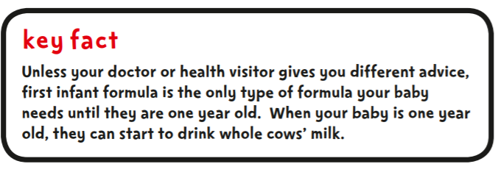
‘Hungry baby milks’ or ‘second milks’
These contain more of a protein called casein than first infant formula and this is thought to make your baby feel more full. However, there is no evidence that babies settle better or sleep longer when fed this formula. Unless your doctor or health visitor gives you different advice, there is no need to switch to these milks. Babies can drink first infant formula until they are one year old.
Follow on formula, ‘Toddler’ and ‘Growing Up’ milk
Other milks are available that are labelled as being suitable for babies aged six months and over, such as ‘follow-on milk’, ‘toddler milk’ and ‘growing up milk’. They should never be fed to babies under six months old and there is no need to switch to these milks after six months. Your baby can have first infant formula up until the time when ordinary cows’ milk can be introduced (at one year old). However, the labels on these milks can look very similar to those on first infant formula, so read them carefully to avoid making a mistake. Like powdered infant formula, follow-on formula is not sterile.
Other formula
Some follow-on formula has cereal added to it, and is described as a ‘night time feed for babies’. This type of formula is not necessary and there is no evidence that babies settle better or sleep longer when fed this. It should never be given to babies under six months. If you think your baby might be allergic to cows’-milk-based formula, talk to your GP. They can prescribe special formula feeds for babies with cows’ milk allergy. Some formulas in the shops are labelled as being ‘hypoallergenic’ but they are not suitable for babies diagnosed with a cows’ milk allergy. You should not give your baby soya-based infant formula unless your GP or a dietician has advised you to. Infant formula can also be made from goats’ milk. Goats’-milk-based formulas should not be given to infants with a cows’ milk protein allergy, unless directed by a healthcare professional. Remember, if you have any questions about the infant formula you are giving your baby, you can ask your midwife, health visitor or GP for information and help.

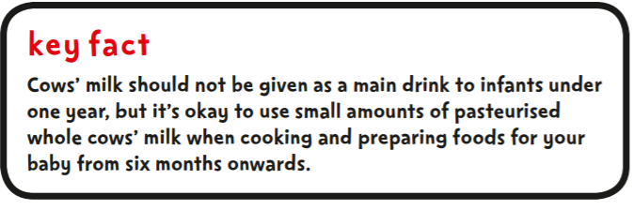
Other full-fat dairy products such as yoghurt or fromage frais can be given after six months, once your baby is used to eating solid foods
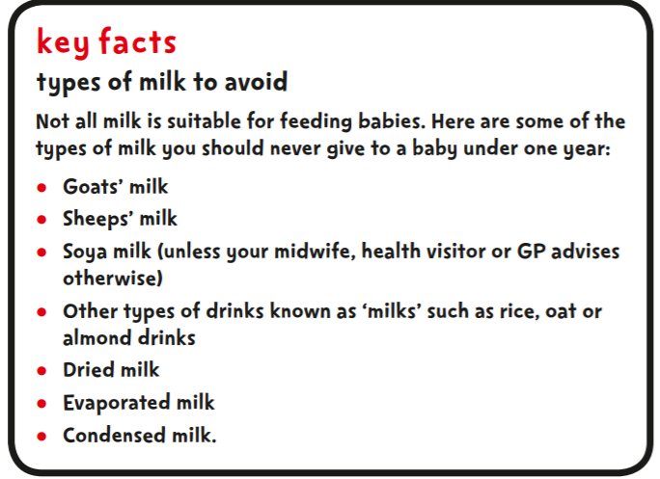

4.3 What you need for formula feeding
You need to make sure you clean and sterilise the equipment to prevent your baby from getting infections and stomach upsets. You’ll need:

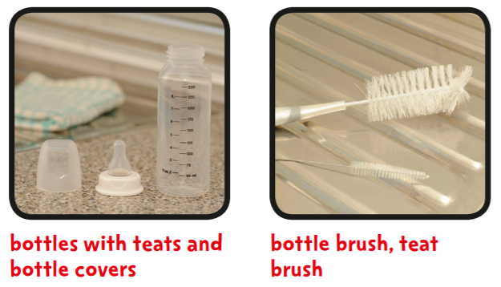
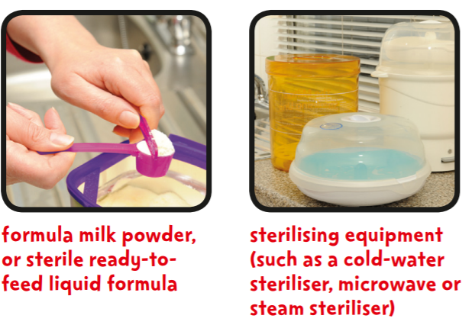
How to sterilise feeding equipment
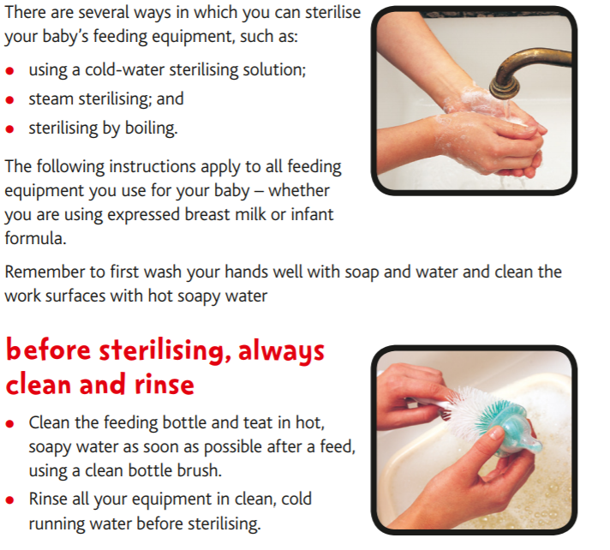

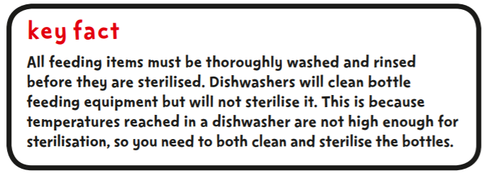
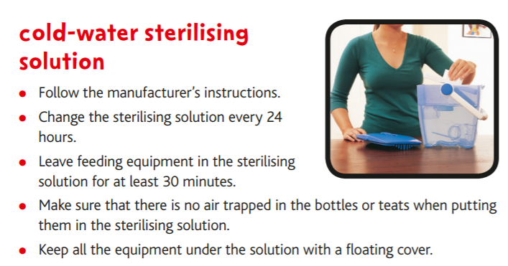

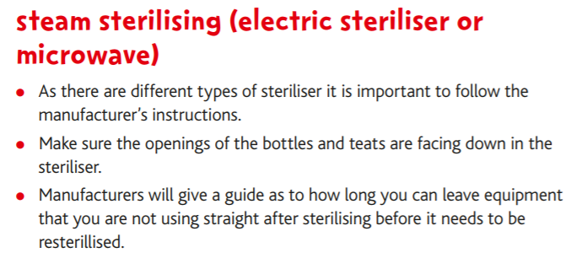
Sterilising by boiling
• When you use this method, you must take care to ensure safety and prevent scalds or burns. Never leave hot pans and liquids unattended, especially if children are present.
• Make sure that whatever you sterilise in this way is safe to boil.
• Boil the feeding equipment in water for at least 10 minutes, making sure that all items stay under the surface of the water.
• Remember that teats tend to get damaged faster with this method.

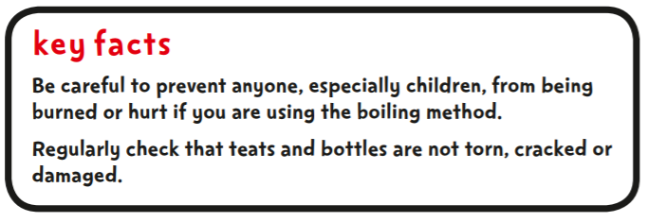

Wash hands thoroughly. Clean and disinfect the surface where you will put together the bottle and teat.
• It is best to remove the bottles just before they are used.
• If you are not using the bottles immediately, put them together fully with the teat and lid in place to prevent the inside of the sterilised bottle and the inside and outside of the teat from being contaminated.

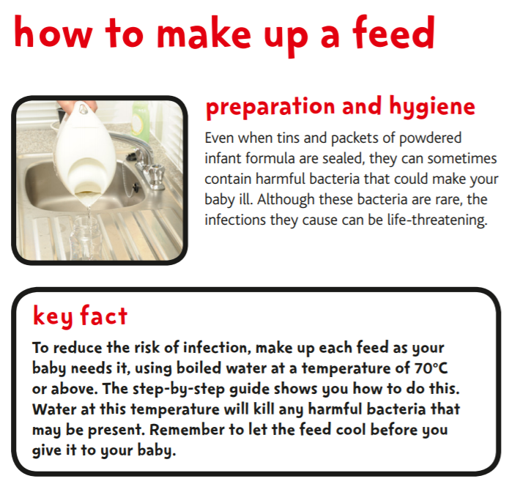
A baby’s immune system is not as strong or well developed as an adult’s. This means that babies are much more susceptible to illness and infection. Therefore, good hygiene is very important when making up a feed. All equipment used to feed your baby must be sterilised. Bottles, teats and any other feeding equipment need to be cleaned and sterilised before each feed to reduce the chances of your baby getting sickness and diarrhoea. It is best to use drinking water from the tap that has been freshly boiled (and cooled slightly to 70˚C or above) to make up a feed. Do not use water that has been previously boiled or artificially softened water. This is because the balance of minerals in previously boiled water and artificially softened water may not be suitable for making up formula feeds.
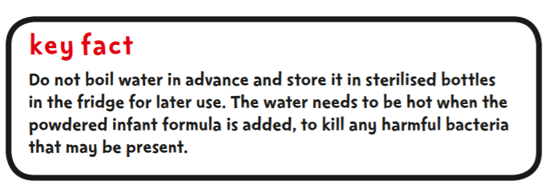
Bottled water
Bottled water is not recommended to make up a feed as it is not sterile and may contain too much salt (sodium) or sulphate. Water labelled as ‘natural mineral water’ may contain too much salt (sodium) or sulphate. If you have to use natural mineral water to make up a feed, check the label to make sure the sodium (also written as Na) level is less than 200 milligrams (mg) per litre, and the sulphate (also written as SO4 ) content is not higher than 250 milligrams (mg) per litre. Like tap water, bottled water is not usually sterile, so if you have to use it you will still need to boil it before you prepare the feed.
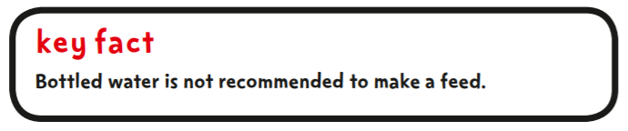

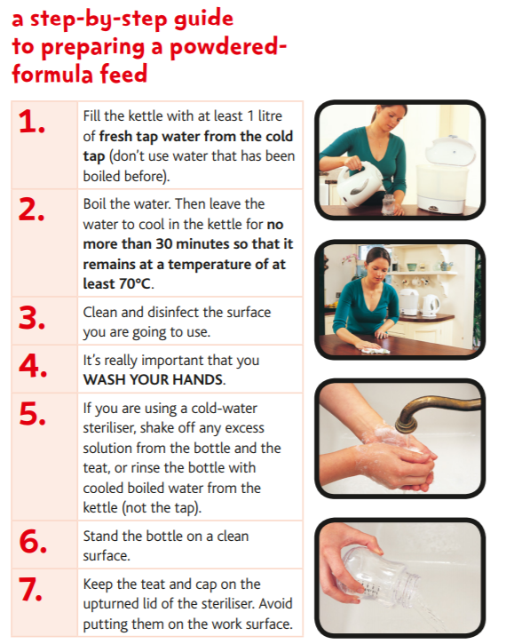
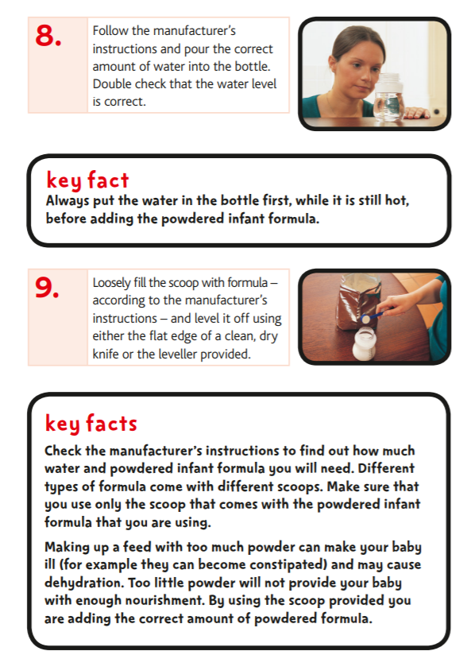

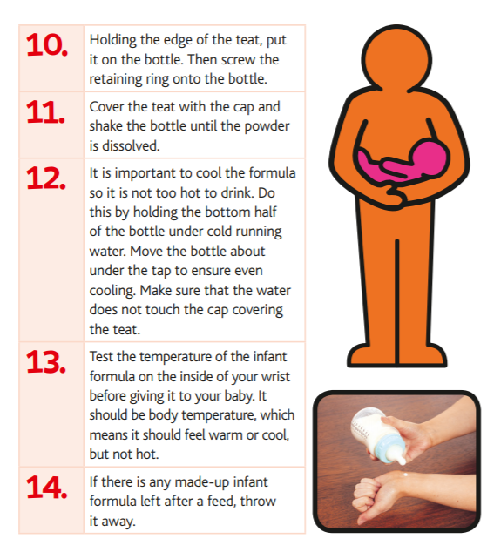
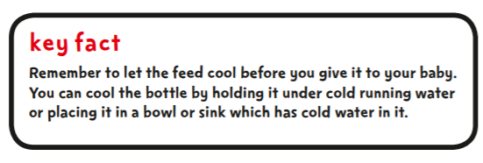
Ready-to-feed liquid infant formula
Ready-to-feed liquid infant formula is sterile. This can help to reduce the risk of infections. It is suitable for high-risk infants – for example, those that are pre-term, low-birthweight or particularly vulnerable to infections. Ready-to-feed liquid infant formula should be prepared and stored according to the manufacturer’s instructions. Remember that all feeding equipment will still need to be sterilised if you are using ready-to-feed liquid formula.
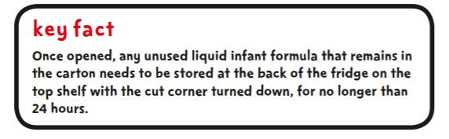

Storing a feed
A feed should be freshly made up when it is needed to reduce the risk of infection that can make your baby ill. If you have no choice and need to store a feed, it should always be stored at the back of the fridge and for no longer than 24 hours. Any infant formula left in the bottle after a feed should be thrown away. Infant formula that has not been used and has been kept at room temperature must be thrown away within two hours. Bacteria multiply very fast at room temperature. Even if a feed is kept in a fridge, bacteria can still survive and multiply, although they do this more slowly. The risk of infection increases over time so that is why it is important to make up the feed each time your baby needs it.

Feeding away from home
If you need to feed your baby away from home, a convenient choice is to use ready-to-feed infant formula milk with an empty sterilised feeding bottle. However, if you are using powdered infant formula this is the safest way to make up a feed to take with you.
You will need:
• A measured amount of infant formula powder in a small clean and dry container
• A vacuum flask of hot water that has just been boiled
• An empty sterilised feeding bottle with cap and retaining ring in place which can be removed when you are ready to make up the feed.
Make up a fresh feed only when your baby needs it. The water must still be hot when you use it, otherwise any bacteria in the infant formula may not be destroyed. Remember to cool the feed before giving it to your baby by holding the bottom half of the bottle under cold running water. Move the bottle about under the tap to ensure even cooling. Make sure that the water does not touch the cap covering the teat. The vacuum flask does not need to be sterilised but should be clean and only used for your baby. The boiling water should kill any bacteria present in the flask. If the flask is full and securely sealed, the water will stay above 70˚C for several hours.

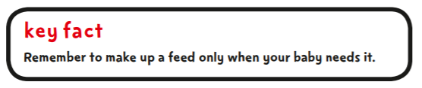
Transporting a feed
If it is not possible to make up a fresh feed by following the advice above or if you need to transport a feed – for example to a nursery or childminder – you should prepare the feed at home and cool it, for at least one hour, at the back of the fridge. Take it out of the fridge just before you leave and carry it in a cool bag with an ice pack – and use it within four hours. If you do not have an ice pack, or access to a fridge, the made-up infant formula must be used within two hours.
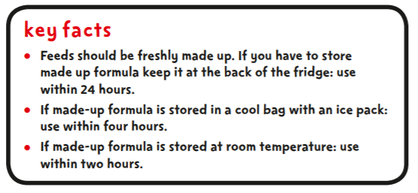

Warming a feed
When you are ready to use the feed, place the bottle in a container of warm water to heat it up. Always test the feed on the inside of your wrist to make sure if it isn’t too hot before you give it to your baby.

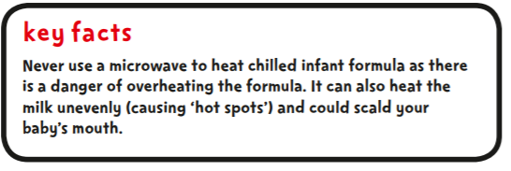

4.4 Feeding your baby
• Make sure that you are sitting comfortably. Always hold your baby close to you and look into their eyes when feeding. This helps the baby feel safe and loved.
• Hold your baby fairly upright for feeds, with their head supported so that they can breathe and swallow comfortably.
• Brush the teat against your baby’s lips and, when your baby opens their mouth wide, allow them to draw in the teat.
• If the teat becomes flattened while you are feeding, pull gently on the corner of your baby’s mouth to release the vacuum.
• Your baby may need short breaks during the feed and may need to burp sometimes. When your baby does not want any more feed, hold them upright and gently rub or pat their back to bring up any wind. This may be a very small amount, as wind is not as big a problem as many people think.
• Look out for your baby’s cues that they have had enough milk. Don’t try and force your baby to take more than they want.

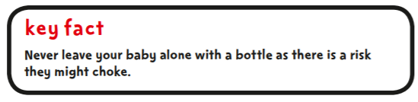

How often should I feed my baby?
New-born babies may take quite small amounts of infant formula to start with. However, by the end of their first week, most will require approximately 150 to 200 millilitres (ml) per kg of the baby’s weight per day, until they are six months old. For example, a baby aged four months, weighing 6kg would need approximately 900–1200ml of infant formula per day. This amount will vary from baby to baby. As solid food is introduced from around six months of age, your baby will gradually drink less infant formula.

Although most babies gradually settle into a feeding pattern, they vary in how often they want to feed and how much they want to drink. Feed your baby when they show signs that they are hungry. Babies tend to feed little and often, so they may not finish their bottle. However, a big feed does not mean that your baby will go longer between feeds. Your baby is likely to need night feeds for at least the first few months of their life. You can expect night feeds to reduce as your baby gets older.
How will I know if my baby is hungry?
After a while, you will get to know the signs that show your baby is ready to feed.
• Your baby will begin to move their head and mouth around.
• They will find something to suck – usually their fingers. If you can spot these signs before they are crying for food, your baby will be easier to feed.
Babies cry for lots of different reasons. If they have been fed recently then hunger is unlikely to be the cause of their crying.
How do I know if my baby is getting enough infant formula?
Your baby’s weight gain and the number of wet and dirty nappies will help to tell you if your baby is getting enough formula. A few days after the birth, your baby should be producing around six wet nappies a day. These nappies should be soaked through with clear or pale yellow urine. For the first few days after birth your baby will pass dark sticky stools (known as meconium). After the first week, however, your baby should pass pale yellow or yellowish-brown stools. Your baby should have at least six wet and two dirty nappies a days, and the amount of poo varies from baby to baby. If you are concerned your baby is not getting enough milk, speak to your midwife or health visitor.

Your baby will be weighed (naked) at birth and again at around five and ten days. Once feeding is established, healthy babies should be weighed (naked) no more than once a month up to six months of age and at one year. This weight should be filled in on the chart in your Personal Child Health Record (the red book). If you have any questions or concerns about your baby’s weight gain, speak to your midwife or health visitor.
Breastfeeding, giving infant formula and introducing solid foods
If you are combining both breastfeeding and formula feeding, and would like to discuss any changes, such as increasing your milk supply, remember to talk to your midwife or health visitor. You can also call the National Breastfeeding Helpline on 0300 100 0212 to speak to someone, often local, about breastfeeding your baby.

Choosing to restart breastfeeding
Breastfeeding is the healthiest way to feed your baby. If you decide not to breastfeed or have stopped breastfeeding, it is possible to restart. This can be difficult because your milk supply will naturally reduce once you are not breastfeeding, but it can increase again to meet your baby’s needs. Giving infant formula to a breastfed baby will reduce your breast-milk supply. You do not need to eat any special foods while breastfeeding, but it is a good idea for you, just like everyone else, to eat a healthy diet. If you are giving your baby infant formula milk, you should continue with this until they are one year old, after which time full-fat cows’ milk can be introduced.

4.5 References
PHE (2015) Guide to bottle feeding, How to prepare infant formula and sterilising feeding equipment to minimise the risks to your baby. PHE

SECTION 5

Fluids and drinks

5.1 Milk

For the first six months, it is best to give baby only breast milk or infant formula. Follow-on milk is not recommended at all before six months of age, babies who are formula fed do not need to change on to a follow on milk, and they are able to stay on their first infant formula as their main drink until they are one years old.

Pasteurised whole cow’s milk should only be used as a main drink after the age of one year as it doesn’t contain the right balance of nutrients for children under this age and is particularly low in iron. Semi-skimmed milk is not suitable before the age of two years but thereafter it may be introduced gradually if the child’s energy and nutrient intake is otherwise adequate and growth remains satisfactory (DOH 1994). Skimmed or 1% cow’s milk should not be introduced before the age of five years.

Goat’s milk and sheep’s milk should not be given to children or infants under one year. If given after one year the milk must be pasteurised.

A child can have unsweetened calcium-fortified milk alternatives, such as soya, almond and oat drinks, from the age of one as part of a healthy balanced diet. Toddlers and young children under the age of five shouldn't be given rice drinks due to the levels of arsenic in these products. There is no health benefit in giving soya-based infant formula to a healthy baby.
Soya-based infant formula was originally developed for babies who are unable to have infant formula based on cows' milk because, for example, they have a milk allergy. Soya-based infant formula contains a type of sugar called glucose. Glucose is more harmful to babies’ and small children’s teeth than the lactose contained in cow’s milk based infant formula.
Food or drink containing sugars should not have contact with baby’s teeth too often or for too long. Use a trainer cup for baby’s drinks as soon as they are able to do so.

5.2 Water

Tap water

Tap water used to make up infant formula feeds should always be boiled and cooled before use.

If tap water is given as a drink, it should be boiled and cooled for infants under the age of six months. There is generally no need to boil tap water from normal public water supplied in the UK for infants over six months of age. (NHS Choices, 2015)

In circumstances where boiled tap water is unavailable or could be unsuitable, bottled water should be used. Remember that bottled water is not sterile, so, like tap water, it should be boiled and cooled before giving as a drink to babies under six months (NHS Choices, 2016).

Bottled water

Bottled water from a shop isn't recommended as a drink for a baby as it may contain too much salt (sodium) or sulphate.
You may need to use bottled water to make up a feed if;
• Your drinking water has been contaminated due to flooding
• You’re travelling abroad and drinking the local water is not recommended

If you do have to use bottled water to make up a feed, check the label to make sure;
- The sodium (also written as Na) level is less than 200 milligrams (mg) per litre.
- The sulphate (also written as SO or SO4) content is no higher than 250mg per litre.

Like tap water, bottled water isn't sterile, so you will need to boil it before you use it to prepare a feed.
Always use boiled water at a temperature of at least 70C to make up a feed. Remember to let it cool before you give it to your baby. (NHS Choices, 2016)
The following guidelines should be followed if bottled water is used to make up formula feeds or used as a drink:

- Bottled water should be still i.e. NOT carbonated (fizzy). Carbonated bottled water is acidic and can damage teeth.
- Avoid using water in bottles labelled ‘natural mineral water’ as their mineral content is unsuitable for babies.
- Bottled water should contain less than 200mg of sodium per litre (Natural mineral water, spring water and bottled drinking water (Amendment) (England) (No.2) Regulations 2004).
- If travelling abroad and choosing bottled water to prepare infant formula, look for bottled water that contains 200mg of sodium or less per litre. If there is any concern about using bottled water when travelling, ready prepared infant formula could be used as an alternative.
- Remember that bottled water is not sterile, so, like tap water, it should be boiled and cooled before giving to babies (DOH 1994). Bottled water should be boiled and cooled if used to make up infant formulae or given to infants under six months as a drink.
- Only boil bottled water once as the mineral content will increase if boiled more than once.
- Check that the seal at the top of the bottle is intact, indicating no tampering of its contents.
- Keep the bottle cap away from all impurities.
- Once opened, bottled water should be kept in a fridge.
- Sterilise feeding bottles, teats etc. as usual.

Softened water

Don't use artificially softened water or water that has been boiled before.

5.3 Other drinks

Fruit juice

Babies under the age of six months should not be given fruit juices. Babies younger than 12 months old do not need fruit juices or smoothies. Fruit juices, such as orange juice, are a good source of vitamin C. However, they also contain natural sugars and acids, which can cause tooth decay. Diluted fruit juice (one part juice to 10 parts water) can be given to children with their meals after six months. Giving fruit juice at mealtimes (rather than between) in an open cup or free flow beaker helps to reduce the risk of tooth decay in babies.

When fruit is juiced or blended, the sugar contained in the fruit is released, which can damage your child's teeth and may cause tooth decay. However, fruit juices contain valuable vitamins and minerals. You can try making your own milkshakes and smoothies by blending soft fruit, such as banana, strawberries or mango, with milk or yoghurt. From age five, it is okay to give the child undiluted fruit juice or smoothies, but stick to no more than one glass (about 150ml) a day served with a meal. Government advice is to limit the amount of fruit juice and smoothies we have to a combined total of 150ml a day (one portion).
150ml of unsweetened, fresh, 100% fruit juice or smoothie can count as one of your five daily portions of fruit and veg. Watch out for drinks that say 'fruit' or 'juice' drink on the pack as these can contain a lot of sugar.

Carbonated (fizzy) drinks

Fizzy drinks are acidic and can damage baby’s teeth. It is advised that you do not give them to babies or toddlers. Diet or reduced-sugar drinks are not recommended for babies or toddlers either.

Soft drinks (squashes, diluting drinks)

Squashes, fizzy drinks, juice drinks and flavoured waters are not suitable for young babies. These drinks contain sugar and can cause tooth decay, even when they are diluted. Allowing a child to drink lots of juice drinks and fizzy pop throughout the day, can negatively impact their appetite, which could in turn lead to poor weight gain. Even drinks containing artificial sweeteners can encourage children to develop a sweet tooth.

If parents wish to use squashes, fizzy drinks, flavoured milk and juice drinks, keep these to mealtimes only and use a suitable feeder cup. Make sure all juices are well diluted. These drinks should never be given at bedtime or put in a bottle for a baby to hold.

Tea and coffee

Tea and coffee are not suitable for babies or young children. They can reduce the amount of iron absorbed from food, especially if they're given with meals. If sugar is added, this can lead to tooth decay.

5.4 Bottles, feeders and cups for babies

For bottle fed babies, it’s a good idea to introduce a cup rather than a bottle from about six months. By the time baby is one, they should have stopped using bottles with teats. Otherwise, they may find it hard to break the habit of comfort sucking on a bottle.
Comfort sucking on sweetened drinks is the biggest cause of tooth decay in young children. When using a bottle or trainer cup, don’t put anything in it other than formula milk, breast milk or water.
Using an open cup or a free-flow cup without a valve will help baby learn to sip rather than suck, which is better for their teeth.

Choosing a baby beaker or cup
It’s important to choose the right kind of beaker or cup. A beaker with a free-flow lid (without a non-spill valve) is better than a bottle or beaker with a teat. Drinks flow very slowly through a teat, which means that children spend a lot of time with the teat in their mouth. As soon as a child is ready, encourage them to move from a lidded beaker to drinking from an open cup.

Never leave a baby alone with a bottle as there is a risk of choking.
(NHS Choices, 2015)

5.5 Advice on relieving constipation in infants

Babies who haven't been weaned
If baby is constipated but hasn't started to eat solid foods, the first way to treat them is to give them extra water between their normal feeds. If using formula milk, make the formula as directed by the manufacturer and do not dilute the mixture.
You may want to try gently moving baby's legs in a bicycling motion or carefully massage their tummy to help stimulate their bowels.

Babies who are eating solids
If baby is eating solid foods, give them plenty of water or diluted fruit juice. Try to encourage them to eat fruit, which can be puréed or chopped depending on their ability to chew. The best fruits for babies to eat to treat constipation are:
- apples
- apricots
- grapes
- peaches
- pears
- plums
- prunes
- raspberries
- strawberries
Never force a baby to eat food if they don't want to. If you do, it can turn mealtimes into a battle and your child may start to think of eating as a negative and stressful experience.
If baby is still constipated after a change in diet, they may have to be prescribed a laxative. Bulk-forming laxatives aren't suitable for babies, so they'll usually be given an osmotic laxative. However, if this doesn't work, a stimulant laxative can be prescribed.

Children
For children, laxatives are often recommended alongside changes to diet. Osmotic laxatives are usually tried first, followed by a stimulant laxative if necessary.
As well as eating fruit, older children should have a healthy, balanced diet which contains vegetables and wholegrain foods, such as wholemeal bread and pasta.
Try to minimise stress or conflict associated with meal times or using the toilet. It is important to be positive and encouraging when it comes to establishing a toilet routine. Allow the child at least 10 minutes on the toilet to make sure they've passed as many stools as possible.
To encourage a positive toilet routine, try making a diary of the child's bowel movements linking it to a reward system. This can help them focus on using the toilet successfully.

Top tips for parents
A diet rich in fibre and plenty of fluids will help, even if your child is being treated with laxatives.
Children with long-term (chronic) constipation don't usually have anything physically wrong with them. However, it can take time to correct the problem, so be patient.
Encourage your child to have a regular toilet habit and allow them plenty of time.
A reward chart for passing a stool can be useful if your child tends to "hold on".
(NHS Choices, 2015)

5.6 References

Department of Health (1994) Report 45: Weaning and the Weaning Diet. HMSO: HMSO

Department of Health (2005) Revised guidance on preparation and storage of infant formula milk. DOH: London.

Food Standards Agency (2001) Healthy Diets for Infants and Young Children - A Guide for Health Professionals. Food Standards Agency: London.
Natural mineral water, spring water, and bottled drinking water (Amendment) (England) (No.2) Regulations 2004

NHS Choices (2015) Drinks and Cups for babies and toddlers
https://www.nhs.uk/Conditions/pregnancy-and-baby/Pages/drinks-and-cups-children.aspx

NHS Choices (2016) Can I use bottled water to make up baby formula (infant formula)?
https://www.nhs.uk/chq/Pages/1945.aspx

NHS Choices (2015) Bottlefeeding advice
https://www.nhs.uk/Conditions/pregnancy-and-baby/Pages/bottle-feeding-advice.aspx

NHS Choices (2015) Constipation
https://www.nhs.uk/conditions/constipation/treatment/#Babies

Thomas B Ed (2001) Manual of Dietetic Practice. 3rd edition. Blackwell Science.

SECTION 6

Weaning and infant feeding

6.1 Introduction

Parents and care givers who have questions around weaning can be directed to the health visiting service. Alternatively for parents/carers attending either first friends or growing friends within the Family Hubs, health professionals are available to answer any questions face to face.

If a parent/carer requires an information source, please advise that they read “Introducing solid foods, giving your baby a better start in life”. Available online at https://www.unicef.org.uk/babyfriendly/baby-friendly-resources/leaflets-and-posters/weaning-starting-solid-food/

Alternatively a health visitor or nursery nurse will have a paper copy to hand out.
The following information has come predominantly from “Introducing solid foods, giving your baby a better start in life” (2011) Department of Health.

Starting a baby on solid foods

Introducing baby to solid foods, sometimes called weaning or complementary feeding should start when baby is around 6 months old.
Initially the amount that baby eats is not as important as getting them used to the idea of eating. They will still be getting most of their nutrients from breast milk or first infant formula.
Begin by offering food at a time that suits you both. You'll be able to gradually increase the amount and variety of food baby eats until they can eat small portions of the same food as the rest of the family.
(NHS Choices, 2018)

6.1 When to start weaning baby
Babies get most of the nutrients they need from breast milk or first infant formula until they are around 6 months old.
If a mother is breastfeeding, having breast milk alone up to the age of around 6 months will help protect baby against illness and infections. Breast milk will carry on protecting baby for as long as mum carries on feeding. Waiting until baby is ready for solid food means they'll quickly be able to feed themselves and will be able to swallow more easily.
The outlined behaviours below are normal for babies and not necessarily a sign that they are hungry or ready to start solid food.
- chewing their fists
- waking in the night even though they were sleeping through before
- wanting extra milk feeds
Starting solid food won't make baby any more likely to sleep through the night. Extra milk feeds are usually enough until they are ready for solids.
(NHS Choices, 2018)

6.2 Signs a baby is ready for their first food
All babies are individual, but there are three clear signs which, together, show your baby is ready for first solid foods alongside mum’s milk or infant formula.
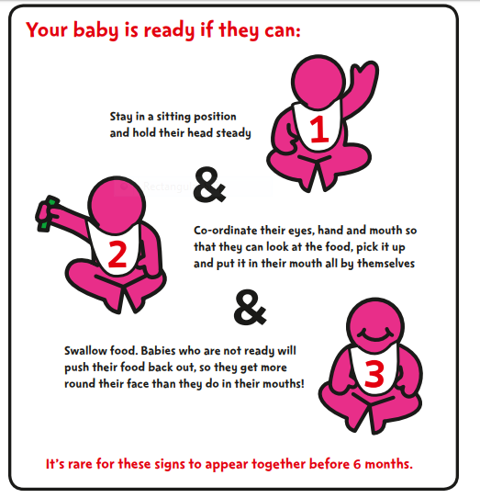
(Introducing solid foods, 2011, DoH)

(DOH, 2011)

6.3 How to start solid foods (information for parents/caregivers)
Try not to worry about how much baby eats at first. There will be some days when baby eats more and others when they eat less. They may reject some foods completely.
Don't be put off. All babies are different, and some learn to accept new foods and textures more quickly than others.
To get your baby off to a good start with solid foods:
- Let them enjoy touching and holding the food
- Allow your baby to feed themselves, using their fingers, as soon as they show an interest
It may take time for your baby to accept a new food – keep trying, it may take several attempts
- Don't force your baby to eat – wait until the next feed if they're not interested this time
- If you're using a spoon, wait for your baby to open their mouth before you offer the food – your baby may like to hold a spoon too
- Allow your baby to go at their own speed
- Start by offering just a few pieces or teaspoons of food, once a day
- Cool hot food and test it before giving it to your baby
- Don't add sugar or salt (including stock cubes) to your baby's food or cooking water
- Always stay with your baby when they are eating in case they start to choke. Never leave a baby unsupervised whilst they are eating.
(NHS Choices, 2018)

6.4 What foods to give your baby (information for parents/caregivers)

0 to 6 months
Your baby only needs breast milk or first infant formula.
"Follow-on" formula isn't suitable for babies under 6 months and there is no need to introduce it after 6 months either.
Speak with your health visitor or GP first if you want to introduce solid foods before 6 months.

Vitamins for babies
It's recommended that babies from birth to 1 year of age are given a daily supplement containing 8.5 to 10 micrograms (µg) of vitamin D, whether or not you are taking a supplement containing vitamin D yourself.
Babies who are fed infant formula don't need a vitamin D supplement if they're having 500ml (about a pint) or more of formula a day. This is because formula is already fortified with vitamin D.

From 6 months

First foods
Your baby's first foods can include mashed or soft cooked fruit and vegetables such as parsnip, potato, yam, sweet potato, carrot, apple or pear – all cooled before eating. Soft fruits, like peach or melon, or baby rice or baby cereal mixed with your baby's usual milk. Babies often like to start eating these by having them as finger foods or mashed. You can spoon feed your baby, although they will soon be able to do it for themselves.
Keep feeding your baby breast milk or infant formula, but don't give them whole cows', goats' or sheep's milk as a drink until they are 1 year old.
Some babies like to start with mashed foods. Other babies need a little longer to get used to new textures so may prefer smooth or blended foods on a spoon at first.
To help your baby get used to a range of tastes and textures, try to move on from purées to mashed foods as soon as they are able to have them.
Keep offering different foods, including foods your baby has rejected before. It can sometimes take many tries before your baby will accept a new food or texture.

Finger foods

Finger food is food that’s cut up into pieces big enough for baby to hold in their fist and stick out of the top of it – pieces about the size of your own finger. Babies learn to chew this way.
As soon as your baby starts solid foods, you can encourage them to have finger foods so they can practise feeding themselves.
Start off with finger foods that break up easily in their mouth and are long enough for them to grip such as soft ripe banana or avocado.
Always stay with your baby when they are eating in case they start to choke.

Next foods
Once your baby is used to the foods above, they can have soft cooked meat such as chicken, mashed fish (check carefully for any bones), pasta, noodles, toast, pieces of chapatti, lentils, rice and mashed hard-boiled eggs.
They can also have full-fat dairy products such as yoghurt, fromage frais or custard. Choose products with no added sugar or less sugar. You can use whole cows' milk in cooking or mixed with food from 6 months.

Cups
Introduce a cup from around 6 months and offer sips of water with meals. An open or free-flow cup without a valve will help your baby learn to sip and is better for their teeth.

From 8 to 9 months
Your baby will gradually move towards eating 3 meals a day. It will be a mixture of soft finger foods and mashed or chopped foods.
Your baby's diet should consist of a variety of:
- fruit and vegetables
- bread, rice, pasta, potatoes and other starchy foods
- meat, fish, eggs, beans and other non-dairy sources of protein
- milk and dairy products

From 12 months

Your baby will now be eating 3 meals a day (chopped if necessary) plus breast or whole cows' milk, and healthier snacks such as fruit, vegetable sticks, toast and rice cakes.
They can now drink whole cows' milk. Choose full-fat dairy products as children under 2 need the extra fat and vitamins. From 2 years old, if they are a good eater and growing well, they can have semi-skimmed milk. From 5 years old, 1% fat and skimmed milk is acceptable.

6.5 BME Considerations

The 2011 census of the Doncaster population indicated that black and ethnic minority groups make up 5.1% of the population (Doncaster observatory 2012). The Polish community in Doncaster is the largest of the black and minority ethnic groups (1.5%). Other groups identified in Doncaster include Asian (1.5%), African (0.4%), African-Caribbean (0.4%), Chinese (0.4%), Arab (0.1%) and Turkish. Doncaster also has the second largest settlement of Gypsy/Irish travellers (0.2%) in the region.

Traditional eating patterns have assisted with transmitting cultural values through society; it is therefore necessary that health professionals giving advice on diet for infants to achieve optimal growth understand and are aware of the traditional eating customs of their clients. Foods, religious restrictions, cooking methods and possible nutrition-related problems will need to be taken into account before advice is given.

It is necessary to remember that generalisation of the degree of adherence to cultural or religious dietary constraints is impossible, and assumptions on the basis of these should never be made.

The effect of migration is complex and can result in the evolution of new eating and weaning practices. A combination of both traditional weaning experiences and practices adapted from the UK can result in an unhealthy mixture. It must be noted that some of these infant feeding concerns prevail across the whole of the Doncaster population, e.g. those associated with poorer socio-economic conditions.

6.6 What milk, when?

For around the first 6 months, you should feed your baby only breast milk or first infant formula.
First infant formula made from cows' or goats' milk is the only suitable alternative to breast milk in the first 12 months of your baby's life.
Only use soya-based formula if advised by your GP.
Follow-on milks are available for babies older than 6 months but there is no evidence to suggest they have any extra benefits to your baby.
Cows' milk can be mixed with food from 6 months and whole cows' milk can be given as a drink from 1 year old.
Semi-skimmed milk can be introduced to children over the age of 2 years, as long as they're a good eater and have a varied diet.
Skimmed and 1% milk does not contain enough calories for children under 5 years old.
First infant formula, follow-on formula or growing-up milks are not needed once your baby is 1 year old.
Goats' and sheep's milk are not suitable as a drink for babies under 1 year.
You can give your child unsweetened calcium-fortified milk alternatives such as soya drinks, as part of a balanced diet from the age of 1 year.
Toddlers and young children under the age of 5 shouldn't be given rice drinks because of the levels of arsenic they contain.
If your child has an allergy or intolerance to milk, talk to your health visitor or GP. They can advise you on suitable alternatives.

6.7 What to watch out for

If after checking with your health visitor or doctor, you decide to introduce solid foods before 6 months, you should avoid giving your baby certain foods. These include foods containing wheat, gluten, nuts, peanuts, peanut products, seeds, liver, eggs, fish, shellfish, cows’ milk and soft or unpasteurised cheese.
When you do start to feed your baby, watch out for the following:
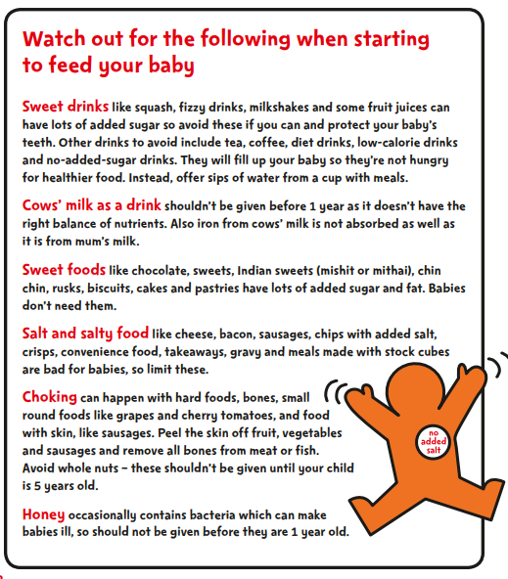
Snacks

There are plenty of healthy and nutritious snacks that you can give to baby instead of crisps, chocolate and ice cream.
Top snacks for babies:
- Rice pudding or porridge (both with no added sugar or salt)
- Canned fruit in fruit juice
- Fresh fruit
- Yoghurt (unsweetened)
- Toast/pitta/chapatti fingers
- Unsalted rice cakes
- Bagels
- Small cubes of cheese
If you start by giving baby sweet foods they are more likely to develop a taste for them. Giving babies food and drink which contains added sugar or honey can cause serious health problems;
- Sugar can rot babies’ teeth. Drinks with added sugar are not recommended. The best drinks for baby are milk or water.
- Too much sugar means excess energy, which can give babies a higher risk of becoming overweight or obese. This can lead to type 2 diabetes, heart disease and some cancers in later life. Babies who develop a taste for sugary foods are likely to keep asking for more.

6.8 Myth Busting

My baby needs to start eating before I go back to work.
False: Your baby can begin eating food any time you are together to fit in around your work. They will soon get the hang of it.

Babies who are big for their age need solid foods earlier than other babies.
False: It’s easy to see why people might think that. But remember, it’s what’s going on in the inside that counts. Babies are ready for solid foods when their digestive systems are developed enough to cope - this is usually at around 6 months. Every baby is individual so if you think yours is ready; speak to a member of your health visiting team.

You shouldn’t give your baby extra solid foods to stop them crying.
True: Babies learn very quickly to use solid food or drinks from a bottle as a comforter. This could lead to weight problems in later life.

Helpful tips
- Babies copy their parents and other children so you can help them by showing them that you eat healthier foods.
- Meal times can be messy, but this is an important part of your child’s development. You may want to cover the floor around your baby to make cleaning up easier.
- You could try letting your baby feed themselves with their fingers. This way they can choose how much they want to eat and familiarise themselves with different types of foods.
- Babies only have tiny stomachs and will know when they are full. Don’t make them finish a portion of food if they don’t want to. Eating smaller, more frequent meals is better for babies and small children.
- The best food for your baby is homemade with simple ingredients that do not contain any additional sugar or salt. You can freeze or refrigerate left overs if you’ve made too much.
- Babies enjoy watching you eat and learn from being part of a family at meal times. You can help them by talking to them and giving them food when you or the rest of the family is eating.
- Baby food in jars or packets can be handy but portion sizes are often too big and much of it has the same texture. Jars and packets are best left for when you don’t have much time or when you’re out with your baby.
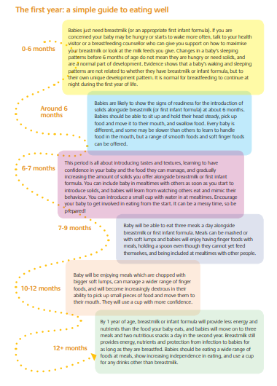

6.9 First Steps Nutrition

First Steps Nutrition has produced a guide last updated in November 2017 - “Eating well: the first year”. The guide can be accessed at http://www.firststepsnutrition.org/newpages/infants/first_year_of_life.html

This new guide provides information and practical advice on introducing solid foods to babies, including recipes and photos to show the sorts of foods, and amounts of foods, that will give them a good start to their eating journey.
The information is in line with current policy in the UK and provides a pictorial guide which can be used to support families in the first year of their baby’s lives. The guide can be accessed for free online, downloaded for free or if preferred, a hard copy can be obtained for a cost of £15.00.

6.10 Vitamins for babies and children

It is recommended that babies from birth to 1 year of age are given a daily supplement containing 8.5 to 10 micrograms (µg) of vitamin D.
It is also recommended that all children aged from 6 months to 5 years have daily vitamin supplements containing vitamin A (233µg) and vitamin C (20mg).
Babies who are having more than 500ml (about a pint) of infant formula a day do not need vitamin supplements as formula is already fortified with vitamins.

6.11 Food allergies in babies and young children
Exclusive breastfeeding or first infant formula is recommended for around the first 6 months of life.
If your baby has a cow's milk allergy and is not being breastfed, talk to your GP about what kind of formula to give your baby.
Pregnant or breastfeeding women don't need to avoid foods that can trigger allergic reactions (including peanuts), unless you're allergic to them.
If your baby already has an allergy such as a diagnosed food allergy or eczema, or if you have a family history of food allergies, eczema, asthma or hay-fever, you may need to be particularly careful when introducing foods, so talk to your GP or health visitor first.

Introducing foods that could trigger allergy
When you start introducing solid foods to your baby from around 6 months old, introduce the foods that can trigger allergic reactions one at a time and in very small amounts so that you can spot any reaction.
These foods are:
- cows' milk
- eggs (eggs without a red lion stamp should not be eaten raw or lightly cooked)
- foods that contain gluten, including wheat, barley and rye
- nuts and peanuts (serve them crushed or ground)
- seeds (serve them crushed or ground)
- soya
- shellfish (don't serve raw or lightly cooked)
- fish
See more about foods to avoid giving babies and young children.
These foods can be introduced from around 6 months as part of your baby's diet, just like any other foods.
Once introduced and if tolerated, these foods should become part of your baby's usual diet to minimise the risk of allergy.
Evidence has shown that delaying the introduction of peanut and hen's eggs beyond 6 to 12 months may increase the risk of developing an allergy to these foods.
Lots of children outgrow their allergies to milk or eggs, but a peanut allergy is generally lifelong.
If your child has a food allergy, read food labels carefully.
Avoid foods if you are not sure whether they contain the food your child is allergic to.

How will I know if my child has a food allergy?
An allergic reaction can consist of 1 or more of the following:
- diarrhoea or vomiting
- a cough
- wheezing and shortness of breath
- itchy throat and tongue
- itchy skin or rash
- swollen lips and throat
- runny or blocked nose
- sore, red and itchy eyes
In a few cases, foods can cause a severe allergic reaction (anaphylaxis) that can be life-threatening. Get medical advice if you think your child is having an allergic reaction to a particular food.
Don't be tempted to experiment by cutting out a major food, such as milk, because this could lead to your child not getting the nutrients they need. Talk to your health visitor or GP, who may refer you to a registered dietitian.

Food additives and children
Food contains additives for many reasons, such as to preserve it, to help make it safe to eat for longer, and to give colour or texture.
All food additives go through strict safety testing before they can be used. Food labelling must clearly show additives in the list of ingredients, including their name or "E" number and their function, such as "colour" or "preservative".
A few people have adverse reactions to some food additives, like sulphites, but reactions to ordinary foods, such as milk or soya, are much more common.
NHS Choices (2018)
https://www.nhs.uk/conditions/pregnancy-and-baby/food-allergies-in-babies-and-young-children/

6.12 Hygiene essentials:

When preparing and serving foods for a baby, ensure that:
- Hands are always washed well and dried before you start to serve or prepare any food.
- Babies’ hands are clean before you give them anything to eat.
- All chopping boards are thoroughly clean.
- All surfaces are clean and ensure pets do not come into contact with areas where food is being prepared or served.
- Raw meat and eggs are stored in the fridge, keeping them covered and away from other foods including cooked or ready to eat meats. Raw meat should ideally be kept in a sealed container at the bottom of the fridge so it can’t touch or drip onto other foods.
- All bowls and spoons are washed in hot soapy water and dried thoroughly, ready for feeding.
- Pre-made baby food can be frozen in individual portions and each portion is only served once. Do not re-use food that hasn’t been eaten as this might make baby ill.
- Cooked food is not reheated more than once.
- All food is cooked thoroughly and cooled as quickly as possible to a lukewarm temperature before giving it to your baby.
- Fruit and vegetables such as apples and carrots are washed and peeled.
- Raw eggs and shellfish are avoided.

Storing and reheating food

- Cool food as quickly as possible (ideally within one or two hours) then place into the fridge or freezer. Food placed in the fridge should be eaten within 2 days.
- Ensure frozen food is thoroughly defrosted before reheating. The safest way to do this is in the fridge overnight or using the defrost setting on a microwave.
- Reheat food thoroughly so it is very hot all the way through. Allow it to cool before offering it to your baby.
- To cool food, quickly place the food in an airtight container and hold it under cold running water, stirring the contents from time to time to allow it to cool all the way through.

References

Department of Health (2011) Introducing solid foods, Giving your baby a better start in life

https://www.unicef.org.uk/babyfriendly/baby-friendly-resources/leaflets-and-posters/weaning-starting-solid-food/

First Steps Nutrition (2017) “Eating well: the first year”. http://www.firststepsnutrition.org/newpages/infants/first_year_of_life.html

NHS Choices (2018) Your baby’s first solid food.

https://www.nhs.uk/conditions/pregnancy-and-baby/solid-foods-weaning/

NHS Choices (2018) Food allergies in babies

https://www.nhs.uk/conditions/pregnancy-and-baby/food-allergies-in-children/

NHS Choices (2015) Children’s food safety and hygiene.

https://www.nhs.uk/conditions/pregnancy-and-baby/food-safety-hygiene/

NHS Choices (2018) Vitamins for children and babies

https://www.nhs.uk/conditions/pregnancy-and-baby/vitamins-for-children/

SACN (2018) Feeding in the first year of life

https://www.gov.uk/government/publications/feeding-in-the-first-year-of-life-sacn-report

SECTION 7

Vegetarian and Vegan Weaning

7.1 Introduction

It is estimated that approximately 2% of the UK population follows a vegetarian diet, with 1% of the population following a Vegan diet (NDNS, 2017).Increasing numbers of people are choosing to follow a vegetarian diet. Vegetarian and vegan diets are chosen for a variety of reasons including religion, culture, moral and ethical beliefs (animal welfare), health, environmental, ecological and economic reasons (Thomas 2001). Section 6 covers information on the introduction of solid foods whilst this section focuses specifically on issues to be aware of with vegetarian and vegan weaning.

7.2 Classification of Vegetarianism and Veganism

The Vegetarian Society defines a vegetarian as follows:
"A vegetarian is someone who lives on a diet of grains, pulses, legumes, nuts, seeds, vegetables, fruits, fungi, algae, yeast and/or some other non-animal-based foods (e.g. salt) with, or without, dairy products, honey and/or eggs. A vegetarian does not eat foods that consist of, or have been produced with the aid of products consisting of or created from, any part of the body of a living or dead animal. This includes meat, poultry, fish, shellfish*, insects, by-products of slaughter** or any food made with processing aids created from these."

Type | Characteristics
Lacto-ovo  vegetarian | Eat eggs and dairy products but excludes all meat, poultry, fish, shellfish and ingredients derived from them such as gelatine and rennet.
Lacto vegetarian | As above but do not eat eggs.
Vegan | A vegan eats a plant-based diet, free from all animal flesh, animal products, and their derivatives including milk, eggs and honey. Most vegans do not wear leather, wool or silk.
Fruitarian | A type of vegan diet which consists mainly of raw fruit, vegetables, nuts, seeds, sprouted pulses and grains. Fruitarians believe only plant foods that can be harvested without killing the plant should be eaten.
Macrobiotic | Based on the Chinese philosophy of yin and yang. Aims to balance foods which contain qualities of these two opposing but complementary forces of nature. Has seven levels which become increasingly restrictive. Lower levels are most varied and contain fish but still exclude meat, poultry, eggs and dairy products. The highest level consists only of brown rice.

There is a wide variation in vegetarian dietary practices, so it is not possible to suggest a universal diet to meet the needs of vegetarian or vegan infants. It is essential that health professionals investigate the extent and variety of foods excluded and any associated food and health beliefs and assist parents to plan an appropriate weaning diet to avoid any nutritional deficiencies (Thomas 2001). If there are concerns about the nutritional adequacy of an infant’s diet then this may be discussed with a dietitian and referral to a dietitian for further assessment can be made.

It is also important that health professionals recognise that a vegetarian diet is suitable for infants and children of all ages and can provide all the nutrients needed for normal growth and development (DOH 1994).

7.3 Adequacy of the vegetarian and vegan diet for infants

The nutritional requirements of an infant (whether raised on a vegetarian vegan or omnivorous diet) are high, needing more protein, calcium and most other nutrients than at any other time of life. Weaning onto solid foods should follow the same principles as omnivorous babies (see section 6). However, important nutrients to consider and an outline of the stages of weaning will also appear in this section.

Studies have found that vegetarian children show similar patterns of growth and development as non-vegetarian children (Dwyer 1982, Tayter & Stanek 1989, Nathan et al 1993).

Infants can also be raised safely on a vegan diet, with no animal foods at all, as long as foods provided are nutrient rich. Vegan infants need good sources of calcium, iron, vitamin B12, vitamin D and protein.

Very restrictive diets such as Fruitarian, Rastafarian and Macrobiotic carry a high risk of deficiencies and cannot be recommended for infants and children (Jacobs and Dwyer 1988 & DOH 1994).

7.4 Home prepared or manufactured baby foods for vegetarian/vegan infants

See section 6 for more detailed information

Many companies produce baby foods suitable for vegetarian diets but families may prefer to prepare their own food for the baby to ensure the ingredients are acceptable. Manufactured food labels will need to be carefully checked or if ‘The Vegetarian Society's’ seedling symbol is on the label, the foods should be suitable for vegetarian diets.

The Vegan Society has its own symbol for foods suitable for a vegan diet. Some manufactured foods such as baby cereals may contain animal derived vitamin D3 so vegans will want to check if vitamin D2 has been used. The Vegetarian Societies ‘animal free shopper’ will list foods completely free of animal products (Vegetarian Society 2008).

7.5 Important nutrients to consider when weaning vegetarian/vegan infants

Energy

Babies and young children do not have the capacity to eat large quantities of food and so they need small, frequent meals and snacks. The diet should not be high in fibre and low in fat as recommended for the adult population as this fibre can make the diet bulky resulting in insufficient energy being consumed. Concentrated sources of energy foods like lentils with vegetable oil, avocado, cheese or smooth nut butter can be included. Sugar is not a good source of energy for babies as it provides no other nutrients.

Protein

As babies are growing rapidly they require more protein than adults per kilogram body weight. Dietary sources of protein for vegans are beans, pulses, seeds and nuts (but not whole nuts or nut pieces before five years). Additional sources of protein for vegetarians are eggs, milk and milk products, yoghurts, cheese and protein alternatives e.g. Quorn (Quorn is very low in fat so should not be used a major source of protein in an infants diet). A variety of different protein foods should be eaten daily in order to obtain the right balance of amino acids.

Iron

This is an important nutrient during weaning, as milk is a poor source of iron. Babies are born with their own store of iron but this will be depleted by six months (26 weeks). Although iron is less easily absorbed from non-animal sources, vitamin C can aid absorption (Mills 1990).

Iron rich foods suitable for babies after six months (26 weeks) include well mashed beans and lentils, iron fortified cereals, dark green vegetables and dried fruits such as apricots & prunes. Avoid cereals that are very high in fibre e.g. muesli, bran cereals, as these may inhibit the absorption of iron and other minerals.

Once solids have been introduced, diluted fruit juice (diluted 1 part juice to 10 parts water) with meals will aid iron absorption as well as other sources of vitamin C. Other sources of vitamin C include frozen and fresh fruit and vegetables. Citrus fruits and juices should not be given before six months (26 weeks).
The tannins found in black tea inhibit iron absorption so this should not be given to babies and young children. (Advice for all children, not just those following Vegetarian/Vegan diet).

Calcium

Breast or formula milk contains all the calcium a baby needs initially. Good dietary sources of calcium for the later weaning stages include cow's milk in cooking (not to be given as a drink until after one year), cheese, yoghurt, fortified soya milk in cooking , fortified soya yoghurt and cheese, dark green vegetables, white flour products such as white bread, soybean products such as tofu, sesame paste (tahini) and ground almonds . Whole nuts, including peanuts, shouldn't be given to children under 5, as they can choke on them.
As long as there's no history of food allergies or other allergies in your family, you can give your baby peanuts once they're 6 months old, as long as they're crushed or ground into peanut butter. (NHS,

Vitamin B12

Vitamin B12 occurs only in foods of animal origin and in micro-organisms including yeast. There are no known plant sources of vitamin B12. Very young infants will get all the vitamin B12 they need from formula or breast milk, dependant on the quality of the maternal diet.

Vegetarian infants should obtain enough of this vitamin from dairy products and eggs.

It is important that vegan infants receive a reliable source of vitamin B12 in their diet. Vegan infants, receiving an infant formula will receive vitamin B12 from this (see section 4 on the use of infant soya formula). Other dietary sources of vitamin B12 fortified yeast extract (these will have a high salt content so avoid in infancy), fortified soya milks and margarines, fortified breakfast cereals and fortified textured vegetable protein. Supplementation may be required for some infants.
Vitamin D

Vitamin D is found in dairy products, eggs and fortified foods like margarine and some breakfast cereals, and is made by the action of sunlight on the skin. The vitamin D status of vegetarian and vegan infants and young children can be maintained by ‘safe’ sunlight exposure (i.e. in the shade) of the lower arms, legs and face for 30 minutes daily in the summer months or by appropriate supplementation (DOH 1994). Vitamin D is found exclusively in animal foods so vegan babies may get vitamin D from fortified foods such as soya milk, margarine (all of which are fortified by law in the UK), breakfast cereals and vitamin supplements where the vitamin D is derived from yeast or other fungi (vitamin D2). Fortified vegan products contain vitamin D2 (ergocalciferol). Other foods that have been fortified with vitamin D are, however, usually animal derived and contain the vitamin D3 (cholecalciferol), (Vegan Society 2005). Parents are advised to check the source of vitamin D in supplements and fortified foods.
The Department of Health recommends that all children aged 6 months to 5 years are given vitamin supplements containing vitamins A, C and D every day.
It's also recommended that babies who are being breastfed are given a daily vitamin D supplement from birth, whether or not you're taking a supplement containing vitamin D yourself.
Babies who are having more than 500ml (about a pint) of infant formula a day shouldn't be given vitamin supplements. This is because formula is fortified with vitamin D and other nutrients.

Fibre

A diet too high in fibre may fill up a child before their nutritional needs have been met and can interfere with absorption of minerals, such as iron, calcium and zinc. If a baby appears to be constipated extra fluid such as water should be given. Fruit juices can be used from six months (26 weeks) but should be diluted well (diluted 1 part juice to 10 parts water) and given at meal times only in a feeding cup to avoid damaging teeth. Refined bran must not be added to a young child's diet.

Salt

Salt should be avoided in the diet of babies and young children. A baby's kidneys are not mature enough to cope with too much salt, leading to dehydration and adding salt to food may encourage a liking for salty tastes in adulthood.

Sugar

Sugary foods and drinks are a prime cause of tooth decay. Sugar gives calories without any associated vitamins or minerals. In addition, a baby who is encouraged to develop a sweet tooth may have problems with obesity in later life.

7.6 Foods to consider for vegetarian and vegan infants

Milk

The nutritional status of exclusively breastfed infants depends largely on the nutrient stores and intake of the mother. Breastfeeding mothers, particularly of vegan babies will want to ensure their diet includes foods fortified with vitamin B12, calcium and riboflavin such as fortified soya milk, spreads or cereals. Infants on a vegan diet should ideally be breastfed frequently until one year old.

Many of those who choose a vegetarian diet will breastfeed their babies and will not require an infant milk in the first year of life. Currently the only first animal milk based infant milk powders on the market suitable for vegetarians are Similac First Infant Milk, Kendamil First Infant Milk, Kendamil Mehadrin First Infant Milk and Holle organic goats’ milk formula 1. Other milks either contain fish oils and/or use the animal-derived enzyme rennet during the lactose production process. Rennet is used to separate curds from whey and, although vegetarian alternatives are available, they are not used by all manufacturers. Although soya protein based infant formula are vegetarian and are advertised as suitable for vegetarians by manufacturers, these are not recommended for use in the first 6 months of life without medical supervision.
Currently there are no infant milks suitable for vegans on the UK market, since even those that do not contain a source of animal protein do all contain vitamin D sourced from sheep’s wool. Those who choose a vegan diet for themselves and who breastfeed throughout the first year can move their child onto a non-animal milk at one year of age. It is recommended that parents who want to bring up their baby as a vegan seek expert advice to make sure that all their baby’s nutritional needs are met. Guidance on how to ensure a breastfed baby with a vegan mum gets all the nutrients he or she needs, can also be found in the resource Eating well: vegan infants and under-5s, which can be downloaded from www.firststepsnutrition.org/pdfs/Eating_well_for_veg_infants_for_web.pdf

Infants under two years should not be given semi-skimmed milk and children under five years should not be given 1% milk or skimmed milk because they lack sufficient energy and the fat soluble vitamins A and D.

Nuts

Whole or chopped nuts and seeds are not suitable for children under five years of age because of the danger of choking, but they can be used if finely chopped or ground, for example in cooking or smooth nut spread from six months (26 weeks).

Quorn and Textured Vegetable Protein

Quorn is not suitable to include in a vegan diet as it contains egg white but is suitable for vegetarians. After six months (26 weeks) Quorn may be introduced as a suitable protein source. However, in an infant under two years it should only be used in small quantities due to its low fat content and should not be used as a main source of protein at this time.

Textured Vegetable Protein (TVP) is high in salt and is therefore not suitable for children under the age of 12 months and is generally not recommended before the age of two years.

7.7 References

British Dietetic Association (2016) Policy Statement Complementary Feeding: Introduction of Solid Foods to an Infants Diet
https://www.bda.uk.com/improvinghealth/healthprofessionals/policy_statement_complementary_feeding

Committee on Toxicity of Chemicals in Food, Consumer Products and the Environment (COT) (2003) Phytoestrogens and health, (includes a response from SACN (Scientific Advisory Committee on Nutrition) on the use of soya infant formulas. www.eatwell.gov.uk

NHS Choices (2018) Babies and food allergies.
https://www.nhs.uk/conditions/pregnancy-and-baby/solid-foods-weaning/#babies-and-food-allergies

Dwyer J T et al (1982) Nutritional status of vegetarian children.
American Journal of Clinical Nutrition. 35 (2): 204-216.

Jacobs C & Dwyer J (1988) Vegetarian children: appropriate and inappropriate diets. Am J Clin Nutr. 48: s811-818

Mills A F (1990) Surveillance patterns for anaemia: risk factors in patterns of milk intake. Archives of Disease Control 65:428-431.

Nathan I et al (1993) Vegetarianism and health: is a vegetarian diet adequate for the growing child? Food Science and Technology Today 8 (1): 13-15.

O'Connell J M et al (1989) Growth of vegetarian children: the Farm Study.
Paediatrics 84 (3): 475-481.

Sanders T A B & Manning J (1992) The growth and development of vegan children. Journal of Human Nutrition and Dietetics. 5:11-21.

Tayter M & Stanek K L (1989) Anthropometric and dietary assessment of omnivore and lacto-ovo-vegetarian children. Journal of the American Dietetic Association 89 (11):1661-1663.

Thomas B (2001) Manual of Dietetic Practice. 3rd edition. Blackwell Scientific Publications, London.

Vegan Society (2018) www.vegansociety.com.

Additional Information:

The Vegetarian Society
https://www.vegsoc.org/

The Vegan Society
https://www.vegansociety.com/

SECTION 8

Special Dietary

Considerations for Infants

8.1 Vitamin Supplements

Vitamins A, C and D

From birth, all breastfed babies should be given a daily supplement of vitamin D (8.5 to 10mcg). But if your baby is having more than 500ml (about a pint) of infant formula a day, they do not need a supplement because formula is already fortified with vitamin D.
Once your baby is six months old, and up until they are five years, daily vitamin A, C and D supplements are recommended (unless they’re having 500ml or more of formula each day). (Start for life, 2018)

Healthy Start vitamins
Healthy Start vitamins contain vitamins A, C and D for children aged from six months to four years, and folic acid and vitamins C and D for pregnant and breastfeeding women.

Healthy Start vitamins are important because:
- 8% of children under five in the UK don’t have enough vitamin A in their diet¹
- Families in lower-income groups tend to have less vitamin C in their diet¹
- All pregnant and breastfeeding women and young children are at risk of vitamin D deficiency² (teenagers, younger women and those from ethnic minorities are particularly at risk).

Two bespoke Healthy Start branded products are available:
- Healthy Start children’s vitamin drops (containing vitamins A, C and D)
- Healthy Start vitamins for women (containing folic acid and vitamins C and D).
Every eight weeks beneficiaries are sent a green vitamin voucher, which they can swap for either Healthy Start women’s vitamin tablets or Healthy Start children’s drops locally.
Healthcare professionals should discuss the importance of vitamin supplements with beneficiaries and advise them where they can swap their green vitamin coupons locally.
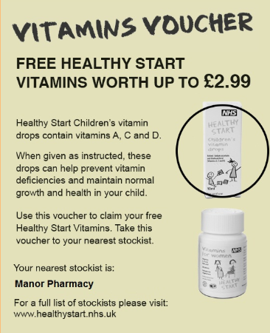

Vitamin Distribution in Doncaster

In Doncaster, Healthy Start has been expanded to enable all pregnant women and those women with babies up to one year of age to have access to free Healthy Start vitamins. These vitamins are distributed through Health Visitors and Midwives, whether they are eligible for Healthy Start or not.

The universal distribution of free vitamins is for women only, it does not include vitamins for children and babies. Children and babies only receive free vitamins if they are eligible for Healthy Start.
Healthy Start children’s vitamin drops
Children receiving Healthy Start vouchers qualify for free vitamin supplements from six months old until their fourth birthday. The daily dose of five drops contains:
- 233 micrograms of vitamin A
- 20 milligrams of vitamin C
- 7.5 micrograms of vitamin D3
Children who are having 500ml or more of formula a day do not need Healthy Start vitamins.
The vitamins are suitable for vegetarians and free from milk, egg, gluten, soya and peanut residues, and have a shelf life of 10 months from manufacture. They come in 10ml bottles, each of which contains just over 56 daily doses. Beneficiaries are entitled to one bottle every eight weeks.
Healthy Start women’s vitamin tablets
The daily dose is one tablet, which contains:
- 70 milligrams of vitamin C
- 10 micrograms of vitamin D
- 400 micrograms of folic acid.
They are suitable for vegetarians and free from wheat, fish, egg, salt. No colours, flavours or preservatives. No gluten containing ingredients. The shelf life is two years from manufacture.

8.2 Vitamin K

Vitamin K
All parents should be offered vitamin K prophylaxis for their babies to prevent the rare but serious and sometimes fatal disorder of vitamin K deficiency bleeding.
Vitamin K should be administered as a single dose of 1 mg intramuscularly as this is the most clinically and cost-effective method of administration.
If parents decline intramuscular vitamin K for their baby, oral vitamin K should be offered as a second-line option. Parents should be advised that oral vitamin K must be given according to the manufacturer's instructions for clinical efficacy and will require multiple doses

8.3 Food intolerance and food allergy

Terminology and definitions

Food intolerance
Food intolerance is the general term used to describe a range of adverse responses to food, including allergic reactions (e.g. peanut allergy or coeliac disease), adverse reactions resulting from enzyme deficiencies (e.g. lactose intolerance or hereditary fructose intolerance), pharmacological reactions (e.g. caffeine sensitivity) and other non-defined responses.

Food allergy
An allergic reaction to a food can be described as an inappropriate reaction by the body's immune system to the ingestion of a food that in the majority of individuals causes no adverse effects. Allergic reactions to foods vary in severity and can be potentially fatal.

Food aversion
A psychological avoidance caused by emotions associated with food. It can be sub divided into:

- Psychological avoidance
Avoidance of foods for psychological reasons

- Psychological intolerance
An unpleasant bodily reaction caused by emotions associated with food

A psychological intolerance or avoidance will not occur if a food is given in an unrecognisable form.

Food allergy

The Food Standards Agency estimates that around 10 people a year in the UK die from severe allergic reactions to food. In food allergy the immune system does not recognise as safe a protein component of the food to which the individual is sensitive (such as some peanut, milk and egg proteins). This component is termed the allergen. The immune system then typically produces immunoglobulin E (IgE) antibodies to the allergen, which trigger other cells to release substances that cause inflammation. Allergic reactions to food are usually localised to a particular part of the body and symptoms may include stomach upsets, rashes, eczema, itching of the skin or mouth, swelling of tissues (e.g. the lips or throat) or difficulty in breathing. A severe reaction may result in anaphylaxis (as with severe peanut allergy) in which there is a rapid fall in blood pressure and severe shock. Food allergy is relatively rare, affecting an estimated 1-2% of people in the UK. It is more common in children than adults especially those under the age of three, and is often wrongly used as a general term for adverse reactions to food.
There are two well-defined mechanisms via which allergic reactions to food (i.e. reactions that involve the immune system) can occur. Most cases of food allergy involve the production of antibodies known as immunoglobulin E (IgE) and are known as IgE-mediated allergies. Symptoms develop quickly and can vary in severity, but the severest form of this type of reaction is anaphylactic shock.
The other recognised mechanism is a delayed response (taking hours or even days to develop), which involves a different immune system component, T-lymphocytes (T cells). The best defined example of this type of reaction is the autoimmune disease, coeliac disease (sensitivity to the protein, gluten, found in wheat and to related proteins in other cereals such as barley and rye), but delayed reactions can also on occasion occur in response to a range of other foods, including milk and soya.
(BNF, 2018)

8.4 References
Start 4 Life (2018) Baby Vitamins.
https://www.nhs.uk/start4life/baby/baby-vitamins/

Healthy Start (2018) Vitamins
https://www.healthystart.nhs.uk/for-health-professionals/vitamins/

NICE (2015) Postnatal care up to 8 weeks after birth (Clinical guideline CG37)
https://www.nice.org.uk/guidance/cg37/chapter/1-recommendations

BNF (2018) What is Food allergy and intolerance? British Nutrition Foundation
https://www.nutrition.org.uk/nutritionscience/allergy/what-is-food-allergy-and-intolerance.html?start=1

SECTION 9

Healthy, Balanced, Nutritious Diet for Children Aged One to Five Years

9.1 What is a healthy, balanced, nutritious diet for children aged one to five years?

A healthy balanced diet for children aged one to five years is based on the four food groups listed below, which provide a range of essential nutrients that children need to grow and develop.
- Starchy foods
- Fruit and vegetables
- Meat, fish, eggs, beans and other non-dairy sources of protein
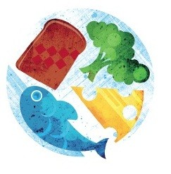
- Milk and dairy foods

British Nutrition Foundation (2014)

One of the basic principles of healthy eating is variety. Eating a wider range of different foods provides a better balance of nutrients. Planning meals and snacks to include a variety of food and drinks from these four food groups each day will provide children with the good balance of nutrients they need.

Bread, rice, potatoes, pasta and other starchy foods
Starchy foods, such as bread, breakfast cereals, potatoes, yams, rice, couscous, pasta and chapattis provide energy, nutrients and some fibre.
You can give your child wholegrain foods, such as wholemeal bread, pasta and brown rice. However, it's not a good idea to only give wholegrain starchy foods to under-twos.
Wholegrain foods can be high in fibre and may fill your child up before they have taken in the calories and nutrients they need. After age two you can gradually introduce more wholegrain foods.
(NHS Choices, 2016)

Fruit and vegetables
Fruit and vegetables contain lots of vitamins, minerals and fibre. It's good to introduce various different types from an early age, whether fresh, frozen, canned or dried, so your baby can enjoy new textures and flavours. Try to make sure fruit and vegetables are included in every meal.
Dried fruit, such as raisins, should be given to your toddler with meals rather than as a snack in between as the sugar they contain can cause tooth decay.
Different fruits and vegetables contain different vitamins and minerals. The more variety your toddler eats the better.
Don't worry if they'll only eat one or two types at first. Keep offering small amounts of other fruit and vegetables so they can learn to like different tastes.
Some children don't like cooked vegetables but will nibble on raw vegetables while you’re preparing a meal.
(NHS Choices, 2016)

Meat, fish, eggs, beans and other non-dairy sources of protein
Young children need protein and iron to grow and develop. Try to give your toddler one or two portions from this group each day.
Beans, pulses, fish, eggs, foods made from pulses (such as tofu, hummus and soya mince) and meat are excellent sources of protein and iron.
Nuts also contain protein but whole nuts, including peanuts, should not be given to children under the age of five in case they choke.
It's recommended that boys have no more than four portions of oily fish (such as mackerel, salmon and sardines) a week, and girls no more than two portions a week. This is because oily fish can contain low levels of pollutants that can build up in the body.
However, do not stop feeding your child oily fish as the health benefits are greater than the risks, as long as they don't eat more than the recommended amounts.
(NHS Choices, 2016)
Milk and dairy products

Breast milk is the only food or drink babies need in the first six months of their life. It is best to carry on breastfeeding alongside an increasingly varied diet once you introduce solid foods.
Infant formula is the only suitable alternative to breast milk in the first 12 months of your baby's life.
Whole cows' milk can be given as a main drink from the age of one.
Whole milk and full-fat dairy products are a good source of calcium, which helps your child to develop strong bones and teeth. They also contain vitamin A which helps the body resist infections and is needed for healthy skin and eyes.
Try to give your child at least 350ml (12oz) of milk a day or two servings of foods made from milk such as cheese, yoghurt or fromage frais.
Semi-skimmed milk can be introduced from the age of two, provided your child is a good eater and growing well for their age. Skimmed or 1% fat milk does not contain enough fat so is not recommended for children under five. However, you can use them in cooking from the age of one.
You can give your child unsweetened calcium-fortified milk alternatives, such as soya, almond and oat drinks, from the age of one as part of a healthy balanced diet. Toddlers and young children under the age of five should not have rice drinks because of the levels of arsenic they contain.
If your child has an allergy or intolerance to milk, talk to your health visitor or GP. They can advise you on suitable milk alternatives.

Foods and drinks high in fat, sugar (and/or salt)

Young children need fat in their diet to ensure they get enough energy. However, if they eat too much, they may consume more energy (calories) than they need and may gain excess weight. The type of fat children eat is also important and the amount of saturated fat, found in foods such as meat and meat products, butter, cakes and biscuits, should be limited. It is also important that children do not eat too much sugar and salt. Eating sugary food and drinks too often can lead to tooth decay and provide ‘empty calories’ which fill children up but do not provide other essential nutrients. Too much salt can give children a taste for salty foods. Eating a diet high in salt can cause serious health conditions in later life.
To establish good eating habits, make sure the food and drink you provide for children is not high in saturated fat, sugar and salt. Limiting or avoiding some foods, ingredients and cooking practices will help to ensure that an appropriate amount of fat, sugar and salt is provided for children and will also help encourage diversity in their diet.
Children are unlikely to take in more energy than they need if they are offered a range of healthy meals and snacks. Conversely, foods that are high in fat, sugar and salt are unlikely to provide the balance of energy and nutrients that young children need. Including them in the diets of very young children may contribute to them becoming overweight and having a poor nutrient intake.
A healthy, balanced diet and regular physical activity are essential for children’s health and well-being. Research confirms that healthy eating habits in the years before school are very important because they influence growth, development and academic achievement in later life.
A recent review of health inequalities by Marmot identifies the early years as a crucial time to intervene to reduce health inequalities across the life course. Quality of early years experiences can have a fundamental impact on all aspects of human development, physically, emotionally and intellectually. Encouraging breastfeeding and ensuring that children eat well in their early years are key to ensuring that they achieve their potential and help prevent them becoming overweight and obese. This approach also helps to reduce the risk of serious diseases such as heart disease, diabetes, stroke and cancers in later life.
Good nutrition is important for children aged under five to:
- ensure that they get the right amount of energy (calories) and nutrients needed while they are growing rapidly
- ensure that they do not consume too much energy (calories), which may lead to children becoming overweight or obese
- encourage them to eat a wide variety of foods and develop good dietary habits to take with them into later childhood and beyond.

9.2 What is the current health status of young children in England?

- Over a fifth of children are either overweight or obese by the time they join reception class in primary school.
- Type II diabetes, which usually appears in adulthood, is starting to be seen among some overweight children.
- Dental health is poor in many young children.
- Cases of rickets are appearing more frequently.
- More than one in four young children in the UK may be at risk of iron deficiency, which is linked to slower intellectual development and poor behaviour in the longer term.
- In recent years, changes in children’s diets have affected their nutrient intakes with some children eating foods that are low in energy, iron, zinc and vitamin A but high in saturated fat, sugar and salt.
- In addition, many young children also eat fewer than the recommended five portions of fruit and vegetables each day.
(Childrens Food Trust, 2012)

9.3 Salt

Babies and children only need a very small amount of salt in their diet. However, because salt is added to a lot of the food you buy such as bread, baked beans, and even biscuits, it is easy to have too much.
The maximum recommended amount of salt for babies and children is:
- up to 12 months – less than 1g of salt a day (less than 0.4g sodium)
- 1 to 3 years – 2g of salt a day (0.8g sodium)
- 4 to 6 years – 3g of salt a day (1.2g sodium)
- 7 to 10 years – 5g of salt a day (2g sodium)
- 11 years and over – 6g of salt a day (2.4g sodium)

Babies who are breastfed get the right amount of salt through breast milk. Infant formula contains a similar amount of salt to breast milk.
When you start introducing solid foods, remember not to add salt to the foods you give to your baby because their kidneys cannot cope with it. You should also avoid giving your baby ready-made foods that are not made specifically for babies such as breakfast cereals, because they can also be high in salt.
Lots of foods produced for children can be quite high in salt, so it's important to check the nutritional information before you buy. The salt content is usually given as figures for sodium.
As a rough guide, food containing more than 0.6g of sodium per 100g is considered to be high in salt. You can work out the amount of salt in foods by multiplying the amount of sodium by 2.5. For example, 1g of sodium per 100g is the same as 2.5g salt per 100g.
You can reduce the amount of salt your child has by avoiding salty snacks such as crisps and biscuits and swapping them for low-salt snacks instead. Try healthy options such as dried fruit, raw vegetable sticks and chopped fruit to keep things varied.
By making sure your child doesn’t eat too much salt, you are also helping to ensure that they do not develop a taste for salty food, which in turn, will make them less likely to eat too much salt as an adult.
(NHS Choices, 2015)

9.4 Suitable snacks

Children need to eat regularly and need nutritious snacks between meals. The best snacks are those which are low in added sugar. A variety of snacks should be offered including fruit, vegetables, milk, yoghurt, any type of bread and sandwiches with savoury fillings.
- Pitta bread 25g, Houmous 30g, Cucumber 20g and Carrot sticks 20g.
Milk 100ml
- Spicy potato wedges 65g, Mozzarella balls 20g and Orange wedges 40g.
Milk 100ml
- Mixed platter: Yellow pepper 20g, Cherry tomato 20g and Grapes 40g.
Milk 100ml
- Popcorn 10g and Pears 40g. Milk 100ml
For more information on suitable snacks refer to link below
https://www.cwt.org.uk/wp-content/uploads/2015/02/CHEW-1-4YearsPracticalGuide3rd-Edition.pdf

9.5 Healthy Start

Healthy Start is a UK wide government scheme to improve the nutrition of low income pregnant women, mothers and children. Women who are at least 10 weeks pregnant and families with children under 4 years old qualify for the scheme if they are in receipt of certain benefits (means tested). Healthy Start provides eligible families free vouchers every week to spend on milk, fresh and frozen fruit and vegetables, infant formula and vitamins.
- Pregnant women get one voucher a week worth £3.10
- Mothers and their babies under one year of age get two vouchers a week worth a total of £6.20
Children over one and under four get one voucher a week worth £3.10
The vouchers can be spent on:
- Plain cow’s milk – whole, semi-skimmed or skimmed. It can be pasteurised, sterilised, long life or UHT.
- Plain fresh or frozen fruit and veg (fruit and vegetables with no added ingredients), whole or chopped, packaged or loose.
- Infant formula milk that says it can be used from birth and is based on cow’s milk.

Healthy Start vitamins

Women and children getting Healthy Start food vouchers also get vitamin coupons to swap for free Healthy Start vitamins. Healthy Start vitamins are specifically designed for pregnant and breastfeeding women, and growing children.
Health professionals can advise families where they will be able to swap their vouchers for vitamins in their local area.
https://www.healthystart.nhs.uk/

About Healthy Start Vitamins

Healthy Start vitamins contain vitamins A, C and D for children aged from six months to four years, and folic acid and vitamins C and D for pregnant and breastfeeding women.
Healthy Start vitamins are important because:
- 8% of children under five in the UK do not have enough vitamin A in their diet¹
- families in lower-income groups tend to have less vitamin C in their diet¹
- All pregnant and breastfeeding women and young children are at risk of vitamin D deficiency² (teenagers, younger women and those from ethnic minorities are particularly at risk).

Two bespoke Healthy Start branded products are available:
- Healthy Start children’s vitamin drops (containing vitamins A, C and D)
- Healthy Start vitamins for women (containing folic acid and vitamins C and D)
Every eight weeks beneficiaries are sent a green vitamin voucher, which they can swap for either Healthy Start women’s vitamin tablets or Healthy Start children’s drops locally.
Healthcare professionals should discuss the importance of vitamin supplements with beneficiaries and advise them where they can swap their green vitamin coupons locally.

Healthy Start children’s vitamin drops
Children receiving Healthy Start vouchers qualify for free vitamin supplements from six months old until their fourth birthday. The daily dose of five drops contains:
- 233 micrograms of vitamin A
- 20 milligrams of vitamin C
- 7.5 micrograms of vitamin D3

Children who are having 500ml or more of formula a day do not need Healthy Start vitamins.

The vitamins are suitable for vegetarians and free from milk, egg, gluten, soya and peanut residues, and have a shelf life of 10 months from manufacture. They come in 10ml bottles, each of which contains just over 56 daily doses. Beneficiaries are entitled to one bottle every eight weeks.

Healthy Start women’s vitamin tablets
The daily dose is one tablet, which contains:
- 70 milligrams of vitamin C
- 10 micrograms of vitamin D
- 400 micrograms of folic acid

They are suitable for vegetarians and free from wheat, fish, egg and salt. No colours, flavours or preservatives. No gluten containing ingredients.
The shelf life is two years from manufacture. Beneficiaries are entitled to one bottle of 56 tablets every eight weeks.
¹Scientific Advisory Committee on Nutrition (2008) The Nutritional Wellbeing of the British Population. London: TSO.
²Scientific Advisory Committee on Nutrition (2007) Update on Vitamin D. London: TSO.
(Healthy Start, 2014)
Vitamin Distribution in Doncaster

In Doncaster, Healthy Start has been expanded to enable all pregnant women and those women with babies up to one year of age to have access to free Healthy Start vitamins. These vitamins are distributed through Health Visitors and Midwives, whether they are eligible for Healthy Start or not.

The universal distribution of free vitamins is for women only, it does not include children and babies. Children and babies only receive free vitamins if they are eligible for Healthy Start.

9.6 Physical activity

Physical activity is the best way to help children maintain a healthy weight.
Children learn from example so encourage the whole family to do physical activities together e.g. swimming, walking, playing football in the park.

Recommendations
It is recommended that children (aged less than 5 years) who are able to walk should participate in physical activity for 180 minutes (3 hours) per day. This can be made up from a variety of activities across the day, including organised sport, energetic play, skipping, walking or cycling to school, physical education or planned exercise. Most children already do 120 minutes a day. Sedentary behaviour such as screen-time (e.g. TV watching/ video games), sat in a pushchair or car seat should be limited. (CMO, 2011)
Children (aged under 5 years) who are not yet able to walk should be regularly active by doing activities such as floor play, tummy time, safe water activities and sedentary behaviour such as being in a car seat should be reduced. (CMO, 2011)
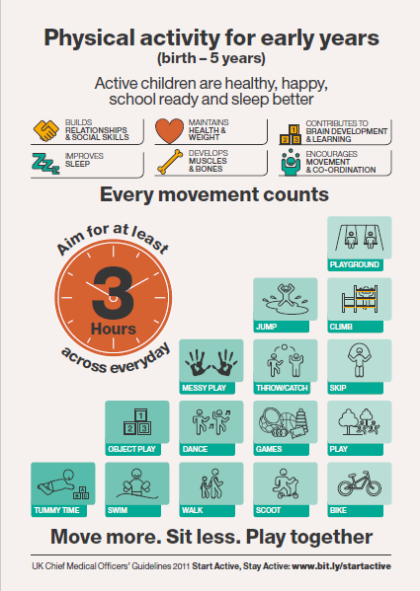

(CMO, 2011)

9.7 Diet related problems

Dental Caries
Tooth decay is the destruction of the hard tissues of the tooth by acids produced in the mouth when bacteria in dental plaque metabolises dietary sugars. Repeated and prolonged acid attacks will eventually cause the tooth surface to weaken and a hole or cavity will form which may lead to pain and infection.
The risk of tooth decay increases as a child’s diet starts to include foods and drinks other than breast milk or formula, depending on the free sugar content.
Every child who has teeth is at risk of tooth decay, but the risk increases for those living in the more deprived areas where the imbalance in income, education, employment and neighbourhood circumstances affect the life chances of children’s development.
Children are more at risk of developing tooth decay if they are:
- eating a poor diet
- brushing their teeth less than twice per day with fluoride toothpaste
- from deprived backgrounds
(Health Matters: Child Dental Health, PHE, June 2017)

Iron deficiency anaemia (IDA)
Iron deficiency occurs when the body's iron demand is not met by iron absorption from the diet [Killip et al, 2007].
Iron deficiency anaemia occurs in the more severe stages of iron deficiency when the body is iron deficient to the degree that red blood cell production is reduced [WHO et al, 2001; Pavord et al, 2012].
The World Health Organization defines anaemia as [WHO et al, 2001]:
- In men over 15 years of age: haemoglobin (Hb) below 13g/100mL.
- In non-pregnant women over 15 years of age: Hb below 12g/100mL.
- In children of 12–14 years of age: Hb below 12g/100mL.
- In pregnant women: Hb below 11g/100mL throughout pregnancy.

A UK guideline on the management of iron deficiency in pregnancy states that an Hb level of 11g/100mL or more appears adequate in the first trimester, and a level of 10.5g/100mL appears adequate in the second and third trimesters [Pavord et al, 2012].
However, there is variability between the criteria for iron deficiency anaemia amongst different studies and the normal range for Hb differs between different populations in the UK, so it seems reasonable to use the lower limit of the local laboratory normal range to define anaemia [Goddard et al, 2011].
(Anaemia - Iron Deficiency, NICE, Clinical Knowledge Summary, 2013)

Prevention/Treatment of iron deficiency anaemia

The most common treatment is a course of iron tablets or liquid to be taken by mouth. Although iron is best absorbed on an empty stomach, taking it this way commonly causes a feeling of sickness. This can be prevented by taking it with some food and vitamin C (for example in orange juice) which increases the absorption. Iron absorption is reduced by milk, tea, coffee and certain medicines, so these should not be taken at the same time. Children taking iron supplements will have black stools. There are ways to increase the amount of iron in the diet as well as medication. Foods rich in iron include:
- Meat
- Beans and lentils
- Eggs
- Fish
- Apricots, prunes and raisins
- Leafy green vegetables
- Oatmeal
- Tuna
- Fortified breakfast cereal

If you have any questions about how to improve your child’s iron intake, you could ask for a referral to a dietician either in your local community or at your local hospital.
(http://www.gosh.nhs.uk/medical-information/anaemia)
Obesity

Today nearly a third of children aged 2 to 15 are overweight or obese and younger generations are becoming obese at earlier ages and staying obese for longer. Reducing obesity levels will save lives as obesity doubles the risk of dying prematurely. Obese adults are seven times more likely to become a type 2 diabetic than adults of a healthy weight and it may cause blindness or limb amputation. Not only are obese people more likely to get physical health conditions such as heart disease, they are also more likely to be living with conditions like depression.
The economic costs are great too. We spend more each year on the treatment of obesity and diabetes than we do on the police, fire service and judicial system, combined. It was estimated that the NHS in England spent £5.1 billion on overweight and obesity-related ill-health in 2014/15.
The burden is falling hardest on those children from low-income backgrounds. Obesity rates are highest amongst children from the most deprived areas and this is getting worse. Children aged 5 and from the poorest income groups are twice as likely to be obese compared to their most well off counterparts, by age 11, they are three times as likely.
The Childhood obesity plan for action outlines the following:
- Introducing a soft drinks industry levy
- Taking out 20% of sugar in products
- Supporting innovation to help businesses to make their products healthier
- Developing a new framework by updating the nutrient profile model
- Making healthy options available in the public sector
- Continuing to provide support with the cost of healthy food for those who need it most
- Helping all children to enjoy an hour of physical activity every day
- Improving the co-ordination of quality sport and physical activity programmes in schools
- Creating a new healthy rating scheme for primary schools
- Making school food healthier
- Clearer food labelling
- Supporting early years settings
- Harnessing the best new technology
- Enabling health professionals to support families

For further information on the Childhood Obesity: A Plan for Action, 2017
https://www.gov.uk/government/publications/childhood-obesity-a-plan-for-action/childhood-obesity-a-plan-for-action

Recognising overweight and obesity

Body Mass Index (BMI) is recommended for use as a practical way to measure adiposity. However, this should be amended for their correct age and gender and therefore the UK BMI charts (Department of Health (DoH), 2013) should be used to plot their BMI and look for trends over time. Tailored interventions should be considered for any child who is on or above the 91st centile with co-morbidities assessed if they reach the 98th centile. Waist circumference should not be measured routinely but may wish to be used to demonstrate the increased risk of co-morbidities. (NICE, 2014)

Poor eating / food refusal

First Steps Nutrition Trust, have a page on their website which is dedicated to good sources of information for support with fussy eating habits.
http://www.firststepsnutrition.org/pdfs/Sources_of_information_on_fussy_eating_2.pdf

Diarrhoea and Vomiting in babies and children

Diarrhoea and vomiting is common in young children. Also known as a stomach or tummy bug, it is usually caused by an infection.
Most babies and toddlers who have diarrhoea and vomiting do not need treatment and can be safely looked after at home.
However, it's important to look out for signs of dehydration. Babies and toddlers can become dehydrated more quickly than older children when they have diarrhoea and vomiting. If dehydration becomes severe it can be dangerous, particularly in young babies.
It's also important to be careful with hygiene while your child is ill to stop diarrhoea and vomiting spreading.

Looking after a baby or toddler with diarrhoea and vomiting

- Carry on offering babies their usual milk feeds. Bottle fed babies can also have drinks of water between feeds. Keep giving them formula at the usual strength – never water it down.
- Toddlers over one can have other drinks such as full-fat cows' milk, but avoid fruit juice and fizzy drinks as these can make diarrhoea worse.
- If your child is having solid foods, offer them food as normal if they seem to want it.
- If you wish, you can give your baby Oral Rehydration Salt (ORS) solution to help prevent dehydration. This is available from your pharmacist.
If you are worried about your child, you can speak to your GP, health visitor or pharmacist, or call NHS 111 for advice.

When to get medical advice

Vomiting usually lasts for 1-2 days, whilst diarrhoea lasts for about 5-7 days. If your child's symptoms last longer than this or if they are showing signs of dehydration speak to your GP.

Signs of dehydration in a baby or toddler

Your child may be dehydrated if they have:
- sunken eyes
- in young babies, a sunken soft spot (fontanelle) on their head
- few or no tears when they cry
- a dry mouth
- fewer wet nappies
- dark yellow urine
(NHS Choices, 2016)
https://www.nhs.uk/conditions/pregnancy-and-baby/pages/diarrhoea-vomiting-children.aspx#signs

Constipation

A child may be constipated because they:
- are not eating enough high-fibre foods like fruit and veg
- are not drinking enough
- are having problems with potty (or toilet) training
- are worried or anxious about something, such as moving house, starting nursery or the arrival of a new baby

How to prevent constipation

Make sure your child has plenty to drink. Offer breastfed babies, who are not yet eating solids, plenty of breastfeeds. Formula-fed babies can have extra drinks of water between their formula feeds.
Give your child a variety of foods, including plenty of fruit and vegetables which are a good source of fibre.
Encourage your child to be physically active. For more information, read the physical activity guidelines for children aged under five years.
Get your child into a routine of regularly sitting on the potty or toilet after meals or before bed, and praise them whether or not they poo. This is particularly important for potty-trained boys who may forget about pooing once they are weeing standing up.
Make sure your child can rest their feet flat on the floor or a step when they're using the potty or toilet, to get them in a good position for pooing. ERIC, The Children's Bowel & Bladder Charity's leaflet, Children’s Bowel Problems (PDF, 2.48Mb) shows this position. https://www.eric.org.uk/guides-to-childrens-bowel-and-bladder-problems
Ask if they feel worried about using the potty or toilet – some children don't want to poo in certain situations, such as at nursery or school.
Stay calm and reassuring, so that your child does not see going to the toilet as a stressful situation – you want your child to see pooing as a normal part of life, not something to be ashamed of.
If you would like advice about taking the stress out of going to the toilet for your child, speak to your health visitor.
(NHS Choices, Constipation in young children, 2017)

9.8 References

British Nutrition Foundation (2014) Nutrition for Toddlers
https://www.nutrition.org.uk/healthyliving/toddlers.html

Caroline Walker Trust (2014) Eating Well for 1-4 years olds. A practical Guide
https://www.cwt.org.uk/wp-content/uploads/2015/02/CHEW-1-4YearsPracticalGuide3rd-Edition.pdf

Chief Medical Officers (2011) Start Active, Stay Active: A Report on Physical Activity for Health from the Four Home Counties. DoH. https://www.gov.uk/government/uploads/system/uploads/attachment_data/file/216370/dh_128210.pdf

Children’s Food Trust (2012) Eat Better Start Better, Voluntary Food and Drink Guidelines for Early Years Settings in England – A Practical Guide
http://media.childrensfoodtrust.org.uk/2015/06/CFT_Early_Years_Guide_Interactive_Sept-12.pdf

DOH (2017) Childhood Obesity a plan for action
https://www.gov.uk/government/publications/childhood-obesity-a-plan-for-action/childhood-obesity-a-plan-for-action

ERIC (No date), The Children's Bowel & Bladder Charity's leaflet, Children’s Bowel Problems (PDF, 2.48Mb). https://www.eric.org.uk/guides-to-childrens-bowel-and-bladder-problems
First Steps Nutrition (No date) Good sources of information and support on fussy eating
http://www.firststepsnutrition.org/pdfs/Sources_of_information_on_fussy_eating_2.pdf
Great Ormond Street Hospital (2016) Anaemia
http://www.gosh.nhs.uk/medical-information/anaemia

NHS, Healthy Start, https://www.healthystart.nhs.uk/

NHS Choices (2017) Constipation in young children https://www.nhs.uk/Conditions/pregnancy-and-baby/pages/constipation-and-soiling.aspx

NHS Choices (2016) Diarrhoea and vomiting in babies and children
https://www.nhs.uk/conditions/pregnancy-and-baby/pages/diarrhoea-vomiting-children.aspx#signs

NHS Choices (2015) Salt, https://www.nhs.uk/livewell/goodfood/pages/salt.aspx

NHS Choices (2016) What to feed young children
https://www.nhs.uk/Conditions/pregnancy-and-baby/Pages/understanding-food-groups.aspx

NICE (2014) Obesity: Identification, Assessment and Management of Overweight and Obesity in Children, Young People and Adults. NICE.

NICE (2013) Anaemia - Iron Deficiency, Clinical Knowledge Summary.
https://cks.nice.org.uk/anaemia-iron-deficiency

PHE (2017) Health Matters: Child Dental Health https://www.gov.uk/government/publications/health-matters-child-dental-health/health-matters-child-dental-health

SECTION 10

Oral Health

10.1 Introduction

Tooth decay remains a significant public health problem. 31% of Doncaster’s 5-year-old school children experience tooth decay (PHE, 2015), which is higher than the average for England (25%). The severity and burden of tooth decay on children is much greater in children living in deprived areas. Tooth decay impacts on children’s lives through pain, difficulty eating and sleeping, and has wider impacts on the family and school. Lots of children have teeth extracted due to tooth decay in Doncaster. Nationally, every 10 minutes a child has to have a decayed tooth extracted in hospital (PHE, 2018). This can be distressing for the child and carers, and lead to future anxiety about dental treatment.

Health Child Programmes are designed to improve the health of children, including their dental health. The commissioning guide for the 0-19 healthy Child Programme (PHE, 2018) advocates talking about dental health at the 5 health visitor mandated reviews: antenatal; new baby; 6-8 weeks; 12 months; and 2-2.5 year.

10.2 Teething

- Teething generally starts from the age of 6 months. Children will have all of their baby teeth (milk or primary teeth) by the time they are 3 years old, and should have 20 teeth. The front 8 teeth (incisors) arrive first, followed by the first molars (first double teeth), canines (pointy teeth), and finally the second molars (very back teeth) at 2.5-3 years.
- Signs of teething may include: dribbling more than usual; difficulty sleeping; chewing or biting hard surfaces; flushed cheeks and restlessness. These signs are also common in babies and young children due to illness, and parents may dismiss these signs as teething without seeking medical advice.
- Advice to give parents about teething:
  - Give the baby something to chew on, like a teething ring, although this only provides short term relief. Avoid giving rusks as they are high in sugar.
  - Teething gels can help numb the pain, although again they only provide short term relief. Parents should check with a pharmacist to make sure it is suitable for a child.
  - Sugar-free paracetamol or ibuprofen can help if a baby is in pain or has a raised temperature.

10.3 Tooth decay

- Tooth decay is caused when bacteria in the mouth feed on sugars from food and drink. The acid the bacteria produce causes damage to teeth leading to decay.
- Tooth decay may be prevented by: reducing the amount and frequency of eating/drinking sugary foods; brushing teeth with a fluoride toothpaste; and having fluoride varnish applied.
- Fluoride toothpaste and fluoride varnish help to strengthen teeth and prevent tooth decay.

10.4 The importance of baby teeth

- Parents should be made aware of the importance of looking after baby teeth (milk teeth/primary teeth) until they fall out (exfoliate) naturally. We know that tooth decay in baby teeth impacts on the lives of children and their families.
- Diet and tooth brushing behaviours learnt as a child are often maintained right into adulthood, so encourage parents to give their children the best start in life by having healthy baby teeth as well as healthy adult (permanent) teeth.
- By the time a child has all their baby teeth, the adult teeth are already forming in the jaw. If a baby tooth is lost too early because it has had to be extracted due to tooth decay, then the baby teeth on each side of the gap will start to move together, thus closing the space. This means that when the adult tooth is ready to come through, there will not be enough room for it to move into its correct position; this could result in teeth looking crooked.

10.5 Brushing children’s teeth

The following outlines simple steps parents, carers and children can take every day to protect and improve their oral health. The evidence based advice is from Delivering Better Oral Health (PHE, 2017).
- Start brushing as soon as the first tooth appears (usually at about 6 months of age), at least twice a day with fluoride toothpaste last thing at night and on at least one other occasion
- Brushing at bedtime is important as it makes sure that the fluoride continues to protect the teeth while the child is asleep
- Parents/carers should brush or help their child to brush their teeth until they are at least seven years old to make sure the teeth are cleaned properly, to supervise the amount of toothpaste used and to prevent licking or eating the toothpaste
- Brush the child’s teeth thoroughly, cleaning all surfaces of the teeth
- For older children disclosing tablets can help to show if any plaque is left on the teeth
- Choose a toothbrush with a small head and medium-textured bristles, a manual or electric toothbrush can be used
- For the maximum prevention of tooth decay for children aged 0-6 years use toothpastes containing 1350-1500 parts per million (ppm) fluoride. Many supermarket ‘own-brand’ ‘family’ toothpastes are suitable.
- The amount of fluoride that is in the toothpaste can be found on the side of the tube or on the packaging
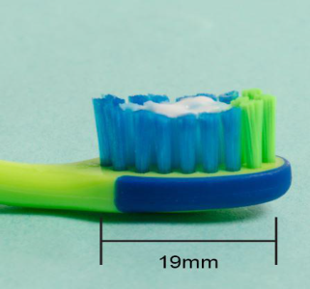
- For children under 3 years of age use a smear of toothpaste containing no less than 1000 ppm fluoride

Smear for 0-3 year olds

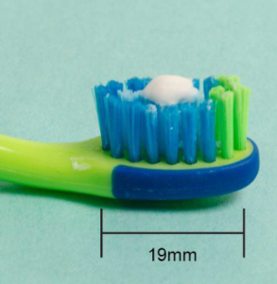
- Children between three and six years old should use a pea-sized amount of toothpaste containing more than 1000ppm fluoride

Pea-sized blob for 3-6 year olds

- Encourage the child to spit out the toothpaste after brushing and do not let them rinse out with water as this will wash away the fluoride and reduces how well it works - spit don’t rinse
- For children who may have difficulties brushing their teeth such as those with special needs, toothbrush adaptations and non-foaming and non-flavoured fluoride toothpaste is available.
- Babies brushing advice
  - find a place that is comfortable and safe
  - never leave a baby or small child alone with a toothbrush or toothpaste
  - toothbrushing could be done with the child: on the parent/carer’s knee; on a changing mat; in a baby chair/high chair; sitting in a buggy/pram; in the bath.
- Toddlers brushing advice:
  - develop a system of brushing that ensures all the surfaces are brushed every time.
  - they may go through phases of not wanting their parents/carers to brush their teeth. While this can be difficult for parents/carers, it is important to continue brushing the child’s teeth as they cannot brush their own teeth properly.
  - Sometimes it can help to sit the child on your lap or stand behind them and cradle the child’s head while brushing their teeth.
- Preschoolers brushing advice
  - They should be encouraged to do some of the brushing themselves so they start learning brushing skills. However, parent/carers will also need to help and supervise with brushing up to age 7 years.
- Health visitors in Doncaster are provided with dental packs to give out to all children at a First Friends group or at their 12 month review. The packs contain an age-appropriate toothbrush, a tube of fluoride toothpaste and an information leaflet. When these packs are given out, it is a useful opportunity to discuss dental health and signpost families to dental services.
- Many schools and nurseries run toothbrushing clubs, to promote brushing. Information on setting up a toothbrushing club is available from Public Health (Doncaster Council) publichealthenquiries@doncaster.gov.uk

10.6 Healthy eating advice

Each time we eat sugary food and drink, the bacteria in dental plaque produce acid that attacks teeth. If we eat or drink sugary foods frequently throughout the day we have more ‘acid attacks’, which can lead to tooth decay.

For babies
- Breast milk is the only food or drink babies need for around the first six months of their life. First formula milk is the only suitable alternative to breast milk.
- Not being breastfed is associated with an increased risk if infectious morbidity (e.g. gastroenteritis, respiratory infections, middle ear infections).
- Current evidence suggests that breastfeeding up to 12 months of age is associated with a decreased risk of tooth decay.
- The UK government recommends exclusive breastfeeding for around the first 6 months of life.
- Complementary foods should be introduced into the infant’s diet from around 6 months of age alongside continued breastfeeding (or infant formula).
- From the age of six months, bottle-fed babies should be introduced to drinking from a free-flow cup. A free-flow cup is a beaker without a valve in the spout, which means the child can drink without having to suck like they would with a teat. Bottle feeding should be discouraged from 12 months old.
- Only breast or formula milk or cooled, boiled water should be given in bottles.
- Only milk or water should be drunk between meals and avoid adding sugar to foods or drinks for babies.
- Parents should be warned about the dangers of putting fruit juice or sweetened drinks into feeding bottles or beakers for the child to sip regularly or use as a comforter, especially at bedtime. Such practices result in almost continuous bathing of the teeth with sugars, and can lead to severe tooth decay. Free-flow cups (beakers) are preferable to bottles and valved cups (beakers) as bottles and valved cups can concentrate the sugary drink even more around the teeth.
- Dummies should never be dipped into sugary liquid, including honey, and never be used as a permanent replacement for comfort, attention or feeding. Long term routine use of a dummy should be avoided as this can lead to speech development problems, and affect the positioning of teeth.

For all children
- SACN (2015) recommends that for all age groups from 2 years upwards the average intake of free sugars should not exceed 5% of total dietary energy intake. Younger children should have even less.
- Recommended maximum daily intake of free sugars is no more than:

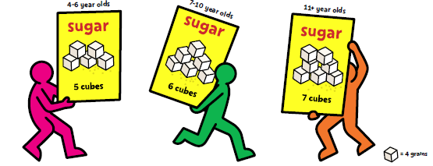
Source: https://www.nhs.uk/change4life/food-facts/sugar

- Reduce the amount and frequency of having foods and drinks that contain sugar, only give sweet foods including dried fruit at mealtimes. Sugars are found in lots of food parents provide for children e.g. cakes, breakfast cereals, biscuits, jams, ketchup, baked beans, yoghurt.
- Milk and water are the best drinks for teeth. Squashes sweetened with sugar, fizzy drinks, soft drinks and juice drinks have no place in a child’s daily diet
-  Limit the amount of fruit juice and/or smoothies a child drinks to a maximum of 150 mls (one portion) in total per day and drink it with meals to reduce the risk of tooth decay
- Avoid sugar-containing foods and drinks at bedtime
- Get into the habit of reading the ingredients on food packaging to see what foods contain sugar. There is also advice and a free Change4Life food scanner app available at: www.nhs.uk/change4life-beta/campaigns/sugar-smart/home
- Snacks which are less likely to harm children’s teeth include: cheese, fresh fruit and vegetables.
- Always ask for sugar-free medicines e.g. paracetomol and ibuprofen.

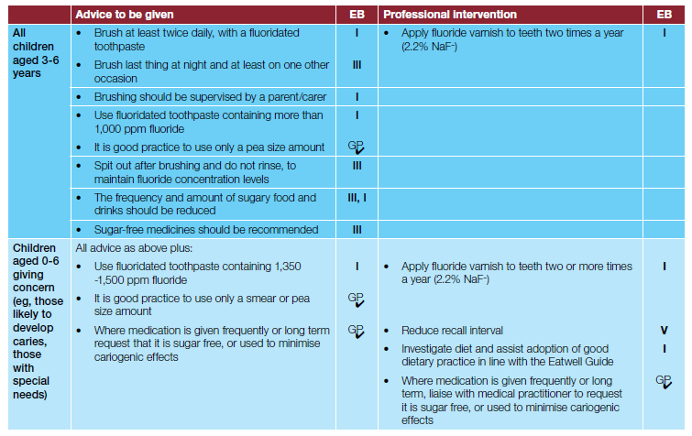
Information tables taken from PHE’s Delivering better oral health: an evidence-based toolkit for prevention (PHE, 2017)
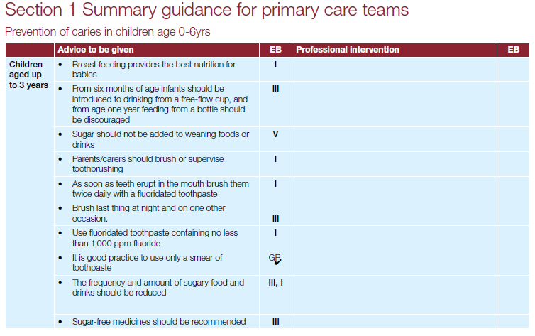
(PHE, 2017)

10.7 Dental care

Routine care
- Children should see the dentist as soon as their baby teeth start to appear, and visit regularly, as often as the dentist recommends.
- Taking children to the dentist along with the rest of the family from an early age, helps them to get used to the dental practice environment and gives the dentist the opportunity to deliver and reinforce preventive advice and raise awareness of good oral health.
- Children (under 18 years) require a routine dental appointment at least once every 12 months, and adults (18 years and over) at least once every 2 years, with increased frequency for those with current dental disease or at higher risk of poor oral health (NICE, 2004).
- All children over 3 years should have fluoride varnish applied to their teeth to strengthen teeth and prevent tooth decay. If younger children are at particular risk of tooth decay the dentist may apply it to their teeth. It is a gel which is painted onto the teeth. It only takes a few minutes to apply and is well-tolerated by children.
- NHS dental treatment is free for children under 18 or under 19 and in qualifying full-time education
- Women are entitled to free NHS dental treatment during pregnancy and any treatment commenced before their child’s first birthday
- The red health visitor book contains a section for the dentist to record that the child has visited the dentist.

- To find a regular NHS dentist near to where someone is living, visit NHS Choices:
https://www.nhs.uk/Service-Search/Dentist/LocationSearch/3

- Dental neglect is often part of a larger picture of general neglect and as such the need for information sharing and a multi-agency approach is vital. A dentist may be able to provide a valuable contribution to the overall assessment of a vulnerable child so, if you are assessing a child’s welfare, don’t forget to ask!

Community dental service
- The community dental service provides dental care for children and adults with special needs who cannot be treated in a general dental practice.

It is based at the Flying Scotsman Centre, 2nd Floor, Sepulchre Gate West, Doncaster, DN1 3AP. Tel: 01302 563163

Urgent care
- People who require urgent care are those requiring attention within 24 hours for:
  - severe dental and facial pain not controlled by over-the-counter preparations
  - dental and soft tissue acute infection/swelling (which is not rapidly increasing around the throat or eye)

- If urgent treatment is needed, people should contact their usual dental practice in the first instance to arrange to be seen there. However, if their dental practice is closed or if the person has no dentist, they should telephone NHS 111 for advice.

Emergency care
- People who require emergency care are those requiring immediate attention in an accident and emergency department in order to minimise the risk of serious medical complications or prevent long-term dental complications.
- Their condition means they are most likely to present with:
  - Uncontrollable dental haemorrhage (bleeding) following extractions
  - Rapidly increasing swelling around the throat or eye
  - Trauma confined to the dental arches

10.8 Useful resources and links

Delivering better oral health: an evidence-based toolkit for prevention
(updated 2017) this is an evidence based toolkit to support dental teams in
improving their patient’s oral and general health https://www.gov.uk/government/uploads/system/uploads/attachment_data/file/605266/Delivering_bette r_oral_health.pdf https://www.gov.uk/government/publications/delivering-better-oral-health-an-evidence-based-toolkit-for-prevention

Infographic for health visitors, school nurses and practice nurses
with key information to provide at mandated assessments across the
life-course:
https://vivbennett.blog.gov.uk/wp-content/uploads/sites/90/2016/11/Improving-oral-health-for-children.pdf

For further information about how to look after your child’s teeth, visit:
www.nhs.uk/Conditions/pregnancy-and-baby/Pages/looking-after-your-infants-teeth.aspx

To find out how much total sugar is in your food and drink, and for information on downloading a free food scanner app
www.nhs.uk/change4life-beta/campaigns/sugar-smart/home

To find an NHS dentist visit NHS Choices
www.nhs.uk/NHSEngland/AboutNHSservices/dentists/Pages/find-an-NHS-dentist.aspx

The community dental services is based at the Flying Scotsman Centre, 2nd Floor, Sepulchre Gate West, Doncaster, DN1 3AP. Tel: 01302 563163

An e-learning resource aimed at the early years workforce including health visitors, nurses and the child health team is available as an update of the oral health promotion module of the RCPCH Healthy Child Programme (HCP) on Health Education England’s e-learning for Healthcare:
http://www.e-lfh.org.uk/programmes/healthy-school-child/.
For public health staff groups outside the NHS the Dental Health session is available on The Healthy Child Programme Open Access webpage:
http://www.e-lfh.org.uk/programmes/healthy-child-programme/sample-sessions/.
It is the third session in the list. Scroll down to the bottom to find it.

Example menus and useful guidance for early years settings to help meet the Early Years Foundation Stage requirements for food and drink. These menus are an important tool to help early years professionals plan healthy meals. https://www.gov.uk/government/publications/example-menus-for-early-years-settings-in-england

All Our Health – children’s oral health
Evidence and guidance to help healthcare professionals improve child oral health.
https://www.gov.uk/government/publications/child-oral-health-applying-all-our-health/child-oral-health-applying-all-our-health

Health Matters: child dental health (June 2017)
This resource outlines how health professionals can help prevent tooth decay in children under 5 as part of ensuring every child has the best start in life.
https://www.gov.uk/government/publications/health-matters-child-dental-health/health-matters-child-dental-health

SECTION 11

Other Information

OTHER INFORMATION

11.1 The International Code of Marketing of Breastmilk Substitutes (the Code)

What is the Code?
The International Code of Marketing of Breastmilk Substitutes (the Code) is an international health policy framework to regulate the marketing of breastmilk substitutes in order to protect breastfeeding. It was published by the World Health Organisation in 1981, and is an internationally agreed voluntary code of practice.

It was written in response to the marketing activities of the infant feeding industry which were promoting formula feeding over breastfeeding, which in turn was leading to dramatic increases in maternal and infant morbidity and mortality.

The underlying basis for the Code is the belief that the health of babies is so important that the usual rules governing market competition and advertising should not apply to products intended for feeding babies. Therefore, all Governments should legislate to prevent commercial interests from damaging breastfeeding rates and the health of their population.

What does the Code do?
The Code regulates the marketing of breastmilk substitutes which includes infant formulas, follow-on formulas and any other food or drink, together with feeding bottles and teats, intended for babies and young children.

The Code also sets standards for the labelling and quality of products and for how the law should be implemented and monitored within countries.

Restricting marketing does not mean that the products cannot be sold, or that factual and scientific information about them cannot be made available. Neither does it restrict parent’s choice. It simply aims to make sure that their choices are made based on full, impartial information, rather than misleading, inaccurate or biased marketing claims.

Does the UK have legislation that reflects the Code?
The UK‘s legislation, named “The Infant Formula and Follow On Formula Regulations” – incorporates some but not all of the Code into law. These regulations only cover infant formula intended for babies under six months old; they do not cover any food, and do not cover the numerous products for babies older than six months. This loophole allows widespread advertising on television, in print media, online and via billboards. By using similar branding for all their products companies can in effect advertise all their products while still staying within the UK law. In addition, the monitoring and enforcement of the UK legislation is very weak which means that companies are rarely prosecuted for breaking the law.

Why does it matter?
Advertising influences our behaviour. The formula milk industry spends millions of pounds every year on advertising and marketing its products, encouraging mothers not to breastfeed or to stop breastfeeding early, and to use an array of different, expensive formula milks, as soon as possible and for as long as possible. In addition, parents are then urged to use costly, processed baby food, often before six months of age, the recommended age for starting solids. There is no evidence that more expensive formula milks or baby foods are beneficial to a baby’s health. Most of these are unnecessary, and can be harmful. Where these products differ from most others is that such advertising can damage the short and long-term health of our children by undermining breastfeeding and misleading parents who bottle feed about what milk to use.

What does this mean for practice?
To maintain and increase their profits, breastmilk substitutes companies need to persuade parents to formula feed rather than breastfeed, to choose their formula milk rather than a competitor’s, and to use their brand of baby food as early and as much as possible. Health workers are widely trusted by the public and have constant access to new parents, making them the ideal conduit for relaying the company’s messages to parents. They are therefore frequent targets for marketing tactics. Influence from companies can be subtle and can involve research, education and supplies or materials often related to topics that seem to have nothing to do with feeding babies.

Baby Friendly accreditation requires services to implement the requirements of the Code. Health workers should ensure that there is:

No advertising for infant feeding products anywhere within public services.
No contact between company personnel and pregnant women or mothers.
No items bearing company logos on public service premises or used by its staff. Examples include: mugs, stationery, diary covers, key fobs, lanyards, pens, tourniquets, gestational / age in weeks calculators, weight conversion charts, post-it note pads.
No free samples to health professionals or mothers.
Only scientific and factual information, free from commercial bias, used in the care of babies and their parents.
Our guide to working within the Code has full guidance to ensure your services meets the required standards.

This information was extracted from (22/6/2018)
https://www.unicef.org.uk/babyfriendly/baby-friendly-resources/international-code-marketing-breastmilk-substitutes-resources/the-code/

11.2 Useful resources
A guide for health workers to working within the International Code of Marketing of Breastmilk Substitutes.
https://www.unicef.org.uk/babyfriendly/baby-friendly-resources/international-code-marketing-breastmilk-substitutes-resources/guide-to-working-within-the-code/

The WHO has produced a Frequently Asked Questions booklet to help readers understand The Code.
http://www.who.int/nutrition/publications/infantfeeding/breastmilk-substitutes-FAQ2017/en/

Guide to bottle feeding – Department of Health.
https://www.unicef.org.uk/babyfriendly/baby-friendly-resources/bottle-feeding-resources/guide-to-bottle-feeding/

Guide for parents who are formula feeding: this gives advice on choosing formula, and how to bottle feed as responsively as possible.
https://www.unicef.org.uk/babyfriendly/baby-friendly-resources/bottle-feeding-resources/infant-formula-responsive-bottle-feeding-guide-for-parents/

First Steps Nutrition Trust has a range of useful reports about infant formulas in the UK
http://www.firststepsnutrition.org/

IBFAN’s Breaking the Rules 2014 report lists Code violators
https://www.ibfan-icdc.org/publications-for-sale/

WHO’s first global status report on implementation of the Code
https://www.unicef.org.uk/babyfriendly/international-code-implementation-report/

Full International Code of Marketing of Breastmilk Substitutes
http://archive.babymilkaction.org/regs/fullcode.html

‘The Infant Formula and Follow-on Formula Regulations 1995’.
http://www.legislation.gov.uk/uksi/1995/77/contents/made

‘The Infant Formula and Follow-on Formula Regulations (England) 2007’.
http://www.legislation.gov.uk/uksi/2007/3521/contents/made

A Standard Operating Procedure (SOP) has been developed by the Infant Feeding Steering Group to outline the procedure for healthcare staff (HCP) who have contact with Infant Feeding Company Representatives. The aim of this is to ensure that all HCP receive the same impartial information, support and advice relating to infant formula products and their use that is in line with the Doncaster & Bassetlaw Infant Feeding Good Practice Guidance, and to avoid parents receiving conflicting information from healthcare professionals.
Materials that advertise infant feeding company branding and logos such as mugs, pens, diary covers, obstetric calculators, notepads, and leaflets should not be accepted or used by healthcare Staff with the public.

Section 12

Resources

Preconception nutrition and nutrition during pregnancy

Name of resource | Website | Type of resource | Company | Languages
Folic Acid – an essential ingredient in making babies | http://www.iow.nhs.uk/Downloads/Health%20Visiting_School%20Nursing/Folic%20acid%20NHS.pdf | Leaflet | NHS | English
The Pregnancy Book | http://www.ouh.nhs.uk/women/maternity/documents/doh-pregnancy-book.pdf  http://www.publichealth.hscni.net/publications/pregnancy-book-0 | Book - download | Government Public Health Agency | English
NHS Choices pregnancy and baby | http://www.nhs.uk/conditions/pregnancy-and-baby/pages/pregnancy-and-baby-care.aspx#close | Website | NHS | English
Start for Life | http://www.nhs.uk/start4life/Pages/healthy-pregnancy-baby-advice.aspx | Website | NHS | English
Healthy habits for baby and you | https://www.porthosp.nhs.uk/departments/Maternity/Start4Life-Healthy_Habits.pdf | Leaflet | Start for Life | English
Healthy Start application leaflet | www.healthystart.nhs.uk/for-health-professionals/healthy-start-resources/ | Leaflet | Department of Health | English  Welsh
NHS Choices – Pregnancy Care Planner | www.nhs.uk/planners/pregnancycareplanner/Pages/PregnancyHome.aspx | Website | NHS | English
Pregnancy and Early parenthood | http://www.doncaster.gov.uk/services/health-wellbeing/pregnancy-and-babies | Website | Public Health Doncaster | English

Breastfeeding

Name of resource | Website | Type of resource | Company | Languages
Breastfeeding at study or work | https://www.unicef.org.uk/babyfriendly/wp-content/uploads/sites/2/2008/04/breastfeedingandwork.pdf | Leaflet | Start 4 life | English
Off to the best start | https://www.unicef.org.uk/babyfriendly/baby-friendly-resources/breastfeeding-resources/off-to-the-best-start/ | Leaflet | Start 4 Life | English
Building blocks for a better start in life | https://www.nhs.uk/Planners/breastfeeding/Documents/Building%20Blocks_S4L_16pp_brochure_6.pdf | Leaflet | Start 4 Life | English
Why breastfeed? | http://www.nhs.uk/conditions/pregnancy-and-baby/pages/why-breastfeed.aspx#close | Website | NHS Choices | English
From Bump to Breastfeeding | http://www.bestbeginnings.org.uk/fbtb | DVD | Best beginnings | English
Start for Life | www.nhs.uk/start4life/Pages/a-start4life.aspx | Website | NHS | English
A mother’s guide to breastfeeding | www.mothersguide.co.uk | Magazine | RL NHS | English
Breastfeeding and Work | https://www.nhs.uk/start4life/baby/breastfeeding/going-back-to-work/  https://www.nhs.uk/conditions/pregnancy-and-baby/breastfeeding-back-to-work/ | Leaflet | Start for life | English
Breastfeeding and Mastitis | https://www.breastfeedingnetwork.org.uk/publications-leaflets/  https://www.nhs.uk/conditions/mastitis/ | Leaflet | The Breastfeeding Network | English
Expressing and storing breast milk | http://www.breastfeedingnetwork.org.uk/wp-content/pdfs/BFNExpressing_and_Storing.pdf | Leaflet | The Breastfeeding Network | English
Breastfeeding and Thrush | http://www.breastfeedingnetwork.org.uk/wp-content/dibm/Thrush_and_Breastfeeding_Feb_2013.pdf | Leaflet | The Breastfeeding Network | English
How safe is…? Alcohol, smoking, medicines and breastfeeding | http://www.breastfeedingnetwork.org.uk/wp-content/pdfs/BfN_how_safe_is_leaflet_2009.pdf | Leaflet | The Breastfeeding Network | English
Teaching breastfeeding skills | http://www.unicef.org.uk/BabyFriendly/Resources/AudioVideo/ | DVD | UNICEF | English
Drugs and Breastfeeding introduction | http://www.breastfeedingnetwork.org.uk/detailed-information/drugs-in-breastmilk/ | Website | Breastfeeding Network | English
Drugs and Breastfeeding factsheets | http://www.breastfeedingnetwork.org.uk/detailed-information/drugs-in-breastmilk/drugs-factsheets/ | Website | Breastfeeding Network | English
Safety of drugs passing through breast milk | http://www.breastfeedingnetwork.org.uk/wp-content/dibm/Introduction.pdf | Fact sheet | Breastfeeding Network | English

Bottle Feeding

Name of resource | Website | Type of resource | Company | Languages
Guide to Bottle Feeding | http://www.nhs.uk/start4life/Documents/PDFs/Start4Life_Guide_to_bottle_feeding.pdf | Leaflet | Start 4 life | English

Vitamin Supplements

Name of resource | Website | Type of resource | Company | Languages
Vitamin supplements and you | http://www.nhs.uk/start4life/Documents/PDFs/S4L_Vitamins_and_You_leaflet.pdf | Leaflet | Start for Life | English

Weaning

Name of resource | Website | Type of resource | Company | Languages
Start for Life  Baby foods | www.nhs.uk/start4life/Pages/a-start4life.aspx  http://www.nhs.uk/start4life/pages/baby-food.aspx | Website | NHS Start for Life
Weaning – first foods | http://www.nhs.uk/Conditions/pregnancy-and-baby/Pages/solid-foods-weaning.aspx#close | Website | NHS Choices | English
Weaning – Taste for life | http://www.nhs.uk/start4life/Pages/baby-food.aspx | Recipes | NHS Start for life | English
Introducing Solid Food | https://www.unicef.org.uk/babyfriendly/wp-content/uploads/sites/2/2008/02/Start4Life-Introducing-Solid-Foods-2015.pdf  https://www.nhs.uk/start4life/baby/first-foods | Leaflet | NHS Start for life | English
NHS Choices – Weaning and beyond | www.nhs.uk/Planners/birthtofive/Pages/Healthydietweaninghub.aspx | Website | NHS | English

Vegetarian and Vegan Weaning

Name of resource | Website | Type of resource | Company | Languages
Vegetarian and vegan pregnancy | http://www.nhs.uk/Livewell/Vegetarianhealth/Pages/Pregnancyandchildren.aspx | Website | NHS choices | English
Vegetarian and Vegan baby | http://www.nhs.uk/conditions/pregnancy-and-baby/pages/vegetarian-vegan-children.aspx#close | Website | NHS choices | English
The Vegan Society | www.vegansociety.com | Website | Vegan Society | English

Special dietary requirements

Name of resource | Website | Type of resource | Company | Languages
Bliss | www.bliss.org.uk | Website | Bliss | English
Breastfeeding your premature baby | www.bliss.org.uk | Booklet | Bliss | English
Weaning your premature baby | www.bliss.org.uk | Booklet | Bliss | English
Weaning factsheet | www.bliss.org.uk | Factsheet | Bliss | English

Under 5’s

Name of resource | Website | Type of resource | Company | Languages
Tiny Tums | www.milk.co.uk/publications/default.aspx | Leaflet | The Dairy Council | English
Birth to Five book | http://webarchive.nationalarchives.gov.uk/+/http://www.dh.gov.uk/en/Publicationsandstatistics/Publications/PublicationsPolicyAndGuidance/DH_107303 | Book | Department of Health | English

Fluoride and dental health

Name of resource | Website | Type of resource | Company | Languages
A quick guide to healthy mouth in children | https://assets.publishing.service.gov.uk/government/uploads/system/uploads/attachment_data/file/601834/healthy_mouth_children_quick_guide.pdf | Website | Public Health England | English

Health Professionals supporting evidence

Name of resource | Website | Type of resource | Company | Languages
NICE guidance  Maternal and Child Nutrition | https://www.nice.org.uk/guidance/ph11/resources/guidance-maternal-and-child-nutrition-pdf  http://www.nice.org.uk/guidance/PH11 | Publication | National Institute for Health and Care Excellence | English
NICE guidance on Weight management before, during and after pregnancy | http://www.nice.org.uk/guidance/PH27 | Publication | NICE | English
NICE guidance on Managing overweight and obesity among children and young people – lifestyle weight management services | http://www.nice.org.uk/guidance/PH47 | Publication | NICE | English
Healthy Child Programme Pregnancy and the first 5 years of life | https://www.gov.uk/government/uploads/system/uploads/attachment_data/file/167998/Health_Child_Programme.pdf | Publication | Government | English
Healthy Lives, Healthy people | https://www.gov.uk/government/uploads/system/uploads/attachment_data/file/216096/dh_127424.pdf | Publication | Government | English

