SECTION B PART 1 - SERVICE SPECIFICATIONS

|  |  |
| --- | --- |
| Service Specification No. |  |
| Service | Wound Care Service |
| Commissioner Lead | NHS Doncaster Clinical Commissioning Group (DCCG) |
| Provider Lead | **Doncaster Provider Alliance** |
| Period |  |
| Date of Review | **This specification outlines the services to be provided by Doncaster Provider Alliance. It is anticipated that during implementation during 20/21 this specification may need to be amended to reflect full delivery and integration which will form a development plan. Following review of data it will also need to include KPI’s for on-going performance management.** |

|  |
| --- |
| 1. Population Needs |
| * 1. **National/local context and evidence base**   A recent study has estimated that the annual cost of managing wounds in the NHS and associated comorbidities is £5.3 billion. This is comparable to the £5 billion spent on managing obesity in the NHS (NHS England 2016). Over a year approximately 4.5% or 2.2 million people of the UK adult population will have a wound (Guest JF et al 2015).  In the UK most wounds are managed largely in the community by nurses (Guest JF et al 2015, Srinivasaiah et al 2013). Tissue viability is not just about the increasingly complex process of wound management, it also covers a wide range of organisational and socioeconomic issues as well as professional relationships and education.  1.5% of the UK population (with wounds) are estimated to have a leg ulcer (Green at al 2016) and 19% of these leg ulcers were not characterised. To ensure the most appropriate treatment, the ‘character’ of leg ulcers needs to be diagnosed to determine the predominant cause, such as venous, arterial or mixed aetiology.  Improved wound care including effective assessment, diagnosis, treatment and prevention of wound care complications can minimise treatment costs and importantly improve outcomes and experience for people with a wound (Guest JF et al 2015).  A key factor that will determine whether or not a person will achieve optimum health outcomes by receiving best practice and evidence based wound care is the ability of the clinician to deliver it. It is therefore essential that the service is well co-ordinated and delivered by professional staff; who have the knowledge and skills to maintain skin integrity and who can manage patients appropriately referring to a more specialist clinician within the service.  Education and training creates an informed workforce that is able to deliver evidenced based care and avoids the pitfalls of fragmented care and a workforce that is not entirely fit for practice.   * 1. **Guidelines**   The service will work to the following policy guidance:   * National Institute for Clinical Excellence (NICE) * NHS England * Royal College of Nursing Guidelines (RCN) * National and local Safeguarding guidance, policies & procedures * Doncaster Wound care and prescribing formularies * NMC Codes of Conduct and professional guidelines and standards * Department of Health Guidance * Contemporary legislation and contemporary local and national guidance * National Wound Care Strategy Programme   The policy guidance detailed above is not exhaustive and the service will be expected to work to new and emerging policy guidance. The service must ensure that they contribute to the wider patient staying safe agenda including, but not exclusively, the control of infection agenda and the identification, reporting and investigation of incidents and complaints.  Participation in clinical audit and implementation of changes arising from audits should take place and the service should be able to demonstrate learning, competency and improvement across the quality agenda and in response to local and/or national policy guidance.  **1.3 Local definitions**  Locally we have defined wound care into tiers to differentiate the complexity of the wound and therefore the skills and clinical critical mass required to maintain competencies (appendix 1).  **1.3.1 Initial Holistic Wound Assessment and Delegation**  At all tiers of care an initial holistic wound assessment must, as a minimum, includes wound cleansing in accordance with the Doncaster Wound Cleansing Pathway and input from a registered general nurse, advanced practitioner or registered nursing associate. This assessment must be documented in the patient record stating what, if any, intervention or treatment is being delegated to any other member of staff i.e. HCA. Delegation must be in line with the competencies of the member of staff being delegated to.  To ensure continual review of the wound any patient care that has been delegated must be reviewed by a registered nurse, advanced practitioner or registered nursing associate at every fourth appointment after the initial assessment. At this point care may be delegated again following the same pattern of review e.g.  Appointment 1 – RGN initial holistic wound assessment, documentation of care plan in  patient record and devise scheme of delegation to HCA  Appointment 2 – HCA review  Appointment 3 – HCA review  Appointment 4 – HCA review  Appointment 5 – RGN holistic wound assessment, update scheme of delegation to HCA  Appointment 6 – HCA review  Appointment 7 – HCA review  Appointment 8 – HCA review  Appointment 9 – RGN holistic wound assessment, update scheme of delegation to HCA  **1.3.2 Exception(s) to the Initial Holistic Wound Assessment**  If the ROS / ROC is being undertaken by a HCA the HCA must have completed and evidenced:   * Module 1 ANNT/ROS/ROC and achieved an 80% pass mark * ANNT/ROS/ROC e-learning package and achieved an 80% pass mark * Clinical competency package and assessment by a CCAST assessor   **1.3.3 Tiers of Care**  Tier 1 wounds are excluded from this specification as these are covered within primary care services by other contracts  Tier 2  Patients with wounds that are not healing under the care of Tier 1 service within 14 days and meet the following criteria:   * Wounds which present with 50% or less slough/necrotic/devitalised tissue in the wound bed * Type 2 and Type 3 Skin Tears * Excoriation of skin to include incontinence associated dermatitis (IAD) and moisture associated skin damage (MASD) * Simple wound infections and localised cellulitis   Tier 3  Patients with wounds that are more complex in their nature, but can be dealt within the GP Practice with shared care following the overarching management plan from Consultants/Tissue Viability and Lymphoedema Services/Skin Integrity Team/Podiatry Team/Local Burns Services  Tier 3 Wounds are wounds that meet the following criteria:   * Wounds which present with 50% or more slough/necrosis/devitalised tissue in the wound bed   For example:   * Larval Debridement Therapy. * Fungating lesions. * Acute phase pilonidal sinus and fistulae * Patients with lymphoedema both simple and palliative * Infected post-surgical wounds * Wounds with heavy exudate – risk of infection/maceration * Wounds requiring physical debridement * Leg Ulceration with venous disease to incorporate comprehensive lower limb assessment including clinical and psychosocial needs * Leg Ulceration with arterial disease to incorporate comprehensive lower limb assessment including clinical and psychosocial needs * Leg Ulceration with mixed aetiology or uncertain diagnosis to incorporate comprehensive lower limb assessment including clinical and psychosocial needs * Negative Pressure Wound Therapy to include PICO   Tier 4  Provision of tier 4 wound care is excluded from the scope of this service although they do form part of the wider pathway and the service should ensure links are robust.  Patients with wounds that are more complex in their nature and are managed by the specialist teams. The wound care interventions are performed by:   * Skin Integrity Team * Tissue Viability and Lymphoedema Services   Tier 4 Wounds are wounds that meet the following criteria:   * Grade 3 or 4 pressure ulcers * Patients with wounds under a Vascular Consultant * Complex Surgical wounds * Complex Breast wounds * Complex C-Section wounds * Complex Fungating lesions/wounds * Plastics (SLA with Sheffield) * Wounds with spreading/systemic infection * Diabetic foot acute phase * Complex leg ulceration with venous disease to incorporate comprehensive lower limb assessment including clinical and psychosocial needs * Complex leg Ulceration with arterial disease to incorporate comprehensive lower limb assessment including clinical and psychosocial needs * Complex leg Ulceration with mixed aetiology or uncertain diagnosis to incorporate comprehensive lower limb assessment including clinical and psychosocial needs * Patients with lymphoedema both intensive and modified * Patients requiring sharp debridement * Initiation of Larval Debridement Therapy * Negative Pressure Wound Therapy to include PICO * Acute phase pilonidal sinus and fistulae   The Service must develop direct referral pathways to vascular and dermatology out patients where required.  **1.3.4 Maintaining Clinical Competencies and Critical Mass**  It is nationally recognised that in order for clinical skill to be maintained at a proficient level an individual must gain experience in the required skill by being given the opportunity for repeated ‘deliberate’ practice of the skill with feedback on accuracy of the skill being applied.  **1.3.5 Training and ongoing maintenance of clinical skills**  It is expected that providers of this service will ensure their clinical staff are trained and skilled to the standards set out in the Doncaster Wound Care Pathways and bespoke Doncaster Wound Care Training Programme.  Details of the Wound Care Training Programme modules are appended to this service specification (appendix 3). In summary the entirety of the Wound Care Training Programmecomprises of :   * 6.7 hours of Tier 1 training * 1.7 hours of Tier 2 training * 11.7 hours of Tier 3 training   Alternative training undertaken must be reviewed by the Skin Integrity Team to ensure the Doncaster Wound Care Training Programme standards are met.  Clinicians providing wound care under the remit of the service must undergo a three yearly update of the Wound Care Training Programme or equivalent approved training.  In delegating any element of a wound care plan to non-registered roles within the healthcare delivery team (see section 1.3.1), it is the responsibility of the provider to ensure that the appropriate competency, supervision, indemnity and insurance is in place, and that patient consent is duly sought and recorded. Declarations of assurance to this effect will be required as part of signing up to this specification. |
| 2. Scope |
| **2.1 Aims and objectives of service**  **2.1.1 Aims**  To provide a service to enable patients with wounds and complex tissue viability needs to achieve quality of life and independence by providing comprehensive assessment and treatment, and provide advice and knowledge for wound care management. This service will enable non-housebound patients with wounds that require more specialist care, to achieve improved quality of life and independence.   * Specialist advice and service provision * High quality and safe-care using evidence-based interventions * Good access to services and education * Responsive patient-centred care   **2.1.2 Objectives**  The overall objectives of the service are:   * Provision of a seamless service that is accessible and delivers a safe and equitable service across the patient journey which will be delivered in an effective and co-ordinated way * Strong management and leadership roles are clearly defined and operating to improve standards of service * Enhancement of the educational and professional development of roles within the service and increased uptake of training. * To provide appropriate Education, Training and Development for healthcare professionals across Doncaster as identified by Training Needs Analysis * In principal, the service must promote independence and self-care by supporting and empowering patients, whenever possible, to manage their own care * To use evidence-based practice to deliver quality clinical outcomes, which achieve high levels of patient satisfaction and ensures that mechanisms are in place to promote patient safety and clinical effectiveness * To formulate policy, guidelines and care pathways ensuring delivery of evidence-based care of equitable quality and responsiveness * To carry out audit and evaluation to ensure continuous quality service improvements * To work collaboratively in a multi-disciplinary way with other health and social care staff specifically the case management approach to ensure positive outcomes for patients * To maintain wellness and support health improvement to the best possible level. * To ensure that patients and their carers are appropriately informed, involved and supported to promote their role in the safe delivery of their care. This is to include self-care and making informed choices including signposting to information services where appropriate * To contribute to preventing inappropriate and unnecessary hospital admissions   **2.2 Population covered**  The service provided shall be for non-housebound patients who are registered with a NHS Doncaster CCG practice to be seen within the specified locality of the service. These patients will have been seen and assessed by a health care professional and referred into the service if the wound meets their criterion.  The provider must ensure that the service is equitably provided, in response to need, particularly in relation to the allocation of resources to ensure that patients have equal access to services which are comparable in terms of quality and responsiveness.  **2.3 Service description/care pathway**  **2.3.1 Service Description**  Practices are responsible for their registered patients for all elements of service delivery during core hours, ensuring that all practitioners have sufficient critical mass and that continuity of care is provided as much as practically possible. The service will provide advice, treatment and management for patients with wounds, complex wounds; wound healing problems that have been assessed as being more complex in nature and/or failing to respond to treatment in Tier 1.  The service will provide the following:   * Professionals who are skilled in the delivery of evidence based wound care * Specialist advice for healthcare staff in managing complex wounds and prevention of pressure damage * Advice and support for patients and carers on self-management and specialist equipment resources. This will be based upon their choices, wishes and any mitigating risk factors * Development and implementation of an integrated and personalised care plan covering tissue viability needs taking into account needs arising from disadvantage, ethnicity, culture, belief, disability, low educational achievement and age * Provision of information and educational resources for healthcare staff, patients and carers * Develop and deliver education across Doncaster on all aspects of tissue viability including wound management, leg ulcer care and treatment, pressure ulcer prevention management and use of pressure relief equipment, the use of new and advanced treatments, such as Larvae Therapy and Topical Negative Pressure * Develop and disseminate policies, standards, guidelines and care pathways based on local and national evidence base to develop consistency across Doncaster * Develop comprehensive standardised documentation and escalation criteria to provide a seamless service with other healthcare staff across the patient journey * Enable individuals with complex tissue viability needs to achieve quality of life and independence where possible * Contribute to the prevention unnecessary appointments and hospital admissions   Integration of services and effective communication is required to provide joined up care for patients. The use of technology such as video and photographic technology will support patient care and enhance mobile working and effective use of resource.  The remit of the service can be defined into two main categories:   * Diagnosis and Assessment * Treatment and Review   **2.3.2 Diagnosis and Assessment**  In partnership with the patient and the referrer, the service provider will undertake a comprehensive and holistic assessment of patients referred to the service, including the agreement of personal goals (outcomes) and the creation of an individual care plan and signposting to other services as appropriate.  The treatment may be carried out by the service provider or passed back to the referrer where appropriate.  The service provider will ensure every assessment is recorded, including objectives and desired outcomes agreed with the patient (or carer where appropriate).  **2.3.3 Treatment and Review**  A fundamental component to the service is that it works in an integrated way across health and social care providers within the locality to ensure multi-disciplinary team working, patient-centred approaches and continuity of care.  The service must provide a patient-centred holistic approach working in partnership with individuals, families, carers, general practice and other professionals, in statutory, independent and voluntary sectors, providing a range of interventions and services to assist individuals to maximise their quality of life, promote independence, assist them to make informed choices and improve or maintain their health.  The service will be flexible and responsive, adapting to the individual needs of the service user in terms of their circumstances and will strive to continually improve health outcomes and utilise innovations that support people to live more independently. Technology-enabled care services can transform people’s lives and the service needs to ensure that technology is closely aligned with integrated care.  A care plan will be implemented in accordance with contemporary wound care formulary and wound management guidelines, leg ulcer guidelines and pressure ulcer prevention and management guidelines. The patient care plan will be reviewed by the service at every visit and updated as necessary and this will be discussed with the patient and carers as appropriate.  Details of how to access the service in hours must be included within the plan and details of who to contact for care and advice out of hours.  **2.3.4 Self-care and service user information**  Patients and carers are offered education, information and support through face to face or telephone consultations and where capable patients will be supported to undertake self-care management of their wound and support the on-going care management through involved self-care, this should include health education advice on healthy lifestyles and health promotion. The service will provide patients and their carers with the relevant written information to support and empower them to self-care where appropriate.  **2.3.5 Discharge planning**  Where appropriate, discharge planning should be discussed with the patient from the day of admission to the service and will be included as an integral part of the patients care plan. Patients will be provided with a copy of their management plan which will include dressings care, prevention and lifestyle changes.  The criteria for discharge will usually be when optimal skin integrity is achieved or treatment is completed or onward referral is required to other specialist service. Onward referrals will be made, as necessary, to the most appropriate organisation or agency and will include direct referral to secondary care where appropriate.  When a patient is discharged, passed back to the referring service or transferred to another provider service such as secondary care, a summary of the assessment and the care plan should accompany the patient and also shared with the patient’s GP.  **2.5 Referral process**  It is expected that the service develops referral and transfer criteria across all partners; this is then to be agreed with commissioners and the communicated across all health and social care stakeholders as appropriate.  To support the appropriate referral between the different Tiers of care and potential service providers it is expected that all providers will ensure that any administrative or clerical signposting or triage staff are trained to understand the different clinical levels of care.  **2.6 Response time and prioritisation**  All referrals will be triaged within 2 working days of receipt with urgent consultations seen within 5 working days (unless clinically indicated through triage to see earlier) and routine with 15 working days.  Urgent: to be seen within 5 working days, includes:   * Highly complex or problematic wounds * Non-progressing wounds * Deteriorating wounds * Wounds presenting with chronicity and complexity   Non Urgent – to be seen within 15 working days, includes:   * Wounds not responding to current management regime * Assessment for ulcer aetiology   Follow up appointments to be seen as clinically indicated.  **2.7 Any acceptance and exclusion criteria**  The service will be provided to adults who:   * Are over the age of 18 * Are registered with a Doncaster GP or normally reside in Doncaster and live within the locality of the Tier 2 Service. * Have wounds meeting Tier 2 or 3 criterion   **2.8 Interdependencies with other services**  The service will have whole system relationships across all health and social care providers and must integrate with and develop effective relationships with other service providers to ensure continuity of care and offer support and advice where appropriate. This includes provision of planned weekend and Bank Holiday activity.  The provider will ensure that they:   * Effectively interface with Treatment Room LES tier 1 wound care providers and the wider core community nursing teams who will continue to manage housebound patients * Build effective relationships within secondary care, social services and community services * Regularly update stakeholders to inform them of the service remit, and how to refer patients   **2.9 Monthly Monitoring and Key Performance Indicators**  **2.9.1 Monthly Monitoring**  The service will be expected to collect and submit the following dataset for monitoring purposes to Doncaster CCG by the 10th working day of each month. We would like to work with the service to agree the data set across the service and across all tiers.  **2.9.2 Key Performance Indicators (KPI)**  The following data collection will monitor the quantity, quality and effectiveness of the service.  2.9.2.1 Referral To Treatment  % of referrals triaged within 48 hours of referral  2.9.2.2 Treatment To Discharge  % of discharges completed (patients may need to have care for a long time, but they should be in the minority).  2.9.2.3 Inappropriate referrals / signposting  % of referrals refused due to clinical inappropriateness  2.9.2.4 Patient Continuity  % of clinician variation per patient  2.9.2.5 Patient Satisfaction  % of ‘positive’ patient experience scores (satisfied, very satisfied)  2.9.2.6 Prescribing  % adherence to wound care formulary   * + - 1. The CCG will be undertaking a clinical audit (including clinical coding) after 12 months of service delivery, which will be carried out by an external auditor, this will also steer the future clinical audit plan requirements       2. Doncaster Provider Alliance must collectively monitor out of hours and unplanned admissions and provide assurance   Key performance indicators are subject to a 6 monthly collection of data to identify accurate baselines. KPI’s maybe subject to change during the length of the service and contract. |
| 3. Applicable Service Standards |
| **3.1 Applicable national standards**  The service will work to the following contemporary policy guidance documents:   * National Institute for Clinical Excellence (NICE) * National & European Guidelines * NHS England * Royal College of Nursing Guidelines (RCN) * National and local Safeguarding guidance, policies & procedures * Wound care and prescribing formularies * NMC Codes of Conduct and professional guidelines and standards * Department of Health Guidance * Contemporary legislation and contemporary local and national guidance   The policy guidance detailed above is not exhaustive and the service will be expected to work to new and emerging policy guidance.  **3.2 Applicable local standards**  The service will work to at least the following policy and guidance and be able to evidence:   * Prior to delivery of this service all staff must have completed the locally accredited training in the care of more complex wounds and have been assessed as competent to manage the wounds listed in the tier 2 and 3 service * That staff have completed continued professional development in wound care and attended updates to maintain of competency of skills * Implement a robust clinical governance framework to reduce clinical risk, promote patient safety and clinical effectiveness * Implement clinical audit to monitor the effectiveness of current practice and improve health outcomes * Review and be able to evidence adherence to local wound care formulary * Review and be able to evidence adherence to locally developed wound care pathways and protocols (appendix 2) |
| 4. Key Service Outcomes |
| The aim is to ensure that patients have equitable access to services within community and acute settings; that these settings are appropriate to the level of care and management required and enable continuity of care and consistent review. The service should ensure that patients are not inappropriately attending urgent and emergency care centres in order to have their wounds managed.  Individuals will experience coordinated, seamless and integrated services using evidence-based care pathways, case management and personalised care. Effective care planning and preventative care will anticipate and avoid deterioration of conditions.  The service shall have the following outcomes:   * Improved clinical outcomes for patients with fewer complications * Reduced need for patients to utilise other services (including unplanned care services) * Improved transition for patients from an acute setting to the community * Reduced health inequalities by improved access and equitable service * An increase in the number of people feeling supported to manage their own conditions * Adopt a public health approach to clinical activities thus ensuring the most clinically effective use of resources to improve patient care |
| 5. Location of Provider Premises |
| **5.1 Accessibility/acceptability**  The Provider must ensure that the Service delivers consistent outcomes for Patients regardless of:   * Gender * Race * Age * Ethnicity * Education * Disability (including access and regress) * Sexual orientation   The Provider must be compliant with all relevant disability discrimination and equality legislation including the Disability Discrimination Act 1995. |

**Appendix 1 – Outline to Clinical Tiers**

•Excoriation of skin to include incontinence associated dermatitis (IAD) and moisture associated skin damage (MASD) will need moving from Tier 1 to tier 2





**Appendix 2 – Doncaster Wound Care Pathways**

List of Pathways:

* Incontinence Associated Dermatitis (IAD)
* Moisture Associated Skin Damage (MASD)
* Upper Body Skin Tear
* Prontosan Solution and Gel Pathway User Guide
* Wound Cleansing Policy
* Larval Debridement Therapy
* Device Related Pressure Ulcer

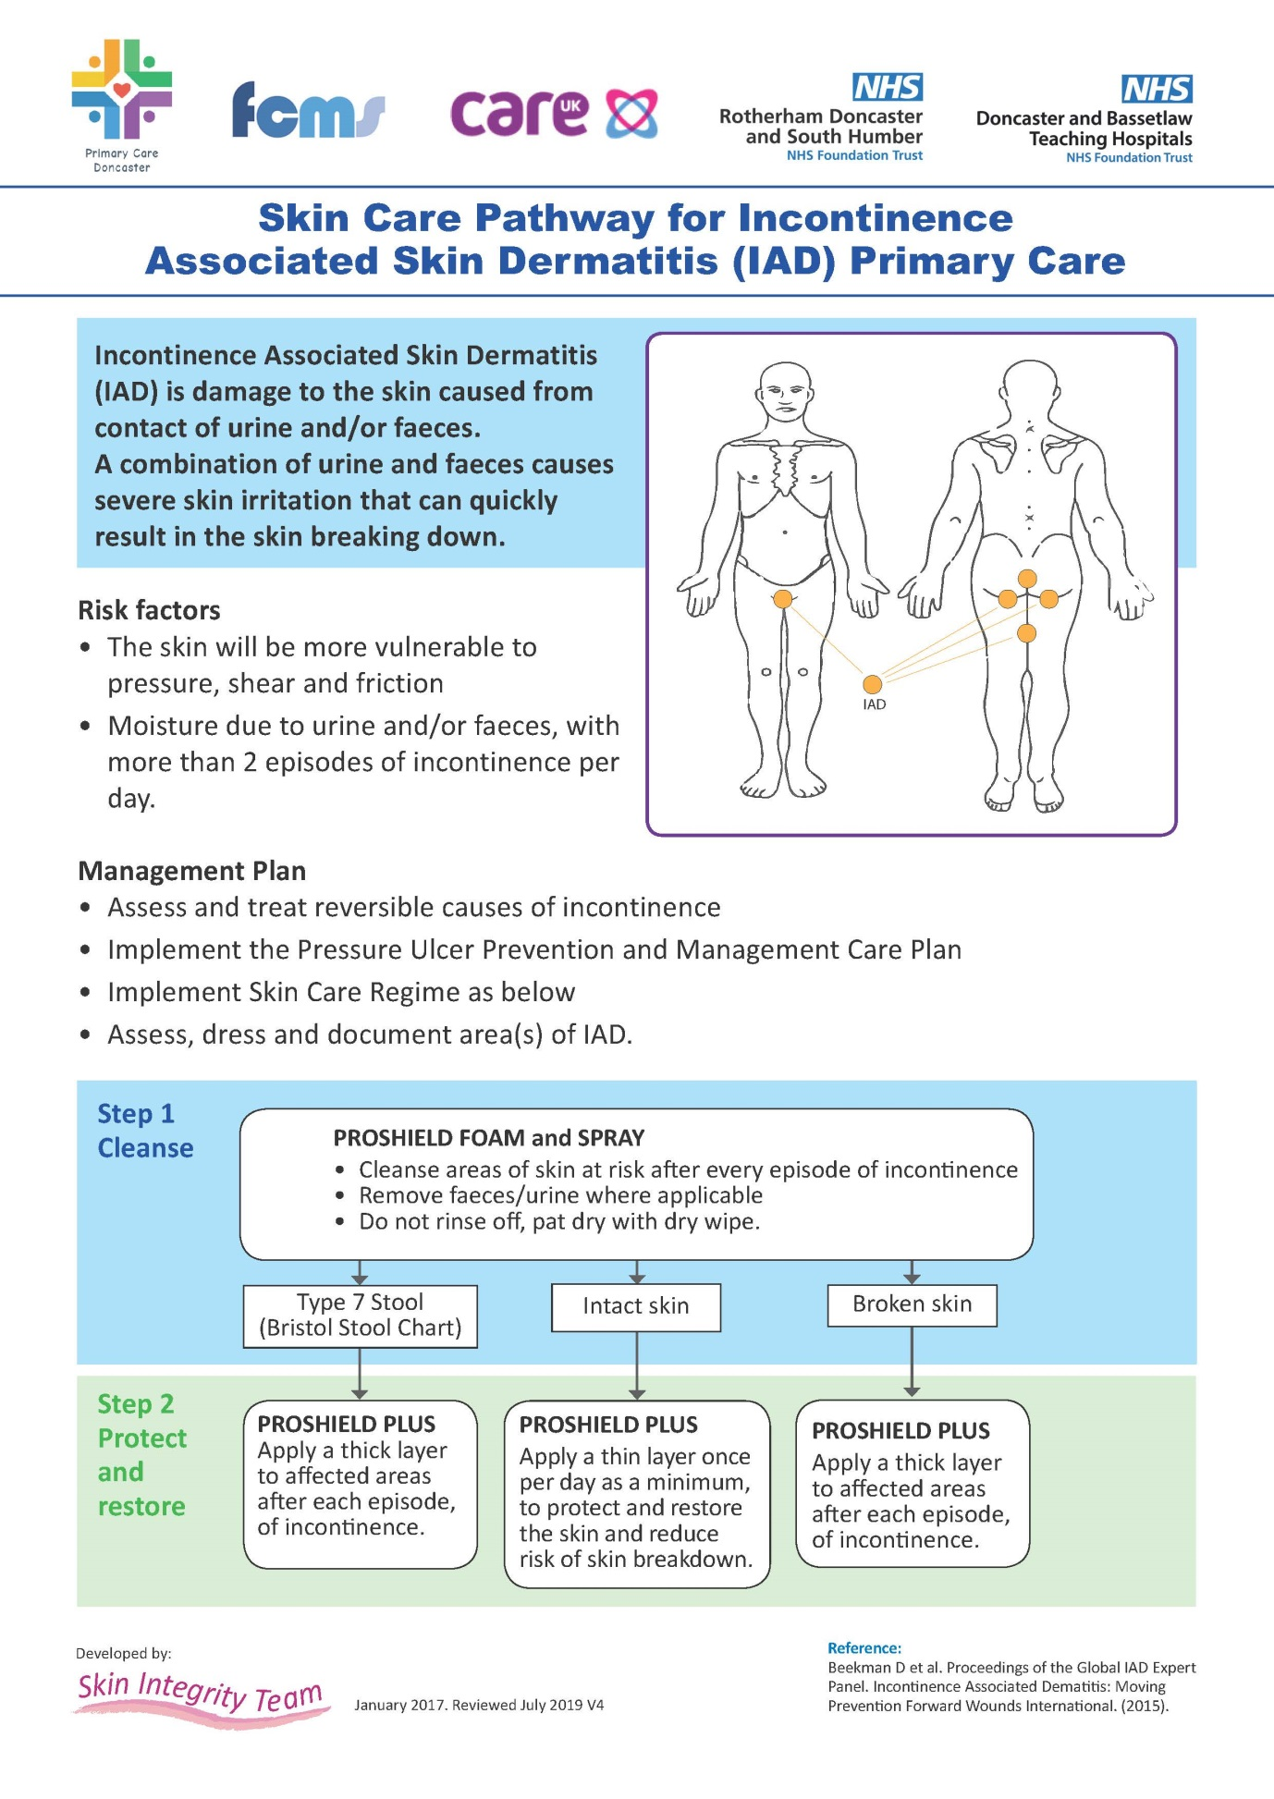

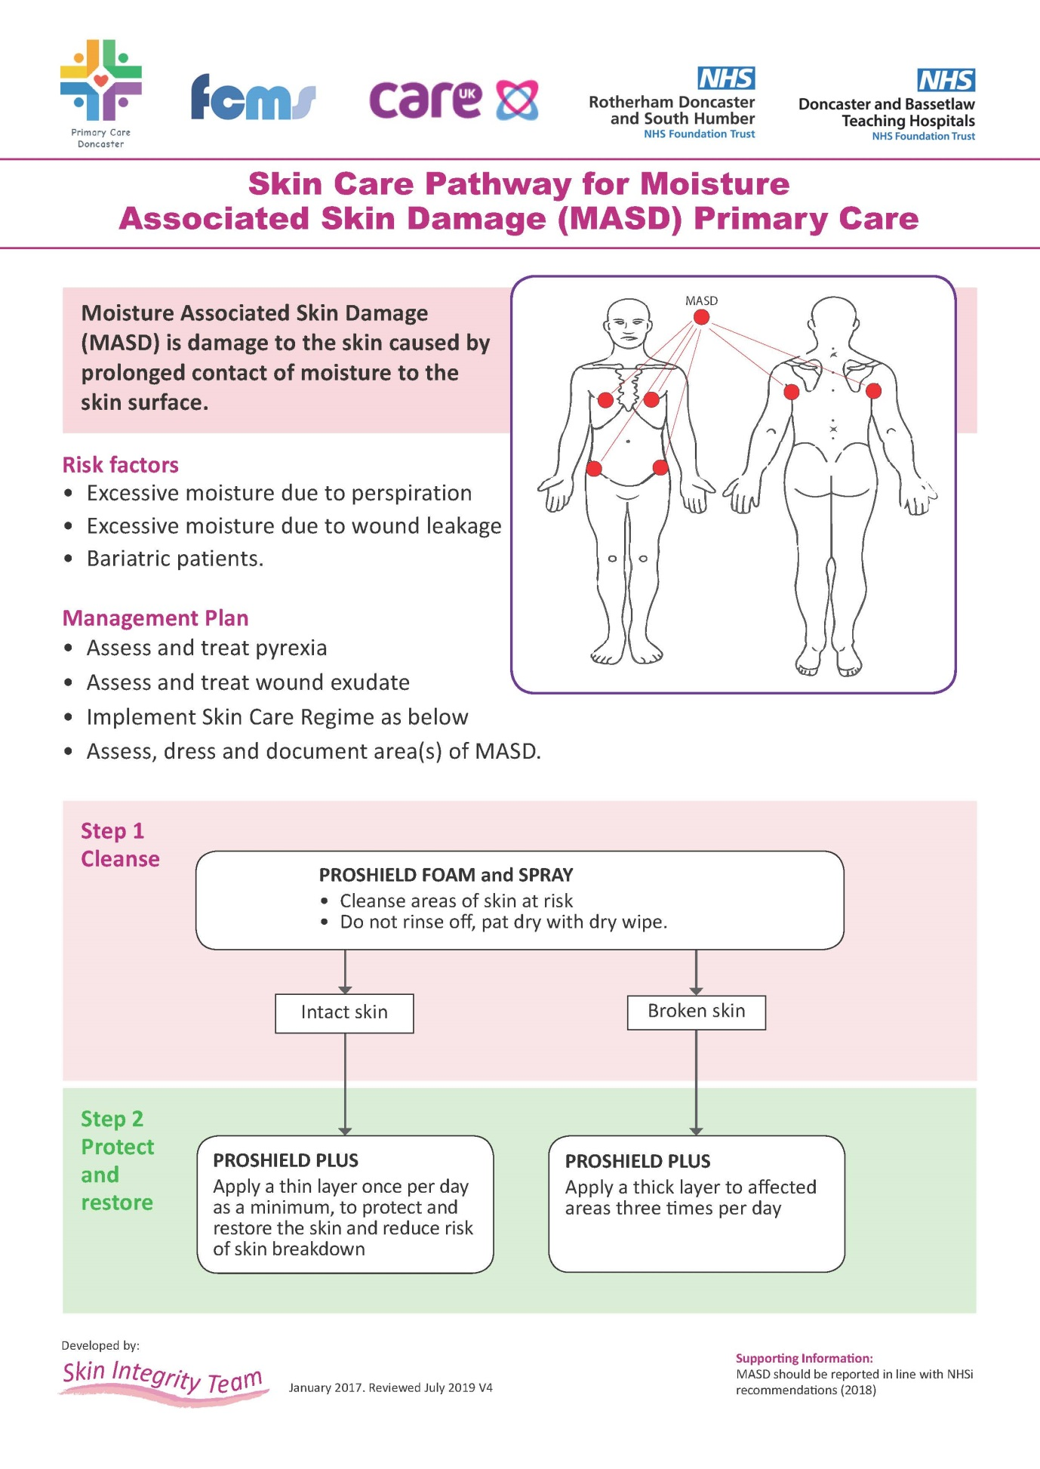

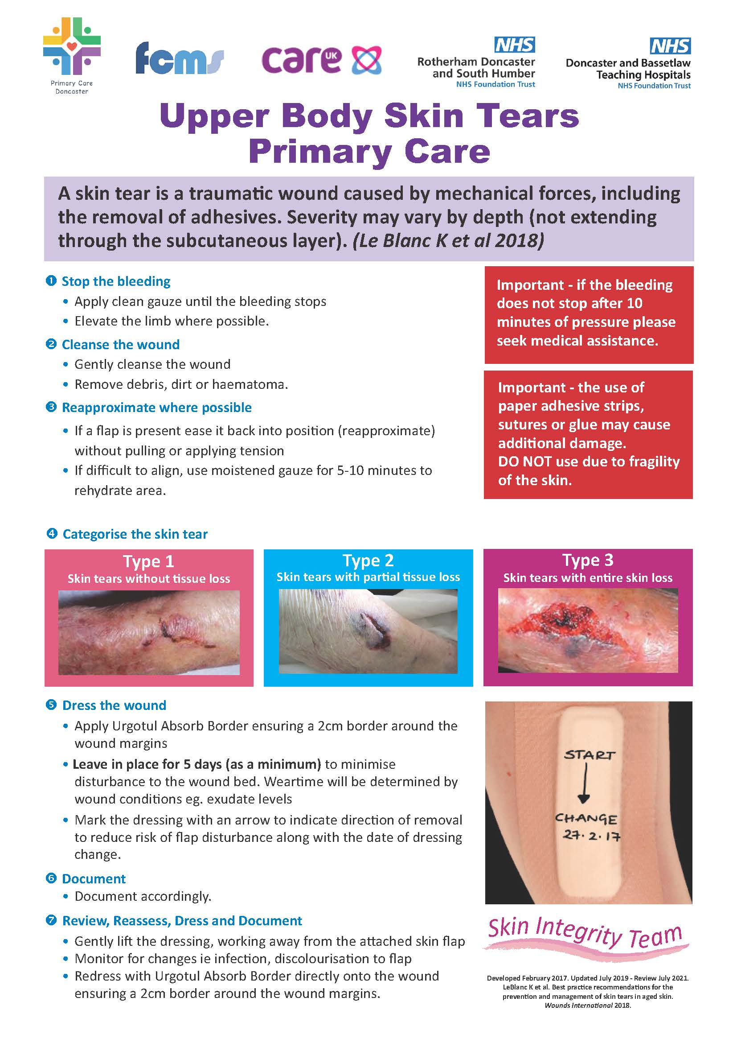

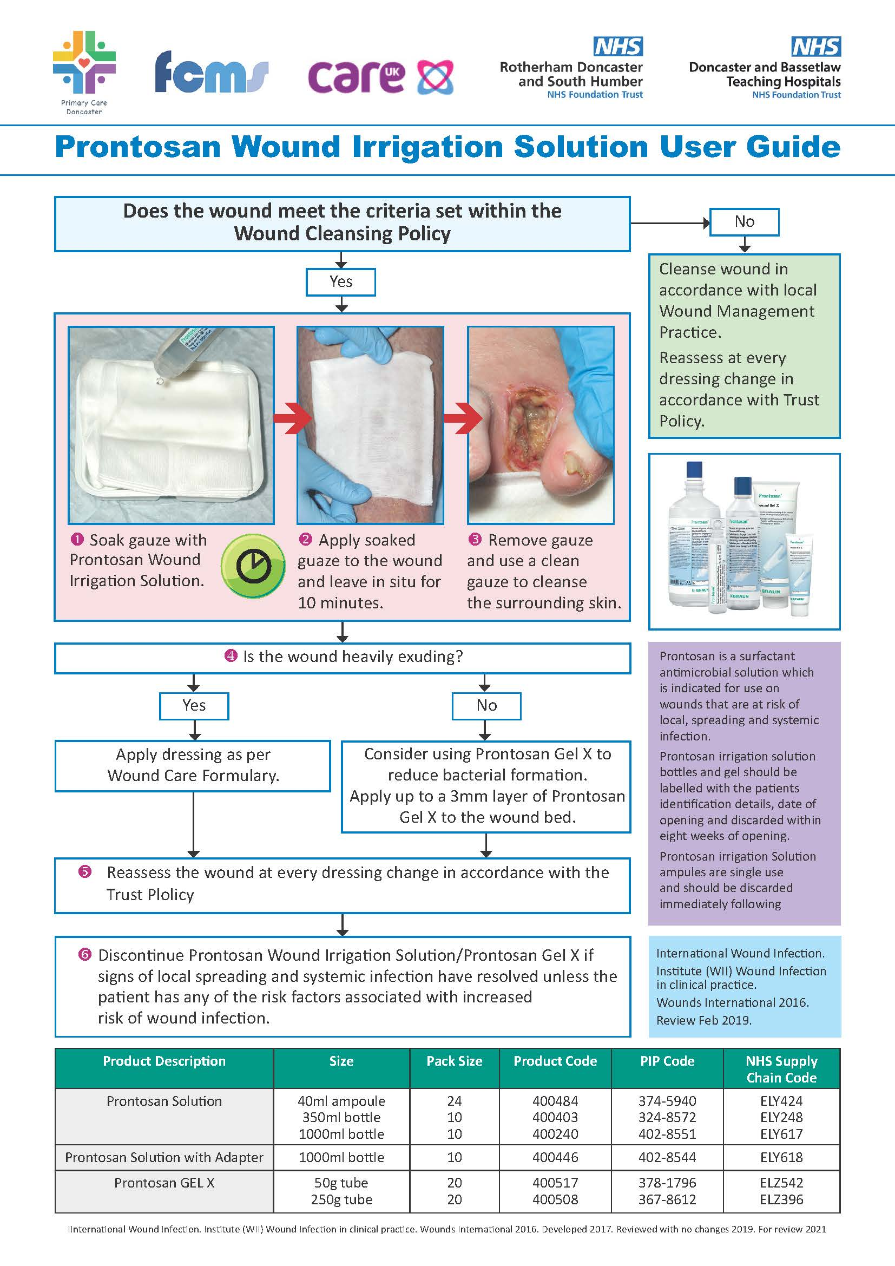

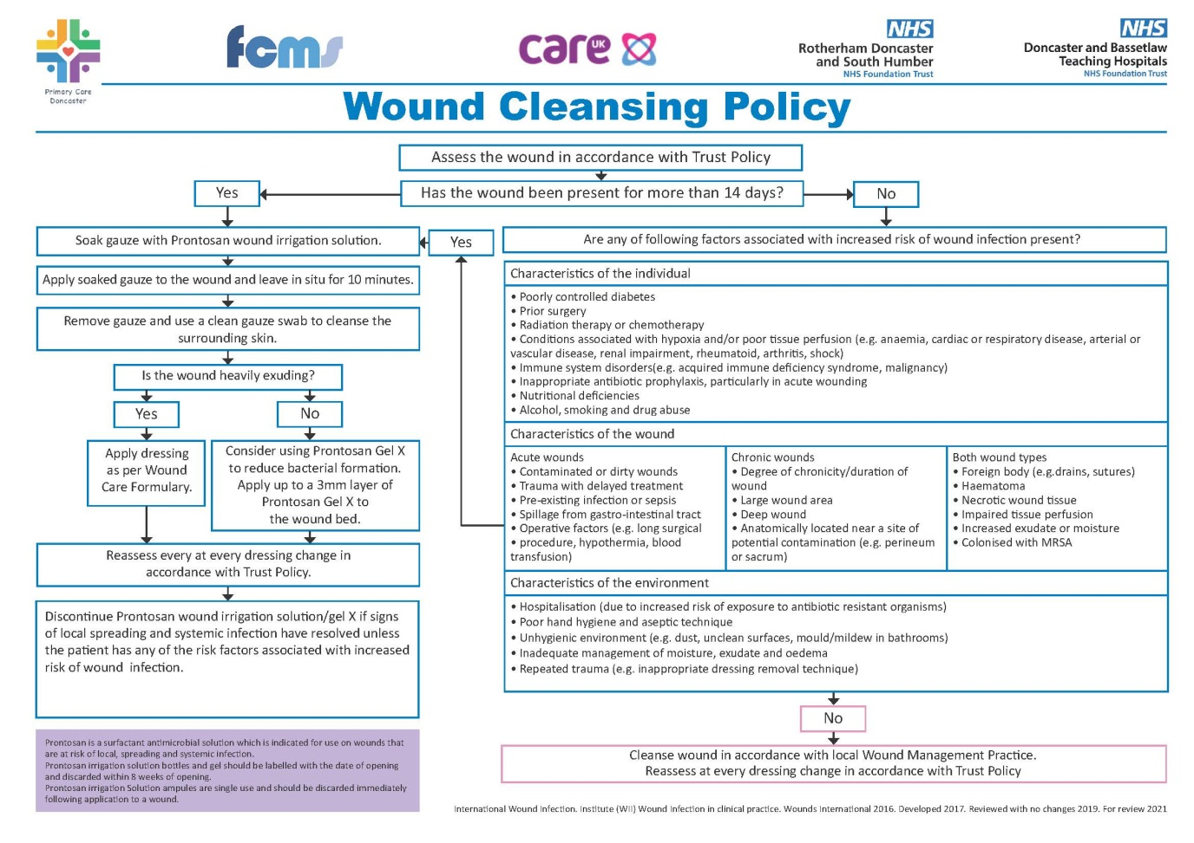

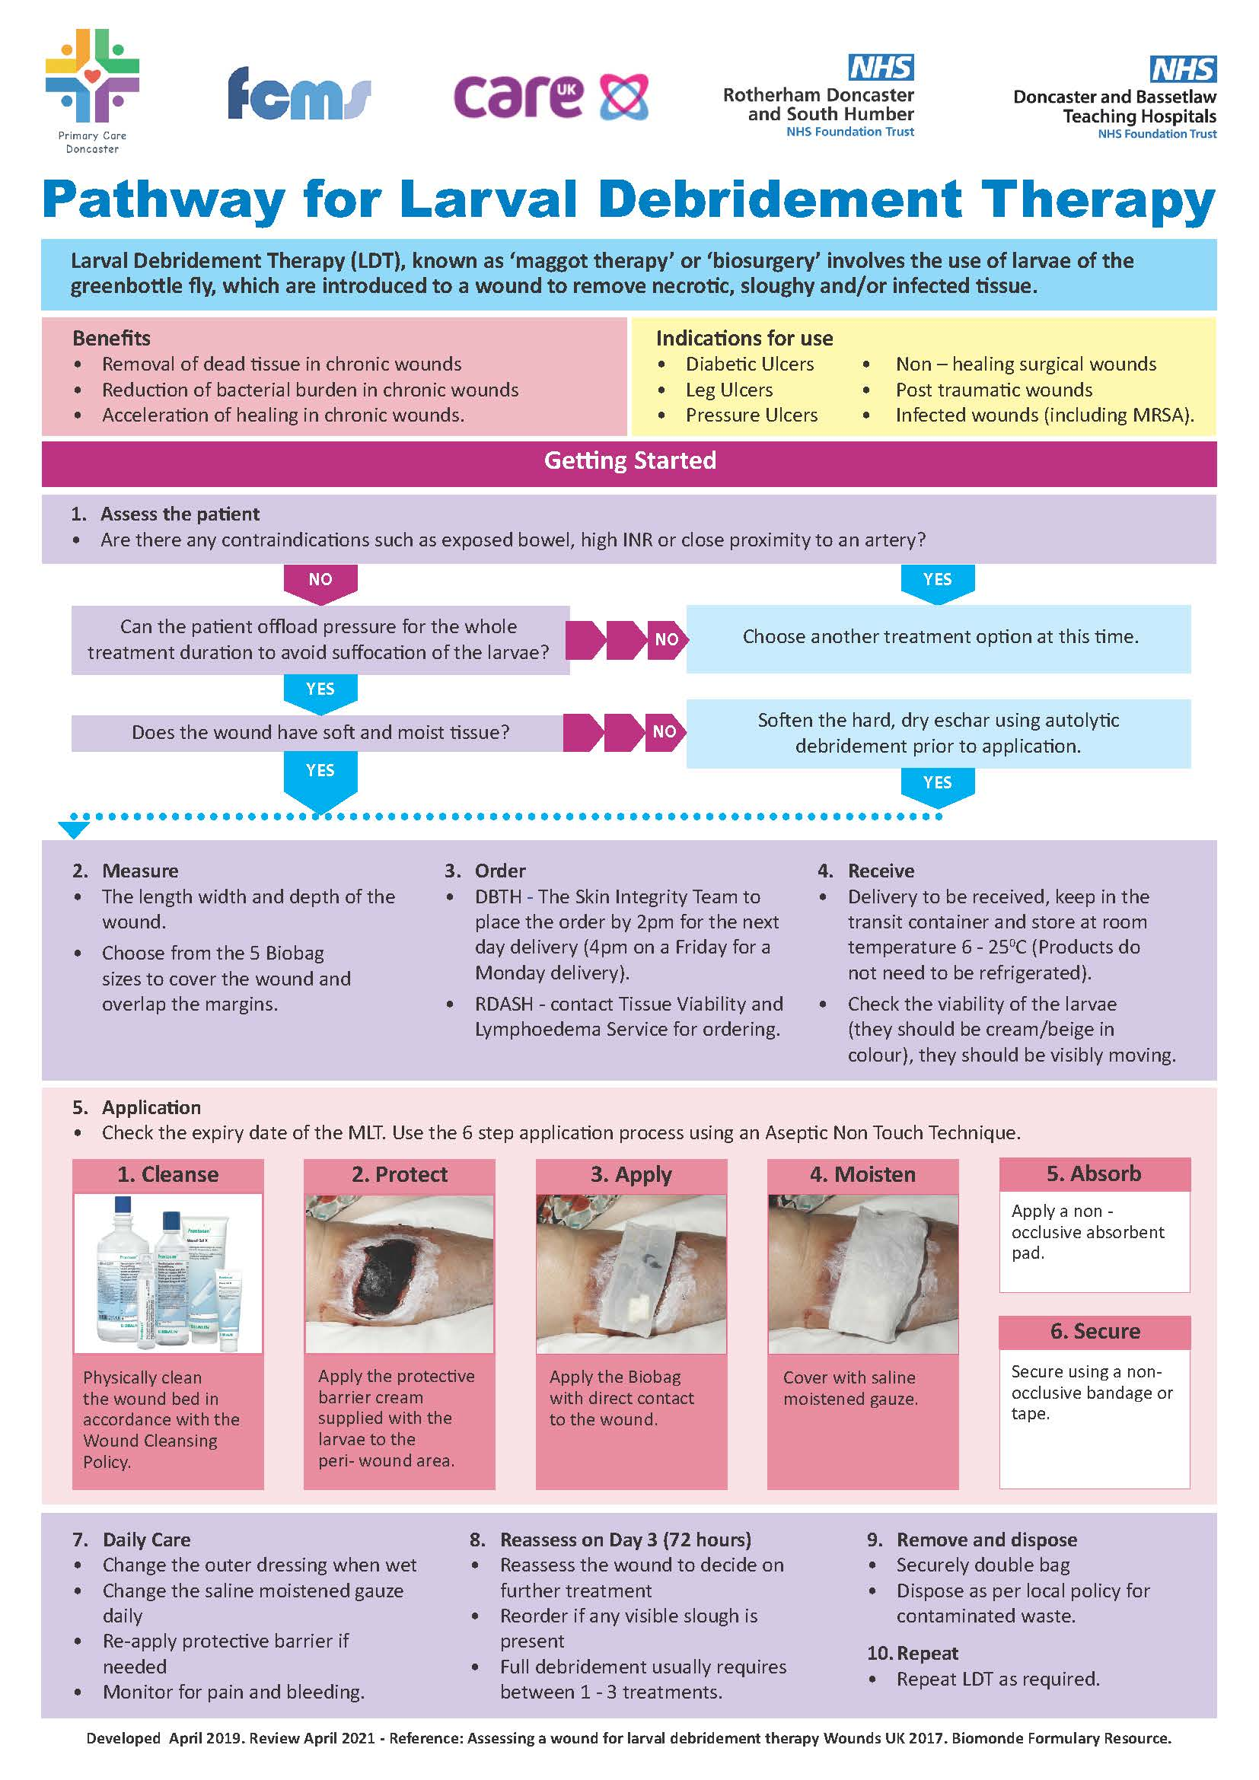

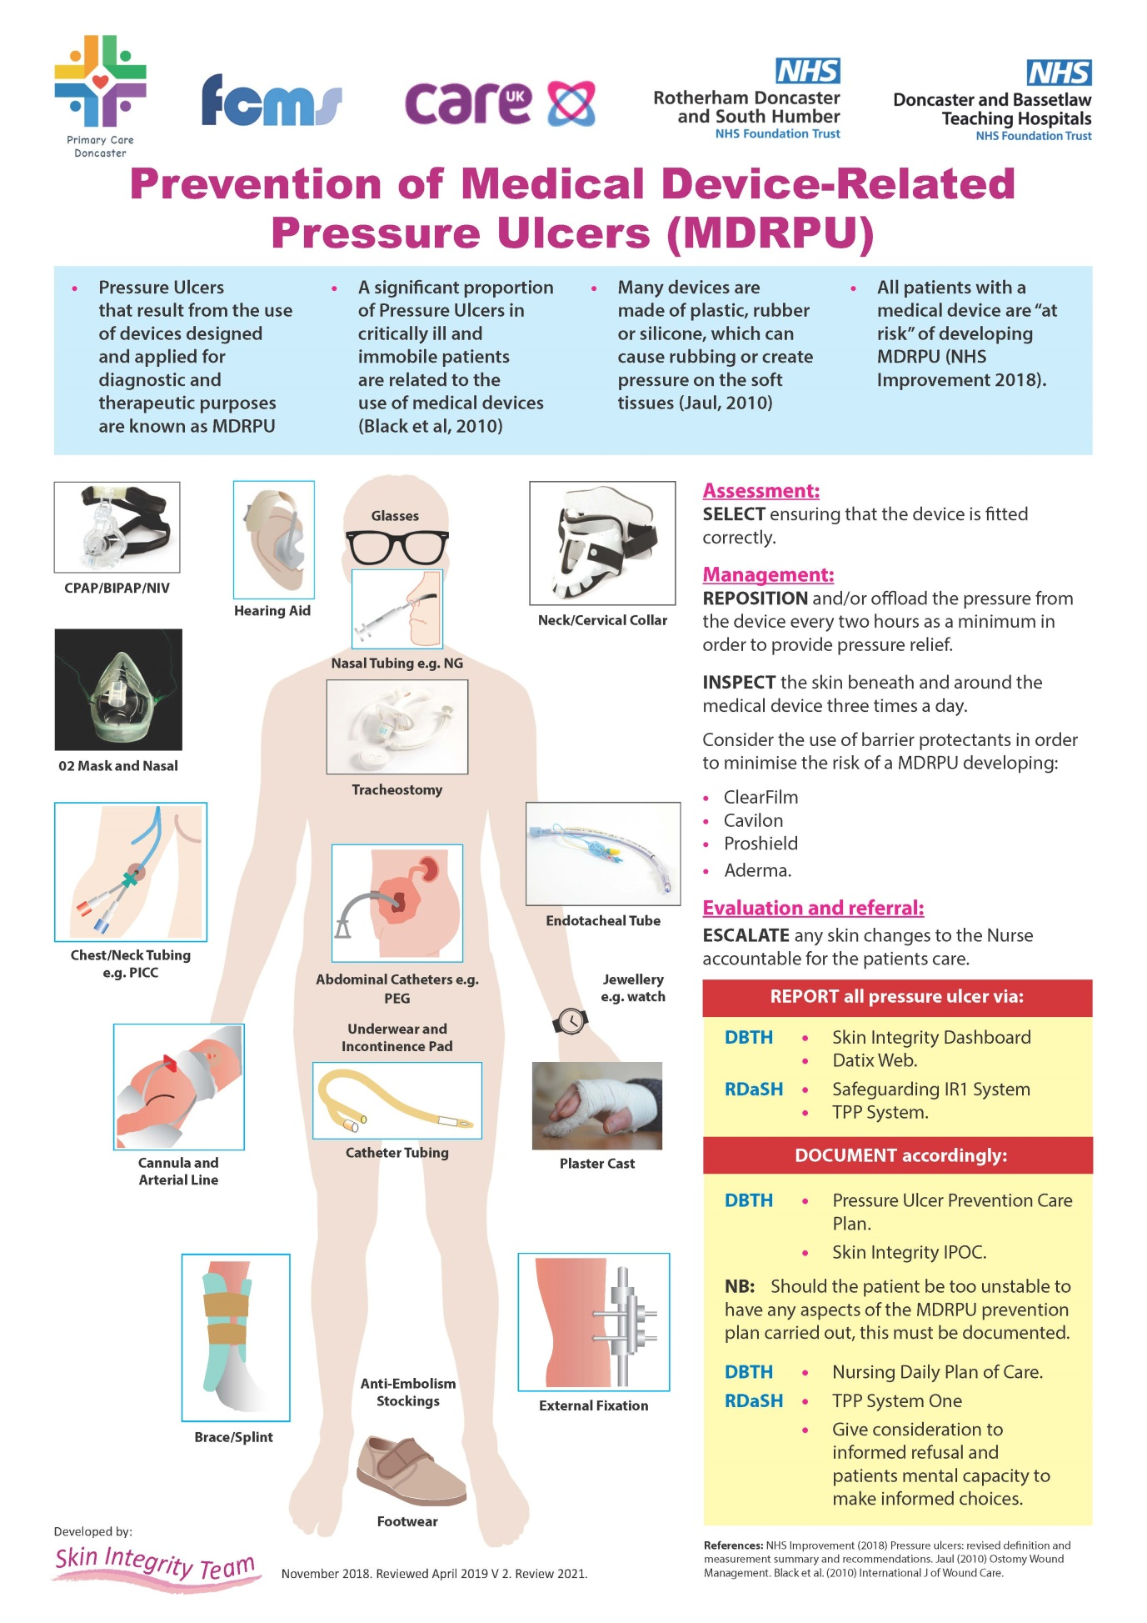

**Appendix 3 – Wound Care Training Programme**



|  |  |  |
| --- | --- | --- |
| **Topic Area Wound Management Tier 1** | **Registered Staff** | **Unregistered Staff** |
| **Module 1 Aseptic Technique (ANTT) with removal of sutures/clips** |  |  |
| Revalidation of the principles of asepsis including the techniques for minimising cross infection (1 assessment) | Yes | No |
| Completion of Aseptic Technique Package including the techniques for minimising cross infection incorporating the removal of sutures/clips | No | Yes |
| **Module 2 TIMES assessment and documentation** |  |  |
| Understanding of the anatomy and physiology of the Skin | Yes | Yes |
| Wound Bed Preparation and TIMES | Yes | Yes |
| Wound healing recognising primary v secondary intention | Yes | Yes |
| Wound assessment with the ability to recognise wounds types acute v chronic | Yes | Yes |
| Accountability and record keeping using a structured and standard approach (TIMES) | Yes | Yes |
| Ability to report escalate concerns and onward referrals to incorporate tiered structure | Yes | Yes |
| **Module 3 Wound healing** |  |  |
| Understanding of skin integrity and identification of risk factors | Yes | Yes |
| Recognition of the sign of skin damage i.e. redness, shear and friction and signs of wound infection | Yes | Yes |
| Understanding of wound healing process and identification of the barriers to wound healing process | Yes | Yes |
| Ability to follow treatment plan and determined by Registered Nurse/ANP/Associate | No | Yes |
| Ability to access first line dressing choices in line with local pathways | Yes | Yes |
| Ability to distinguish wound products types and mode of action in accordance as per Wound Formulary | Yes | Yes |
| Carries out dressing interventions within scope of practice | Yes | Yes |
| Carries out basic microbiological sampling | Yes | Yes |
| Describe the key components of nutrition and its influence on wound healing | Yes | Yes |
| Encourages patient/carer compliance with recommended treatment regimes | Yes | Yes |
| Ability to identify delayed wound healing and the associated risk factors | Yes | Yes |
| Psychosocial impact of wound care and its impact on QoL | Yes | Yes |
| **Module 4 Wound Cleansing** |  |  |
| Wound cleansing incorporating the Wound Cleansing Pathway | Yes | Yes |
| **Module 5 Skin Tears** |  |  |
| Ability to define and classify skin tears in accordance with ISTAP | Yes | Yes |
| Outline of epidemiology and its impact of skin tears on health care | Yes | Yes |
| Identify risk factors associated with skin tears | Yes | Yes |
| Identify skin tear prevention strategies and health promotion | Yes | Yes |
| Ability to actively manage Type 1 skin tears | Yes | Yes |
| Determine local dressing choices for skin tears in line with local pathways | Yes | Yes |
| Determine local pathways for lower leg and upper body skin tears | Yes | Yes |
| Measurement and application of hosiery liners for lower leg skin tears in line with local pathways | Yes | Yes |
| **Module 6 Bandaging** |  |  |
| Ability to define clinical purpose of bandage including tubular bandages | Yes | Yes |
| Determine differing bandaging widths as per clinical application | Yes | Yes |
| Differentiate differences between bandage classifications | Yes | Yes |
| Ability to demonstrate simple bandaging techniques in a range of clinical scenarios | Yes | Yes |
| **Module 7 Pressure Ulcers and Moisture Associated Skin Damage** |  |  |
| Ability to undertake pressure ulcer skin and risk assessment | Yes | Yes |
| Categorise pressure ulcers using EPUAP | Yes | Yes |
| Identification of PU risk factors to include MDRPU | Yes | Yes |
| Understand differences between causal factors of pressure ulcers | Yes | Yes |
| Differentiate between category 1 pressure ulcers and IAD.MASD | Yes | Yes |
| Ability to assess patients with regards to pressure relief/distribution | Yes | Yes |
| Determine difference between IAD and MASD | Yes | Yes |
| Identification of risk factors associated with IAD and MASD | Yes | Yes |
| Classification of IAD and MASD | Yes | Yes |
| The use of barrier protection in line with Skin Care Regimes for IAD.MASD | Yes | Yes |
| **Module 8 Minor Burns and Scalds** |  |  |
| Ability to determine components of the National Burn Care Network (NBCN) Flowchart | Yes | Yes |
| Ability to assess burn/scald using the NBCN Flowchart | Yes | Yes |
| Identify the clinical differences between Non- complex/Complex/Complex non - burns | Yes | Yes |
| Identification of the criteria for onward referrals including the criteria for the local burn service | Yes | Yes |
| Ability to follow the NBCN Non-complex Burn Management Protocol | Yes | Yes |
| Awareness of Burn Blister Management Protocol | Yes | No |
| Ability to carry out burn blister debridement for non - complex burns | Yes | No |
| Ability to advise on the skin care regime after a burn | Yes | Yes |

|  |  |
| --- | --- |
| **Topic Area Wound Management Tier 2** | **Registered Staff** |
| **Module 9 Wounds with delayed healing** |  |
| Provides a detailed enhanced understanding of the stages of wound healing and their effect on delayed wound healing | Yes |
| Demonstrates and understanding on the barriers to wound healing | Yes |
| Ability to investigate the differing types of exudate, the role it plays in wound healing | Yes |
| Ability to use wound based strategies to manage wounds with less than 50% slough/necrosis/devitalised tissue in line with the Wound Formulary/Pathways | Yes |
| **Module 10 Wounds with simple wound infection/localised cellulitis** |  |
| Provides insight into the role of micro - organisms found in wounds and their impact in wound infection | Yes |
| Demonstrates an understanding of the risk factors and the steps to be taken to prevent complications from occurring | Yes |
| Ability to detail complications arising from infection and the importance of evidence based practice. | Yes |
| Understanding of how to define and categorise a SSI | Yes |

|  |  |
| --- | --- |
| **Topic Area Wound Management Tier 3** | **Registered Staff** |
| **Module 11 Diabetic Foot Wounds** |  |
| Understanding of the anatomy and physiology of the arterial and nervous system to the lower leg and foot. | Yes |
| Understanding the impact of poorly controlled diabetes on the body and the foot in particular | Yes |
| Foot assessment including footwear checks. | Yes |
| Assessing diabetes foot ulcerations. Aetiology/ classification (using TIME, consider wound depth), other long term conditions that may impact on wound healing. | Yes |
| When to refer to Podiatry- is the wound static or deteriorating/ischaemic/neuro-ischaemic/neuropathic/pressure? | Yes |
| Education - Basic foot care advice for the patient | Yes |
| Wound dressing selection- exudate management, wound bed preparation, remains in place between appointments/ offloading for diabetes foot wounds. | Yes |
| Charcot foot. | Yes |
| Signs of localised soft tissue infection, systemic infection, Osteomyelitis. | Yes |
| **Module 12 Leg ulceration to incorporate comprehensive lower limb assessment - venous/arterial/mixed aetiology** |  |
| Accurate diagnosis and underlying aetiology of venous leg ulcers | Yes |
| Lower limb assessment including Ankle Brachial Pressure Index (APBi) Doppler /Medi APBi. | Yes |
| Risk factors for venous disease and clinical evidence of venous disease. | Yes |
| Management of venous leg ulcers | Yes |
| **Module 13 Larval Debridement Therapy** |  |
| To identify what stops wounds from healing | Yes |
| Recap on the wound assessment process | Yes |
| Too be able to identify the methods of debridement | Yes |
| Debridement decision making process | Yes |
| History of larvae in Wound Care | Yes |
| History of Modern LDT | Yes |
| Manufacturing Process | Yes |
| Evidence of LDT | Yes |
| To be able to understand the mode of action of LDT | Yes |
| To able to relate the science behind LDT to clinical practice an patient outcomes | Yes |
| To be able to identify the appropriate usage of Bio bag and Free Range Larvae | Yes |
| To be able to relate theory to practice | Yes |
| To have a clear understanding of the key points that could be discussed with patients to enhance concordance | Yes |
| To be able to understand the features and benefits of LDT | Yes |
| To be able to relate all learnings to the practical application and patient outcomes of LDT | Yes |
| **Module 14 Lymphoedema Wound Management Simple and Palliative ­** |  |
| Understanding of the anatomy and physiology of the lymphatic system | Yes |
| Identify primary and secondary form of lymphoedema | Yes |
| Identify lymphatic watersheds | Yes |
| Identification at risk groups cancer, venous insufficiency, obesity, immobility, high exposure to mosquito bites and filariasis | Yes |
| Full holistic assessment with the ability to recognise the various causes of oedema which can co-exist with lymphoedema - cellulitis, deep vein thrombosis, hyperkeratosis | Yes |
| Understanding of the core components of lymphoedema management skin care, exercise , healthy weight management, exercise, rest and relaxation balance | Yes |
| Understanding of promoting self-care with breathing exercises and simple lymphatic drainage | Yes |
| Encourages patient compliance with recommended treatment self-care | Yes |
| Encourage patients to be aware of conditions that could exacerbate their lymphoedema - poor skin hygiene, fungal infections, insect bites | Yes |
| Encourage patients to be aware of trauma prevention – sun bathing, phlebotomy in affected arm, exfoliation with razor, cutting nails with scissors, wearing tight clothing | Yes |
| Encourage patients to be aware of the urgency to seek treatment for cellulitis | Yes |
| Carry out skin care with debridement pad/cloth for removal of hyperkeratosis and application of emollient | Yes |
| Understanding of the various classifications of compression garments | Yes |
| Carries out application of compression garments, bandage regimes and wraps | Yes |
| Understand the role of application aids and their functionality | Yes |
| Encourage patients to put on and take off compression garments promoting self-care | Yes |
| Ability to identify psychosocial impact of lymphoedema | Yes |
| Carry out skin care with debridement pad/cloth for removal of hyperkeratosis and application of emollient | Yes |
| Encourage patients to put on and take off compression garments promoting self-care | Yes |
| Recognise systemic disorders – cardiac, liver, renal impairment | Yes |
| Understanding of the core components of lymphoedema management skin care, exercise , healthy weight management, exercise, rest and relaxation balance | Yes |
| Encourage patients to be aware of the urgency to seek treatment for cellulitis | Yes |
| Ability to identify when palliative becomes end of life and treatment changes to garments and bandages to support tissues and comfort | Yes |
| Ability to report escalate concerns and onward referrals | Yes |
| Accountability and record keeping | Yes |
| **Module 15 Negative Pressure Wound Therapy including PICO** |  |
| To be able to determine NPWT and PICO | Yes |
| To determine the mode of action for NPWT and PICO | Yes |
| To be able to define differences between NPWT and PICO | Yes |
| To establish the clinical indications of use and frequency of dressing changes | Yes |
| To establish key fault findings | Yes |
| NPWT and its role in Wound Bed Preparation | Yes |
| To demonstrate foam and gauze applications | Yes |
| To demonstrate clinical indications for the use of “fillers” | Yes |
| To identify the use of PICO in closed incisional management | Yes |
| To demonstrate the indications of prophylactic use of PICO | Yes |
| Ability to report escalate concerns and onward referrals | Yes |
| Accountability and record keeping | Yes |
| **Module 16 Tier 3 Burns** |  |
| Demonstrate knowledge of the rationale for the selection of burn dressings and incorporate this into existing practice. | Yes |
| Ability to recognise when it is appropriate to link into and/ or move the patient across to other pathways e.g. Referral to Burns Service; Wound Infection; Diabetic Foot; Leg Ulcers/Compression; Sharp Debridement; Lymphoedema/ Heavy Exudate: Chronic Wound. | Yes |
| Carry out more complex dressings with a regard to function and comfort e.g. Hand Dressings; Paediatrics. | Yes |
| Ability to assess the likelihood of functional impairment as a result of burn injury and take appropriate action. E.g. Advise re ROM; Referral to Burns Service; Physiotherapy Referral. | Yes |
| Ability to recognise burn wounds likely to result in hypertrophic scarring, advise and refer accordingly. | Yes |
| Demonstrate an awareness of the care of a Split Thickness Skin Graft and its Donor Site. | Yes |
| Ability to function as a resource for Tier 1 and 2 nurses and provide more in depth advice regarding burn wound care and referral. | Yes |
| Demonstrate an awareness of background and procedural pain and facilitate appropriate analgesia prescription for the patient. | Yes |
| Demonstrate a knowledge of itch as part of burn wound healing and assist with its pharmacological and non-pharmacological relief. | Yes |
| Demonstrate a more in depth knowledge of the psychological issues which may affect a burn patient and how to obtain help for them. | Yes |