SERVICE SPECIFICATION

Service | “Keeping Well”
Commissioner Lead | Doncaster CCG
Provider Lead | Practice name……
Period | 1st May 2017 – 31st March 2018
Date of Review | November 2017

1. Population Needs

Doncaster has a lower life expectancy than the national average with men living to an average of 77.5 years and women living to an average of 81.6 years. Doncaster ranks 124 of 150 local authorities for the number of people who die prematurely. The leading causes of premature death are from diseases that can be prevented such as cancer, cardio-vascular disease and respiratory disease. The causes of these diseases are, in part, linked to a number of unhealthy behaviours these include smoking, physical inactivity, poor diet and high levels of alcohol consumption. In Doncaster 74% of adults are overweight or obese, 22.7% of people currently smoke and 33.6% of people are physically inactive. Doncaster also has higher rates of alcohol related emergency hospital admissions than the national average.
The spread of disease risk factors, disease prevalence and life expectancy in Doncaster is not evenly distributed. There is a difference in life expectancy of 8.9 years for men and 7.2 years for women between the highest and the lowest wards.

A model for prevention (Figure 1) has been developed for Doncaster and endorsed through the Health and Wellbeing Board to communicate prevention at different levels from addressing the causes of the causes of ill health, to reducing disease risk factors and detecting disease early, to proactive management of existing long term conditions.
This model also helps to communicate how disease prevention can take place at different levels within general practice. This “Keeping Well” specification is primarily concerned with Primary Prevention; however in order to deliver this effectively it will need to have links with the Wider Determinants part of the model and may also have an impact on Secondary Prevention through the earlier identification of undiagnosed disease.

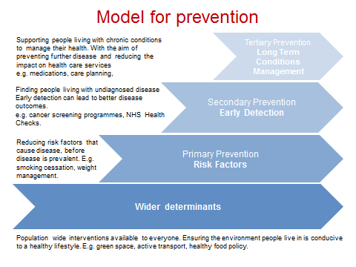
Figure 1 – Doncaster’s Model for Prevention
In Doncaster we recognise that GPs and their practice teams have a crucial role to play in promoting health and preventing disease. There is enormous potential for general practice to take a more central role in ill-health prevention and public health. Hence “Keeping Well” is one of the four pillars of the primary care strategic model for Doncaster (Fig 2), concerned with disease prevention.
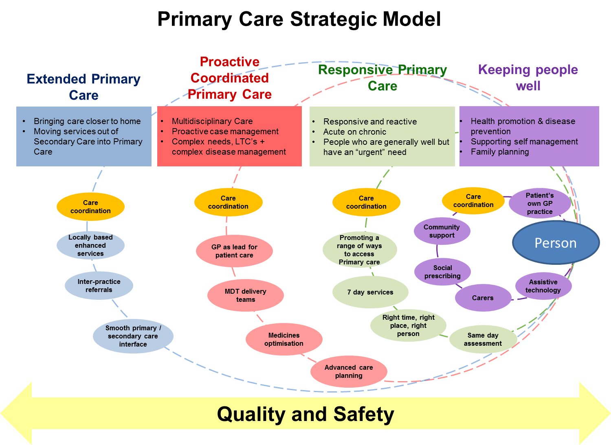
The aim of the “Keeping Well” pillar is to move towards a wellbeing approach to disease prevention in Doncaster which is integrated with Doncaster Council’s Community Led Support Model. This specification sets out how we will take the first steps towards this in 2017-18.

Figure 2 – The four pillars of the Primary Care Strategic Model
2. Scope

2.1 Clustered Risk Factor Approach

A clustered risk factor approach involves identifying individuals that have multiple risk factors that are known to cause ill health. For the Keeping Well specification this will focus on risk factors that are known to be the leading cause of death for the population of Doncaster; cancer, circulatory disease and respiratory disease. The leading risk factors known to cause these diseases are; smoking, high body mass index, alcohol intake and physical inactivity.
As the numbers of people with risk factors in Doncaster is high (22.7% current smokers; 74% overweight or obese, 29.1% physically inactive and alcohol related deaths in Doncaster are significantly higher than the national average) it would not be feasible to target all of the population exhibiting single risk factors within general practice. Therefore a more targeted approach is required.
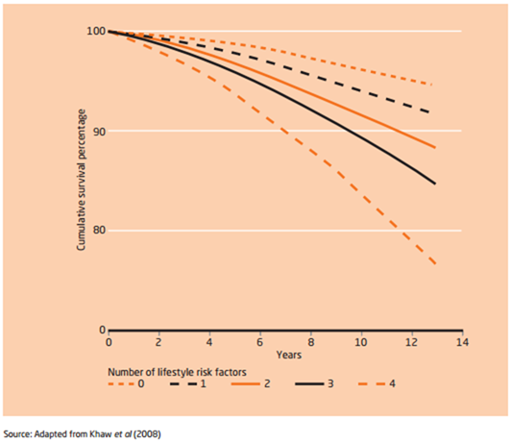
The clustered risk factor approach would involve practices identifying registered patients with multiple risk factors and offering support to reduce these risk factors. Research suggests that those with multiple risk factors are more likely to experience disease and to have a shorter life expectancy compared to those who exhibit fewer or no risk factors. Figure 3 below demonstrates that when the number of risk factors increases, the likelihood of future survival decreases.
Figure 3 – The relationship between multiple lifestyle risks and mortality
A clustered risk factor approach will therefore be used to target those at increased risk of premature mortality in general practice so that prevention interventions could be put in place. The benefits of this approach are the following:
- A targeted approach allowing a more manageable method for identifying those at greatest risk of developing disease in the future (Twisk et al 2001, Buck and Frosini 2012).
- Addressing inequalities – The number of people living with risk factors is not distributed equally across a population. Those with clustered risk factors are more likely to be younger males, from lower socio economic groups, more likely to be unemployed and have lower academic attainment. Targeting these individuals would aim to reduce health inequalities (Schuit et al 2002, Buck and Frosini 2012).
- An approach that addresses overall wellbeing rather than individual unhealthy behaviours (Buck and Frosini 2012).

The proposal is to target this towards those aged 18-40 years as these individuals are not already covered by the existing NHS Health Check programme. An addition benefit of targeting these individuals is that they are the population group most likely to have young families so changes in their lifestyle risk factors will also aim to have a positive impact on maternal health and early years, for example through reductions in exposure to passive smoking, reducing the direct and indirect impacts of alcohol consumption and improved diet in the home.

2.2 Identification of patients

Practices will identify people with multiple risk factors from their patient list and deliver brief wellbeing interventions to these individuals including a Healthy Living Self-Management Action Plan which may include referral to wider community services.
Practices will compile a Clustered Risk Factor Register of patients that are:
- Aged 18-40 years
- on BOTH the practice’s obesity register and smoking register
- NOT on a disease register for {[CHD] or [Diabetes] or [Stroke] or [Hypertension] or [AF] or [COPD] or [Heart Failure] or [PAD]}

If the practice keeps registers for Alcohol and Physical Inactivity, then these should be cross-referenced with the Clustered Risk Factor register, and the patients that appear on 2 or more registers should be prioritised for first attention.
The data searches to identify patients on both the obesity and smoking registers are provided at Appendix 4.

2.3 Interventions for Patients on the Clustered Risk Factor Register

- Those identified on the Clustered Risk Factor Register should be offered an appointment at the practice to assess and record:
If these have been recorded in the last 12 months then they do not need to be repeated unless clinically indicated or there have been changes since checked
- Blood pressure
- BMI (& hip/waist ratio if also appropriate)
- Cholesterol
- HbA1c (or fasting glucose if inappropriate*)
- Alcohol intake (including AUDIT-C or FAST)
- General Practice Physical Activity Questionnaire (GPPAQ)
- Where it is also appropriate, carry out depression screening (PHQ2) and/or offer sexual health screening

- Have a discussion about their lifestyle and health, with the outcomes of this discussion recorded in the format of a Healthy Living Self-Management Action Plan (an example template that can be used or modified can be found at Appendix 2). This should result in advice and support around some of the following:
- Stopping smoking
- Healthy eating
- Physical activity
- Sensible drinking
- Healthy mind
- Supporting families
- Early disease detection (e.g. cervical cancer screening)
- Family planning / sexual health

The Action Plan can also identify opportunities for wider support within the local community which may include signposting or referral to:
- Smoking cessation service
- Social Prescribing
- ASPIRE – Drug & Alcohol Service
- Local walking, cycling or sports groups
- National Diabetes Prevention Programme provider (from April 2017 – pathway still awaiting confirmation)
- Mental health services
- Family support services (e.g. Children’s centres, Early Help Hub, domestic violence support)
- Carer support services
- Sexual health services
- Housing or employment services

The website www.yourlifedoncaster.co.uk is the portal to all the resources available to help practices with the above. It includes details of over 1500 community groups, as well as links to NHS and Council services for more formal referral.
Additionally, these two documents (available from http://www.nesta.org.uk/realising-value-programme-reports-tools-and-resources) provide key guidance and examples of how patients can be supported to self-manage and the techniques practices could deploy. Practice leads are strongly encouraged to read this guidance.

*As per the NICE Clinical Knowledge Summary, HbA1c should not be used to diagnose diabetes mellitus in the following groups:
- Children and young people (younger than 18 years of age)
- Pregnant women or women who are two months postpartum
- People with symptoms of diabetes for less than 2 months
- People at high diabetes risk who are acutely ill
- People taking medication that may cause hyperglycaemia (for example corticosteroids)
- People with acute pancreatic damage, including pancreatic surgery
- People with end-stage chronic kidney disease
- People with HIV infection
And, HbA1c should be interpreted with caution in people with:
- Abnormal haemoglobin
- Anaemia (any cause)
- Altered red cell lifespan (for example post-splenectomy)
- A recent blood transfusion

2.4 Service Delivery Requirements

- Making every contact count (MECC) is an approach to behaviour change that utilises the millions of day to day interactions that organisations and people have with other people to encourage changes in behaviour that have a positive effect on the health and wellbeing of individuals, communities and populations. Doncaster Public Health has developed a MECC e-learning module, taking approximately half an hour to complete. It is a requirement of this specification that members of the practice team involved in the delivery of this specification complete the module and submit the certificates to the CCG. You can register to complete the MECC e-learning course here http://doncasterpublichealth.learningpool.com

- The practice will identify a named professional for the implementation and co-ordination of this specification
- A multiple risk factor register will be developed as per the above scope
- Patients on the register will be invited into the practice to record their clinical indicators (as per section 2.3a) and discuss lifestyle choices and options to improve their health. It is at the practice’s discretion how best to engage patients and get the most value from this; based on input from the Primary Care Provider Engagement Group practices may wish to consider:
- Point-of-care testing for HBA1c & cholesterol, so that the lifestyle conversation can be held at the same appointment and informed by the results
- Telephone/remote consultations for the lifestyle consultation, to be held once the clinical results are available
- Using extended hours slots for appointments as this patient cohort is working age and likely to have in-hours commitments
- Use of phone, text and/or email to contact patients rather than letter through the post
- Patients identified as a result of this as having a previously undiagnosed long-term condition such as hypertension or diabetes will be added to the appropriate disease-specific register and managed in the usual manner. They should still be supported with their Healthy Living Action Plan
- Patients that meet the following criteria will be referred to the National Diabetes Prevention Programme:
- HbA1c 42 – 47 mmol/mol (6.0 – 6.4%) or fasting plasma glucose 5.5 – 6.9 mmol/L
- The above test was conducted within the last 12 months
- The practice will keep records on the number of referrals to the NDPP from the clustered risk factor register and submit this to the CCG on request
- Working in partnership with the relevant organisations, practices will create an environment in which patients have the tools, motivation and confidence to take more responsibility for their health and well-being
- Practices will follow up after 6 months, via an appropriate method agreed with the patient, and record the patient’s progress. Clinical indicators should be recorded again to measure any improvement

2.5 Enablers for Service Delivery

Whilst this specification does not prescribe how the healthy living discussion and resulting action plan should be delivered, it is recognised that it does not need to be conducted by a GP. It is also recognised that general practice is currently under increasing pressure and the workforce challenges are real.

For these reasons, it is suggested that delivery of the specification would therefore be more effective if groups of practices were to come together, and act collectively in engaging and bringing in other system partners who are well-placed to deliver some of the necessary interventions e.g. Healthy Living Pharmacies, Social Prescribing teams or Community Wellbeing services. The Community-Led Support model being developed by DMBC is a key enabler for delivery, and more information can be found in this document.

Furthermore, the specification does not preclude practices pooling resources to deliver various interventions in-house, such as weight management programmes, group coaching, etc.

3. Key Service Outcomes
Expected Outcomes

Approach | Intervention | Key Reporting Indicators
- Case finding and review | Practices will compile a register of patients with multiple risk factors as outlined in the scope above | Numbers of patients on the Clustered Risk Factor Register
- Named professional | Practices will identify the lead professional who will co-ordinate delivery of this specification | Confirmation of named professional
- Proactive prevention | Each individual identified for will be invited to participate in a lifestyle consultation in order to develop an action plan to address key risks to their future health and well being  The Healthy Living Action Plan will be as detailed as possible and tailored to each patient’s needs and circumstances | % of register patients who have a completed Healthy Living Action Plan  Numbers of patients identified as having an underlying LTC, and added to disease-specific registers  Number of referrals to the National Diabetes Prevention Programme as a result of this service  % of patients engaging with follow up after 6 months
- Patients supported to manage their health and wellbeing | Primary care teams will create an environment in which patients have the tools, motivation and confidence to take responsibility for their health and wellbeing | MECC e-learning certificate submitted for at least 2 (1 non-clinical and 1 clinical) team members – one of whom must be the named professional  Patient feedback  Progress reported at six-month follow-up, on both clinical and non-clinical indicators
- Patient’s risk factors are treated holistically | Community-led support will be at the heart of the approach. Non-medical solutions will be discussed with the patient and links made to what their own communities have to offer | Evidence of how practices are working with system partners (e.g. social prescribing, well-being teams, pharmacies)  Patient feedback  Qualitative reporting to include key themes on the needs of the client group and where the gaps/barriers in service are

A reporting template will be developed for practices to submit this information on a quarterly basis. The first period to report on will be 1st May – 30th June, and quarterly thereafter.

Appendix 1
Key references

Twisk J.W; Kemper H.C; Van Mechelen W, Post GB. “Clustering of risk factors for coronary heart disease. the longitudinal relationship with lifestyle.” Ann Epidemiol. 2001 Apr;11(3):157-65.
Schuit AJ, van Loon AJ, Tijhuis M, Ocké M. “Clustering of lifestyle risk factors in a general adult population.” Prev Med. 2002 Sep;35(3):219-24.
David Buck, Francesca Frosini (2012) “Clustering of unhealthy behaviours over time. Implications for policy and practice.” The King’s Fund. http://www.kingsfund.org.uk/publications/clustering-unhealthy-behaviours-over-time
Menu of prevention Interventions, Public Health England, 2016 https://www.gov.uk/government/uploads/system/uploads/attachment_data/file/565944/Local_health_and_care_planning_menu_of_preventative_interventions.pdf

Appendix 2

EXAMPLE
HEALTHY LIVING ACTION PLAN

Clinical Indicators
 | Result |  | Threshold |  |  | Action plan
Blood Pressure |  |  | 140/90 or below | 140/90 or above |  | e.g. management of high blood pressure
Body Mass Index (BMI) |  |  | Under 30  (or 27.5 if from high risk background) | Over 30  (or 27.5 if from high risk background) |  | e.g. plans to lose weight
Blood Cholesterol |  |  | Under 7.5mmol/l | Over 7.5mmol/l |  | e.g. management of high cholesterol
HbA1c (average blood sugar) |  |  | Under 42mmol/mol  *In line with DPP NDH criteria | Over 42mmol/mol |  | e.g. management of diabetic and non-diabetic hyperglycaemia;  Referral made to National Diabetes Prevention Programme if appropriate
Alcohol (units per week / AUDIT score) |  |  | Less than 14 units per week | More than 14 units per week |  | e.g plans to cut down alcohol
Self-Management Plan

 |  | What are you doing at the moment? |  |  | What things would you like to change? |  | How will you do this?
Healthy Eating |  | e.g. daily fruit and vegetable consumption?
Physical Activity |  | e.g how many hours of physical activity a week? Type of physical activity?
Smoking |  | e.g. how many cigarettes smoked per day?
Alcohol |  | e.g. how much alcohol consumed per week?
What extra support do you think you might need?
E.g. wider determinants lifestyle support; housing, debt management, food poverty, fuel poverty, mental health support.

Appendix 3

PAYMENT SCHEDULE

Practices will be paid on an activity basis.

The first attendance will attract a fee of £30 per patient. To qualify for this payment, both the initial clinical tests and the lifestyle consultation/action plan have to be completed.

The 6 month follow up attendance will be paid at £18 per patient (60% of first attendance in line with PBR tariff).

Claims for activity should be submitted on a monthly basis to the CCG via the PBCi portal.

The practice will be required to submit audit information on request.

Activity should be submitted within 14 days of month end for activity undertaken in month. Activity for March 2018 should be submitted within 7 days of month end. DCCG reserve the right to withhold payment on activity not received within these time scales.

Appendix 4
KEEPING WELLCLUSTERED RISK FACTORS
MINIMUM DATA SET

This paper provides the minimum dataset for the Keeping Well Clustered Risk Factors for the year 2017/18.

Read V2 and CTV3

Practices are required to use the Read codes provided in this document to calculate the Clustered Risk Factor Register and to qualify for payment.

Practices will need to re-code patients if they have used codes not included in this document

 | Read V2 | CTV3 | Comments
Tobacco consumption | 137, 1371, 1372, 1373, 1374, 1375, 1376, 1377, 1378, 1379, 137A, 137B, 137C, 137D, 137F, 137G, 137H, 137J, 137K, 137M, 137N, 1370, 137P, 137Q, 137R, 137S, 137T, 137V, 137X, 137Y, 137Z, 137a, 137b, 137c, 137d, 137e, 137f, 137h, 137j, 137l, 137m, 137o | 137R, XaXP9, XEOoq, Ub1tR, XEOoi, Y3985, Ub1ts, 1373, Ub1tT, 1374, Ub1tU, 1375, Ub1tV, Ub1tW, 1376, 137J, 137H, XEOor, XaBSp, 137C, 137G, 137M, XaIIu, XaItg, XaJX2, XaLQh, XaWNE, | Smoking codes
BMI | 22K, 22K5, 22KB, 22KC, 22KD, 22KE | 22K5, X76CO, XaJJH, XabHx, XabHy, XabHz, 22K | Obesity codes
QOF CHD Register |  |  | Please see business rules for up-to-date QOF codes
QOF Diabetes Register |  |  | Please see business rules for up-to-date QOF codes
QOF Stroke/TIA Register |  |  | Please see business rules for up-to-date QOF codes
QOF Hypertension Register |  |  | Please see business rules for up-to-date QOF codes
QOF Atrial Fibrilation Register |  |  | Please see business rules for up-to-date QOF codes
QOF COPD Register |  |  | Please see business rules for up-to-date QOF codes
QOF Heart Failure Register |  |  | Please see business rules for up-to-date QOF codes
QOF PAD Register |  |  | Please see business rules for up-to-date QOF codes

