Service Specification for Minor Surgery Non Registered Patients

Period: 1st April 2017 to 31st March 2018
Date of Review: Annual

Introduction

All practices are expected to provide essential and those additional services they are contracted to provide to all their patients.

This enhanced service specification outlines the more specialised services to be provided. The specification of this service is designed to cover the enhanced aspects of clinical care of the patient, all of which are beyond the scope of essential services.

No part of the specification by commission, omission or implication defines or redefines essential or additional services.

Background

NHS England contracts for minor surgery procedures (registered patients) through the Directed Enhanced Service (DES) for Minor Surgery.

Currently a practice that does not perform minor surgery procedures on its own patients refer into secondary care, similarly some GPs only perform a proportion of minor surgery but also refer patients on to secondary care.

A practice may elect not to perform minor surgical procedures on its own patients; this activity could be absorbed by neighbouring practices.

The purpose of this service is to commission a primary care based minor surgery service for patients whose GP does not participate in the minor surgery DES. This service is intended to improve both choice and access to patients by offering an alternative to secondary care supporting National and CCG priorities and ensuring value for money.

Incorporating low risk BCC Minor Surgery into this specification, where NICE guidance and the Community Skin measures offer the opportunity to extend the knowledge and skills of primary care services and extend the scope of service patients can access without referral to secondary care.

The NICE Skin Cancer Guidance update Improving outcomes for people with skin tumours including melanoma - The management of low-risk basal cell carcinomas in the community (May 2010) specifically recommended the development of new roles for GP’s and GPwSI for responsibility for skin lesions, skin surgery and community cancer services.

The subsequent revised guidance and competences for the provision of services using GPs with Special Interests (GPwSIs) Dermatology and skin surgery (2010) and the NCAT (2011) Manual for Cancer services – revised Community Skin Measures both describe models of care where accredited GP’s can manage Low level BCC’s under existing DES/LES arrangements, the evidence and competencies required for accreditation, CPD and other requirements such as histology & record keeping.

Service Outline

This service is intended to provide within primary care, access to assessment, operative intervention and aftercare for patients with lesions suitable for minor surgery. (See Flow chart) Procedures should be undertaken in line with Doncaster commissioning policies.

This service would continue to adhere to current core standards, best practice and clinical governance stipulated in the GMS & PMS contracts and the minor surgery DES specification.

The service provider must hold a contract for provision of the DES for minor surgery with NHS England.

The service provider must not refer their own patients, with lesions suitable for provision under this service, to other practices or secondary care for minor surgery procedures to be carried out.

The service provider must be able to demonstrate its ability to deliver the activity agreed and show that this will not be to the detriment to the Essential or Additional Services or Minor Surgery DES provided to their registered population.
The service provider must fully comply with the terms of the Minor Surgery DES and demonstrate appropriate training and experience, have premises which fully meet the required standards for treatment rooms as specified by NHS England.

The service provider must provide equipment and work to Infection control policies that fully meet the requirements of the CCG and comply with the national decontamination regulations and the national decontamination strategy.

Patients will be offered an appointment with a service provider who will carry out the initial assessment to establish each referral is clinically appropriate before the procedure is performed.

The patient will not have to wait longer than 8 weeks from referral to the performance of the procedure including the waiting time for assessment.

The patient will attend the referring practice for any aftercare such as removal of sutures and dressings, unless suitable arrangements have been made with the practice providing this service.

The CCG in agreeing to this service is no way commit themselves to the capital expenditure or revenue consequences of the equipment necessary for particular procedures other than those specifically covered by this service.

Referrals must include as a minimum details of the referring GP, patients name, DoB, NHS number, contact details and an outline of the problem requiring treatment. The form (Appendix B) should be used for referral and as a clinical record.

The service provider must supply the referring practice with details of the assessment and procedure performed within 1 week of the completion of the treatment.

The service provider will refer patients back to their registered practice if any procedures are required to be performed in secondary care.

The low risk BCC minor surgery will be delivered in line with the pathway in Appendix 1. Practices across Doncaster will refer to accredited GP’s with a suspected low level BCC in line with the list of clinically defined BCCs suitable for excision (or according to clinical judgment, curettage) by practitioners under the DES/LES service model:

- Patients: Adult, 25 and over, with normal immunity and without any genetic predisposition to BCCs. Patients with immunosupression (including transplant patients) or Gorlin’s syndrome will be referred on.

- Lesion: Newly presenting (patients with BCCs recurrent after previous excision and BCCs persistent (i.e. having histologically positive resection margins) after excision – will be referred on). nodular, definitely, clearly delineated BCC (BCCs of other morphological appearances will continue to be referred on), up to 1 cm.

- Site: Below the clavicle but only in cosmetically and surgically straightforward areas. (Patients with BCCs which are sited such that excision poses a potential risk to important underlying structures, areas where difficult excision may lead to a poor cosmetic result and areas where primary closure may be difficult will be referred on).

Accreditation

Clinicians taking part in this service will have the necessary skills and experience to carry out the procedures in line with the principles of the generic GP with Special Interests (GPwSI) guidance.

Clinicians will be competent in resuscitation and have responsibility for ensuring that skills are regularly updated. Doctors carrying out minor surgery should demonstrate a continuing sustained level of activity (min 12 per annum), conduct regular audits, be appraised on what they do and take part in necessary supportive educational activities.

In each case the patient should be fully informed of the treatment options and the treatment proposed. The patient should give written consent for the procedure to be carried out and the consent form filed by the provider with the ‘referral and clinical record’.

This is split down further for low risk BCC minor surgery where the RCGP/DOH guidance is that a GP should undertake '50 excisions' (not all have to be BCC) a year to remain competent and had a skills assessment undertaken to prove (see below) competency. This can be provided across services that the clinician delivers for NHSE, DMBC and CGG

The specific requirement is to demonstrate competency in performing local anaesthesia, punch biopsy, shave excision, curettage and elliptical excision using the direct observation of procedural skills (DOPS) assessment tool in the Department Health Guidance for GPwSIs in dermatology and skin surgery (link below).

Practitioner competency and updates must be evidenced to include one CPD session (a total of 4 hours) on skin lesion recognition and the diagnosis and management of low-risk BCCs.

The paperwork required for a GP when being signed off as competent: requirements in section 4 – specifically section 4.4 and Annex B & C

From Annex C for the low level BCC work we would expect - Mini-CEX at three monthly intervals until competency is demonstrated Table 1a (recognition and management of common non-malignant, pre-malignant and malignant lesions and Table 1b (inflammatory skin disorders) DOPS assessments (Table 2) dependent upon skin surgery services to be provided.

http://www.rcgp.org.uk/clinical-and-research/clinical-resources/~/media/Files/CIRC/GPwSI/Dermatology%20and%20skin%20surgery%202011.ashx

Performance and Payment

Activity data should be submitted on a monthly basis to the CCG

The practice will be required to submit audit information on a monthly basis outlining:

- Number of patients treated
- Registered Practice
- Description of procedure

The practice may also receive a payment for assessment of a patient if at assessment
the procedure is either not indicated or declined by the patient.

Fees apply for both registered and non-registered patients.

The rate of each fee will be the same as those in the Minor Surgery Enhanced service. Practices that participate in the TeleDERM service will also be able to provide this to non-registered patients under the same terms as this specification.

Activity should be submitted within 14 days of month end for activity undertaken in month.
Activity for March 2018 should be submitted within 7 days of month end. DCCG reserve the right to withhold payment on activity not received within these time scales

Review data for the low risk BCC minor surgery will differ from above and it is expected that All GP’s must provide an annual review including:

- Evidence of clinical compared with histological accuracy in diagnosis for the low-risk BCCs they have managed.
- Details of all types of skin cancer removed in their practice as described in the 2006 NICE guidance on skin cancer services and should not knowingly remove skin cancers other than low-risk BCCs
- Evidence of their ’fail-safe‘ log of all their procedures with histological outcome to ensure that patients are informed of the final diagnosis, and whether any further treatment or follow-up is required.

Each practice contracted to provide the low risk BCC minor surgery enhanced service will be eligible to receive a fee per procedure performed. The fee includes the cost of admin time, consumables, practice nurse time and superannuation.

Referral and Clinical Record for Minor Surgery Procedure

Referrer to complete
Patent Details Referrer Details (use Stamp)

Surname ………………………………. Name
Forename ……………………………….. Surgery
Date of Birth…………………………….
NHA No …………………………………
Address………………………………….
…………………………………………… Contact No
Post Code…………………
Telephone………………………

Lesion Type

Lesion Site

Provider to complete
Assessment Notes

Procedure Notes

Aftercare Notes

Details of Items Used in Procedure
Non Disposable (including Pack ID and sterilisation sequence and cycle audit trail)

Disposable (Including product or drug batch number and details)

Following completion of treatment a COPY of this form should be returned to the referring practice. The original should be retained by the Provider with the consent

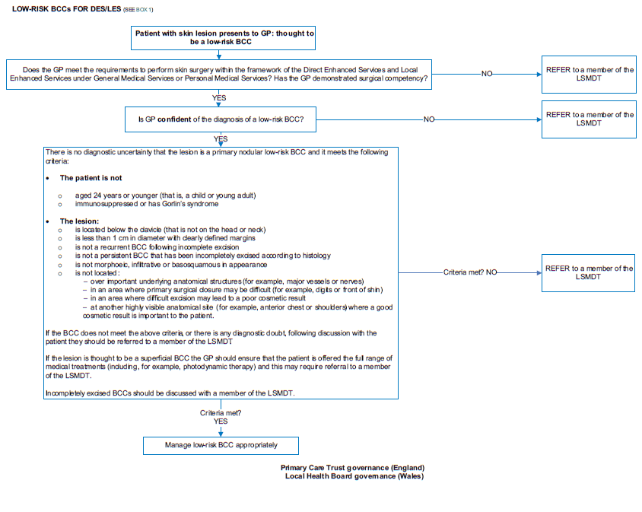
Appendix 1

